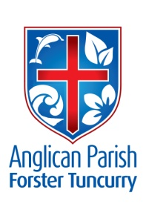
PARISH NEWS

3rd September 2017
THIRTEENTH SUNDAY AFTER PENTECOST

If you want to become a disciple of Jesus, deny yourself, take up your cross and follow him. Matthew 16:24–25

YOU’RE INVITED!
To: Our Anglican Women Spring Celebration (Manning Deanery)
Where: St Nicholas Church
When: 10 for 10.30am this Monday 4th September. Finishes around 2.30pm
Theme: ‘Facing the Future in the Spirit’s Power’ and the guest speaker is Brian Holmes from Anglican Overseas Aid.
Lunch Arrangements: Please bring your own.

CONNECT DINNER
The second CONNECT DINNER is being held at St. ALBANS on Saturday 9th September. As we (The Anglicans) are hosting this event we are asking if you would like to help out with the catering - we anticipate one hundred people in total - WOW - so will require assistance. Dyers Crossing is preparing the desserts so there is a need for main course meals. Lists at Tuncurry and Forster. Contact Lyn 0491-136-455 or Parish Office 6555-4200.

BCA BOXES
BCA box opening time - Please return your boxes to Suellen for counting and processing.
Suellen Belton - BCA Box Secretary - 6554 8264

ACKNOWLEDGEMENT OF COUNTRY
As we gather together we acknowledge the traditional custodians of this area, the Worimi people, and their elders, past, present and future. It is they who hold the memories, traditions, culture and hopes of Aboriginal Australia. May we walk together, united in spirit and respect, towards a better and brighter future for this land, our land, AUSTRALIA.

In Our Prayers:
Our Parish:
- Community leaders
- Please continue to pray for people with ongoing needs in your prayers each day.

If you would like to add someone to the Parish Prayer list, be sure to obtain permission from the person concerned and then contact the Parish Office.

Our Diocese:
- Assistant Bishop Peter Stuart and Nicki
- Parishes of Kotara South, Lambton and Merewether
- Lakes Grammar
- Australian Defence Force Chaplaincy
- First Peoples of the Diocese
The World:
- Episcopal Churches of San Diego & San Joaquin, USA
- Liz Burns (CMS Tanzania)

We commend to God’s keeping those who have recently died and we pray for those who mourn their passing. We remember with thanks those whom we have loved whose anniversary occurs at this time: Enid Thompson, Norma Dowling and Connie Buddery.

CONTACT DETAILS
Parish Priest: The Reverend Mark Harris 6555 4200
revmarkharris@icloud.com
Priest in Local Mission The Reverend Bill Green 6555 4200
Deacon The Reverend Helen Quinn 6555 4200
Parish Office: St. Alban’s Anglican Church: 6555 4200
info@forsteranglican.com
Parish Secretary Judy Hall 0400 890 728
Op Shop: Head St Car park 6555 4267 Enquiries: 6555 4200
Book Shop bookshop@forsteranglican.com 6555 4272
Parish Website: www.forsteranglican.com

Items for Parish News:
Email: PN@forsteranglican.com or phone Janet 6554 5981 or parish office 6555 4200 by 12noon Wednesday.

Our Bank Details: BSB: 705 077 Account: 000400710
Acc Name: Anglican Parish of Forster/Tuncurry

SAFE MINISTRY TRAINING
The next Safe Ministry Training update course will be held in St Albans Hall on Saturday 16th September from 9am-12pm.

COURTHOUSE ROSTER
6th September Heather Milligan & Patricia Dastidar
20th September Frances McPherson & Bev Christiansen

SPRING PROGRAM
Due to unforeseen circumstances the quarterly Sunday services reading program will not be printed for another two weeks. We apologise for this delay. The readings for Sunday 3rd September and Sunday 10th September are as follows:

Pentecost 14(Sunday 10th September)
Exodus 12v1-14; Psalm 149; Romans13v1-10; Matthew 18 v10-20

CONTRIBUTIONS TOWARDS A FAMILIES MINISTER
Donations are starting to roll in for our mission of employing a families minister for our parish. So far $1,820.00 has been forthcoming.
Thanks to those who have so far given donations.

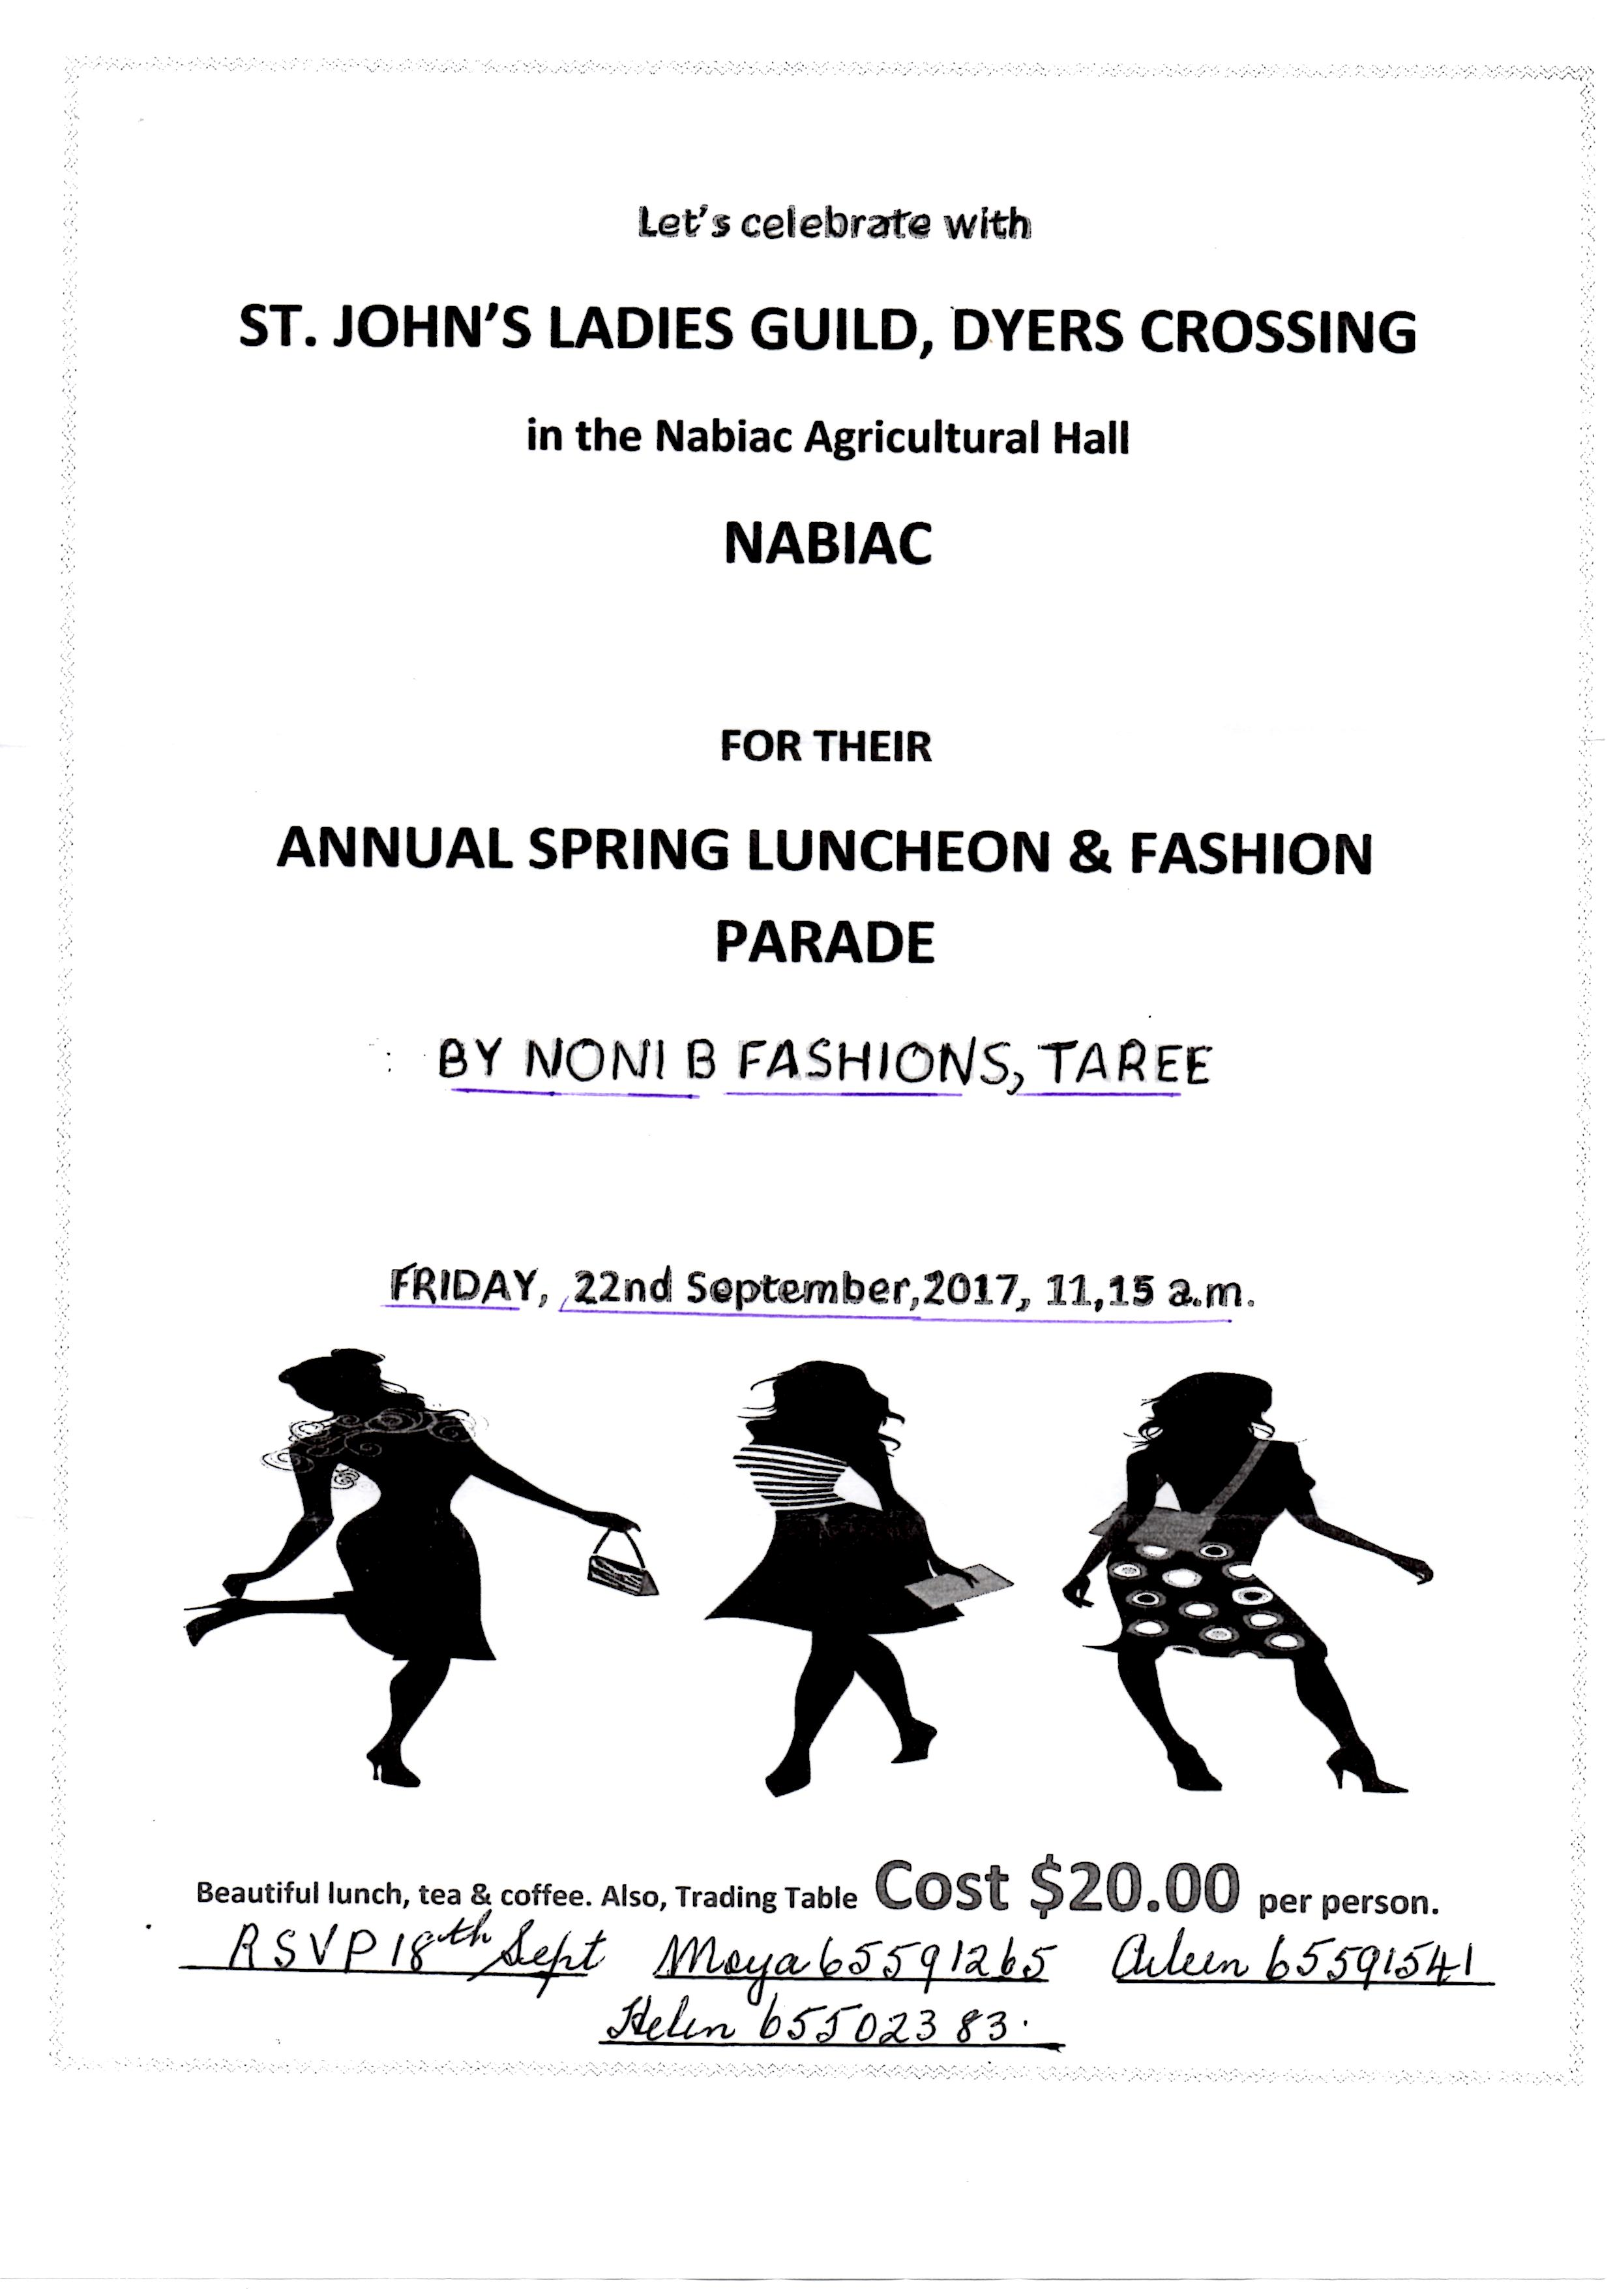

SPRING MINI LUNCH
What’s for lunch??? Come along to St. Albans Parish hall on Wednesday, 13th September, 11.30am for 12 noon start and enjoy the monthly mini lunch, $7.00 each. A trading table, lucky door prizes and raffle plus more importantly - friends to meet.

30TH ANNIVERSARY DINNER
From the first weekend in October at Forster, Tuncurry and Dyers Crossing, there will be an opportunity to list your name and pay $26 a head for the Dinner. More details later.
For info - Contact Suellen Belton - Co-ordinator - 6554 8264

OP SHOP APPEAL
We are desperately in need of volunteers for the Op Shop, specifically for Tuesday afternoons. If we cannot get staff we may need to close the shop on Tuesday afternoons.

CMS SUMMER SCHOOL ‘TECH TEAM LEADER’ – VOLUNTEER ROLE
CMS NSW & ACT is looking for the right person to lead the Tech Team at CMS Summer School. If you enjoy leading a team, can prepare a roster, and have a general understanding of all things technical, then this volunteer role may be for you. You will have a broad understanding of AV systems and WHS. You will be required to work with the internal team leaders to prepare rosters and work schedules and identify equipment to be sourced from external suppliers. If you would like to know more about the role, please contact Tony Hinchon at thinchon@cms.org.au

OCTOBER FETE
Besides having a celebratory service and luncheon on Sunday 29th October to celebrate the 30th anniversary of our St Albans Church, we will also have a fete on the preceding Saturday. The purpose of this event is to get people back to our church and join with others in celebration.
Please mark this date in your diary: Saturday 28th October from 10am-1pm. Start advertising the event to neighbours and friends.
Plans are now underway and we need help. We hope to have the following stalls:
- Plants
- White elephant
- Cooking and cakes
- Second hand books
- Face painting – we already have someone in mind to do this
- Rock painting – we already have someone in mind to do this
- Jumping castle
- Devonshire teas
- Petting Zoo
- Pre-loved clothes
- Sausage sizzle – we already have someone in mind to do this
- Cartooning– we already have someone in mind to do this
We need one main organizer for each stall/event and then a list of people who are willing to help out – either
- Manning the stalls
- Setting up
- Cleaning up
Other things will be going on as well: live music, a short concert by the kids and parents from Toddler Time, pony rides and maybe even a display from local services (still to be arranged)
Events such as this can only be successful if the whole parish gets involved. Trish Harris is our event organizer and would love to hear from you. Alternatively, Judy and Clive in the Parish Office are always willing to take on names and/or ideas.

BOOKSHOP 1ST BIRTHDAY CELEBRATIONS
A huge thanks go out to all who supported the initial day of our 1st Birthday celebration week!

We enjoyed a lovely day with the weather remaining fine for the whole of the time. It was great to have visitors from other churches as well as many from our own parish. Many folk donated good quality second hand Christian books and this was a popular retail outlet with over $40 being made. Books were absolute bargains and prices ranged from 50c through to and including $1, $2, $5 and even one at $10. The remaining goods will be used for a stall at the fete celebrating the 30th anniversary of the consecration of St Albans church on Saturday 28th October.

Many took advantage of the 10% discount off all stock and so far sales of $280+ have been realised. Only one person enjoyed the jumping castle so kindly donated by the Anglican Church at Wingham. Many also enjoyed the expert sausage sandwiches cooked by Barry Levick and Phillip Castle. Morning tea was a real treat with yummy slices, biscuits and scones donated by a large number of parishioners. Over $90 was donated to GLECCA as a result of the generosity of patrons. And at 11am, the 1st birthday cake was cut.

Thanks to all who supported us. Especial thanks go to Deb Laurie, Phillip Castle, Lyn Davies, Helen Connell, Di Kelleher, Barry Levick, Clive Davies and Trish Harris who worked so tirelessly to ensure that the event was a success.
