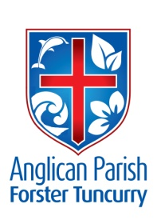
PARISH NEWS

16th July 2017
SIXTH SUNDAY AFTER PENTECOST

The words you have spoken are spirit and life, O Lord; you have the words of eternal life. John 6.63, 68

BREAKFAST PROGRAM
The Chill-out Breakfast Program at Foster High needs a few more volunteers to run efficiently and Jose has prepared information which is on the PowerPoint today. For more details and to offer to be a volunteer see Heather Webster—or phone 6555 3651.

TWO FILM PREMIERES:
1) GLECCA (Great Lakes Education Christian Care Association) in association with Great Lakes Cinema 3 Tuncurry present –
Lee Strobel’s “THE CASE FOR CHRIST” Sunday, 23rd July 2017 at 2.00pm. Afternoon Tea will follow the movie. All proceeds in support of the Great Lakes Chaplaincy Program. Tickets $20.00 from Heather Webster 0439 418 478, 6555 3651 or contact Jan Long 0409 070 311. (See book review.)

2) FILM PREMIERE – “THE PROMISE”
Thursday, 20th July, 5.30pm, Great Lakes Cinema. This film tells the 1915 story of love and survival set against a beautiful but conflicted Turkey during the Armenian genocide. It is a fundraiser for Rural Australians for Refugees supported by GLRAR, Friends of GL Library, Friends of ABC, Hospice, and U3A. Tickets available from Elsa 0407 702 056 or Lyn 0458 238 856.
In Our Prayers:

Our Parish:
- Worshipping communities
- Please continue to pray for people with ongoing needs in your prayers each day:
If you would like to add someone to the Parish Prayer list, be sure to obtain permission from the person concerned and then contact the Parish Office.

Our Diocese:
- Assistant Bishop Peter Stuart and Nicki
- Parishes of Beresfield & Thornton and Branxton, Greta & Lochinvar
- Scone Grammar School
- Examining Chaplains
- The Diocese of North West Australia

The World:
- The Church in Ondo, Nigeria
- Liz Burns (CMS Tanzania)

We commend to God’s keeping those who have recently died and we pray for those who mourn their passing. We remember with thanks those whom we have loved whose anniversary occurs at this time: Margaret McKintosh and Constance Hilda Newman.

COURTHOUSE ROSTER
19th July Suellen Belton & Diane Kellehear
9th August Heather Dwyer and Nerelle Duff
CONTACT DETAILS
Parish Priest: The Reverend Mark Harris 6555 4200
revmarkharris@icloud.com
Priest in Local Mission The Reverend Bill Green 6555 4200
Parish Office: St. Alban’s Anglican Church: 6555 4200
info@forsteranglican.com
Parish Secretary Judy Hall 0400 890 728
Op Shop: Head St Car park 6555 4267 Enquiries: 6555 4200
Book Shop bookshop@forsteranglican.com 6555 4272
Parish Website: www.forsteranglican.com

Items for Parish News:
Email: PN@forsteranglican.com or phone Janet 6554 5981 or parish office 6555 4200 by 12noon Wednesday.

Our Bank Details: BSB: 705 077 Account: 000400710
Acc Name: Anglican Parish of Forster/Tuncurry

ANGLICAN WOMEN MANNING DEANERY SPRING CELEBRATION
Advance notice: The Anglican Women Spring Celebration (Manning Deanery) will be held on Monday 4th September, 2017 at St Nicholas – times 10am for 10.30 start. The theme for the day is ‘Facing the Future in the Spirit’s Power’ and the guest speaker is Brian Holmes from Anglican Overseas Aid. The day will finish around 2.30pm.

CLAIMING THE DATE!
A Safe Ministry Refresher Course at St Alban’s will be held on Saturday 16th September from 9am-12noon. Registration forms have been placed in each of the churches. Cost for the event is $25.

SAMARITANS SUPPLIES
July – Toiletries such as soap, shampoo & conditioner, toothpaste, shower gels. Have a look around your own bathroom for some extra ideas and don’t forget the little people.

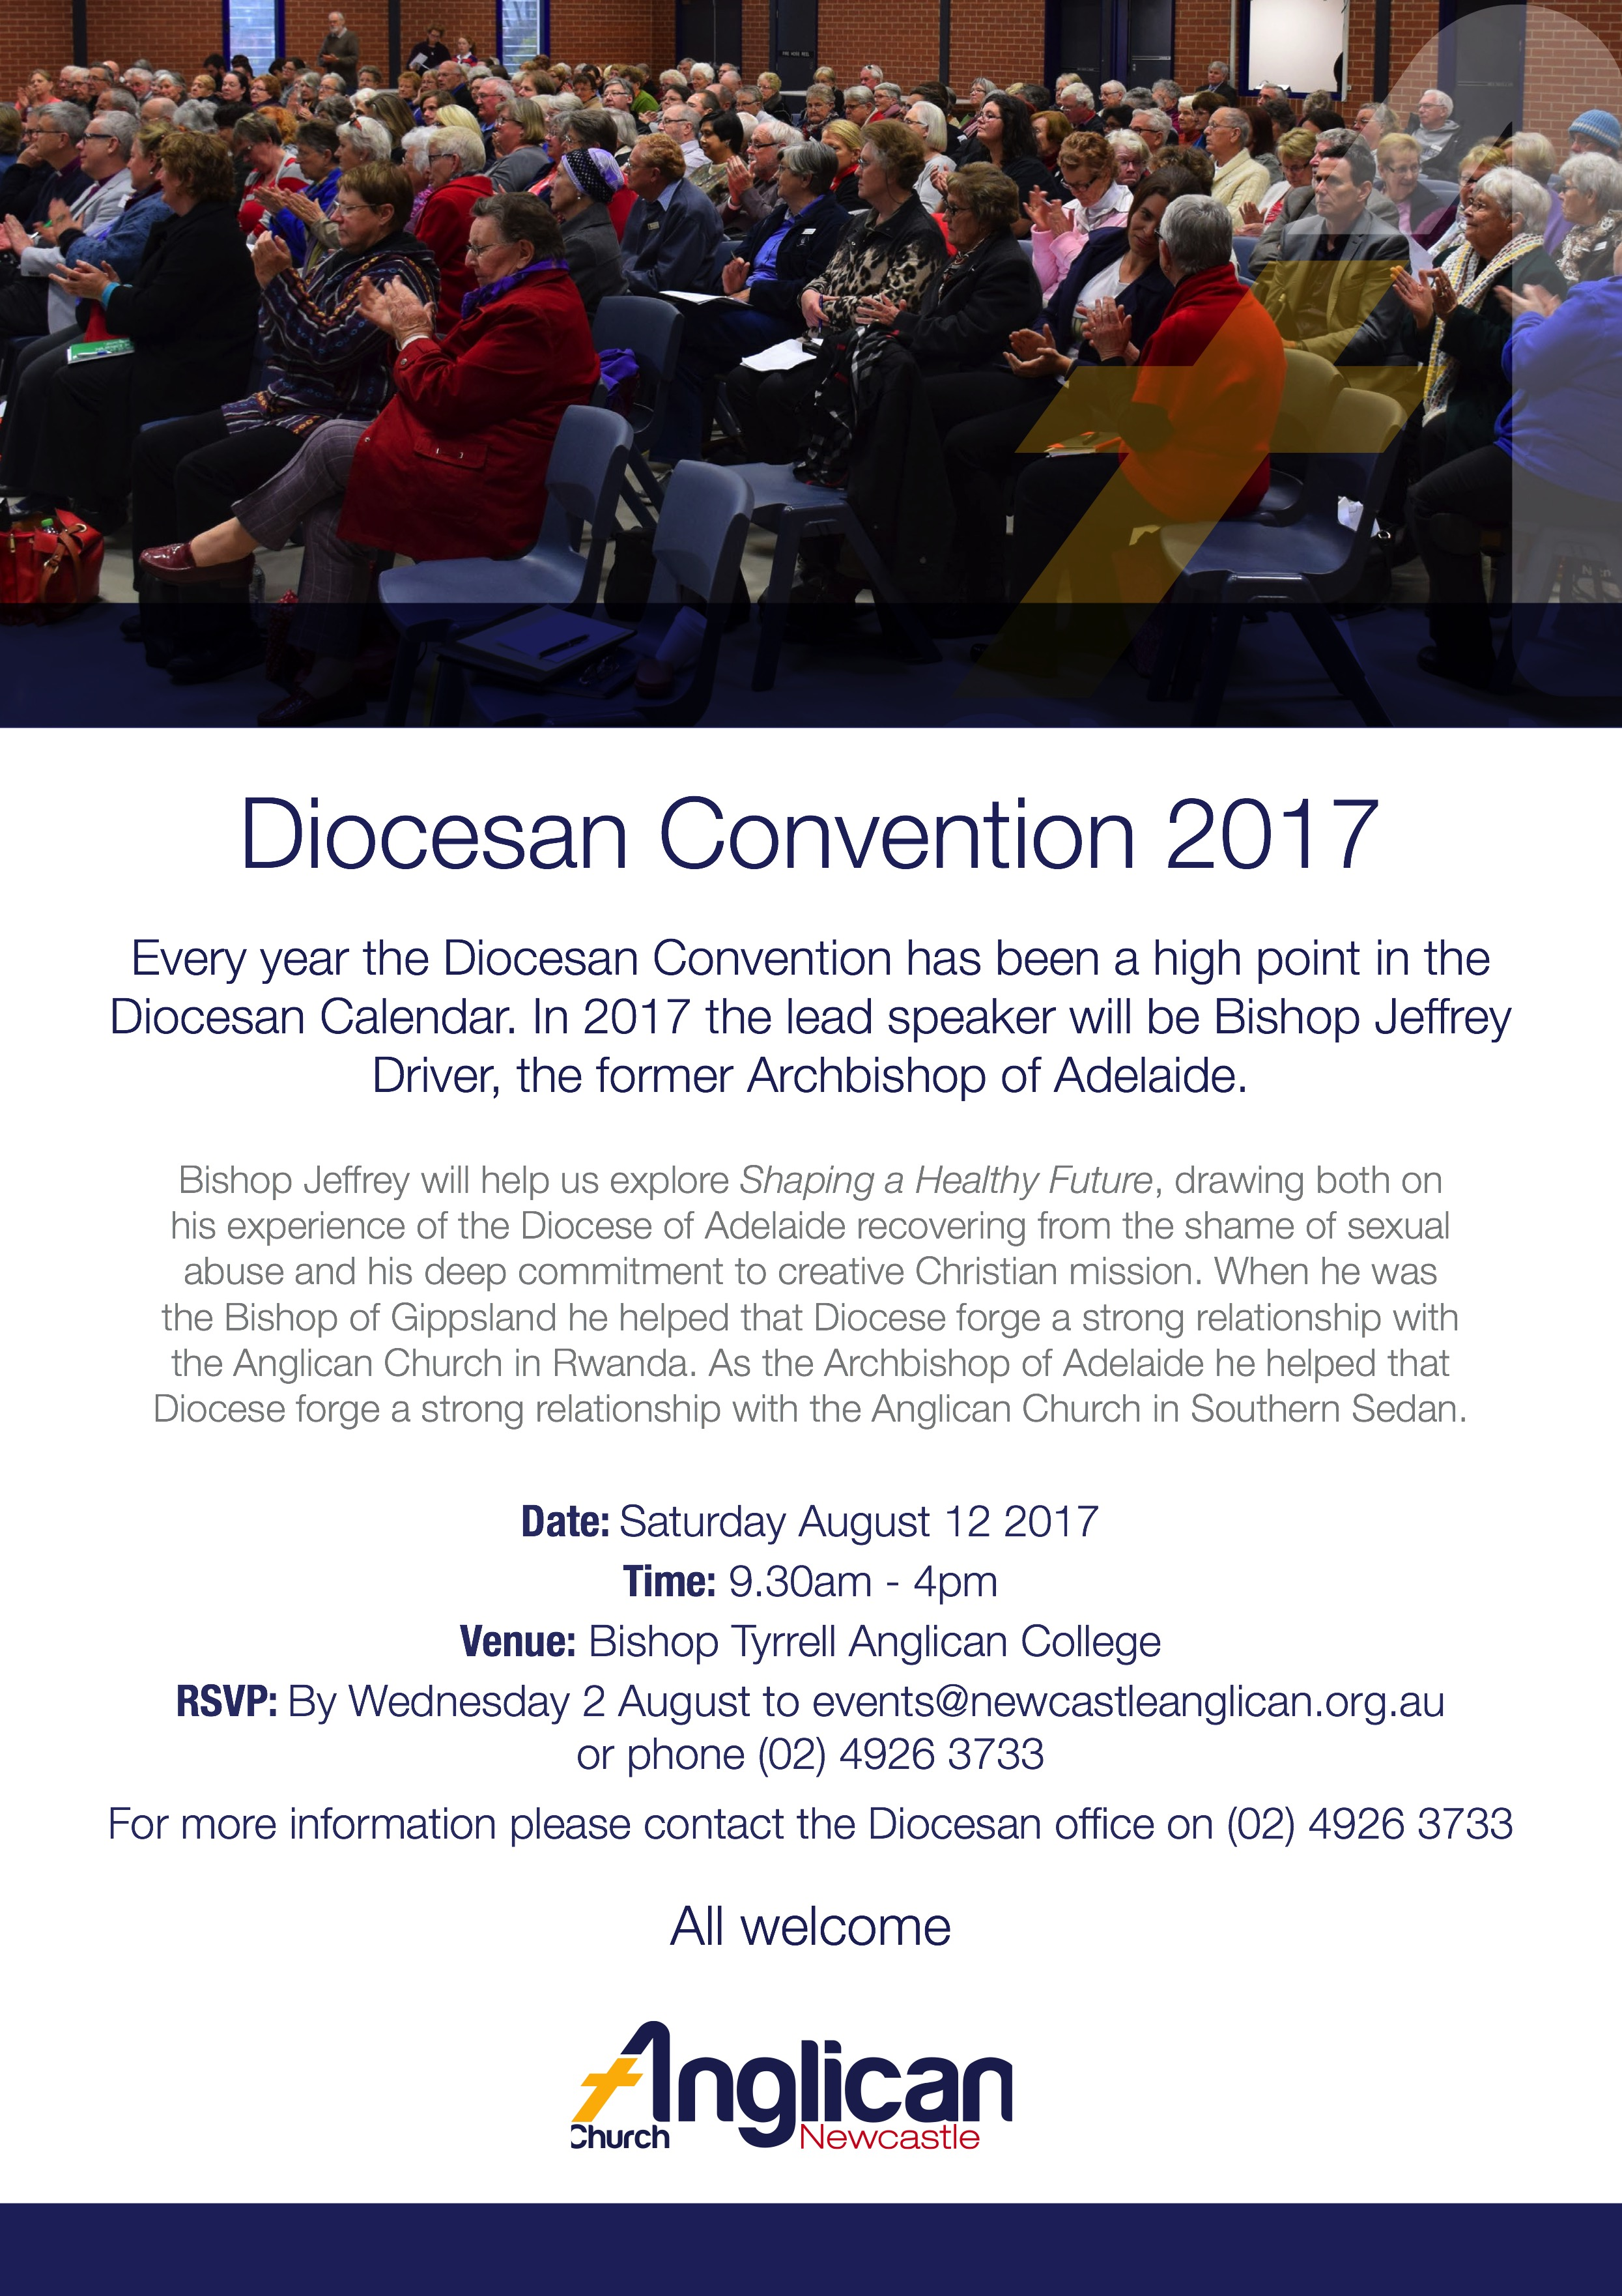

FROM THE BOOKSHOP:
The Case For Grace – A Journalist Explores the Evidence of Transformed Lives...Lee Strobel $16.99
Although I have not read this book in its full completion, I have read different parts of it and it is definitely on my list of must reads.
Why?
Beginning with the first chapter, entitled ‘The Mistake’, Strobel explores how the grace of God really does lead to transformed lives. Each of the chapters focuses on the life story of some interesting characters. He traces their narratives from their early times through turmoil to their ultimate fruition in becoming true Christians. The lives of preachers, orphans, addicts, teachers and drifters are explored in poignant detail, using the everyday language of the speaker to make their stories more’ real’.
This is a heart-warming, convicting book – full of good fireside narratives that will inspire you to look and feel the wonder of God’s grace!

The Case For the Resurrection – Lee Strobel $3.99(?)
This short little book (only 96 pages long!) provides new evidence and shines a fresh light on the Bible’s most important story.
Using his usual journalistic style, Strobel asks penetrating questions to experts who provide authentic detail on how this event is proven fact not historical fiction. As a result, the reader is absolutely convinced that our God is the Messiah, conqueror of death and forgiver of our sins! It is essential reading for all who wish to be true witnesses for Christ.

The Case For Christ – Lee Strobel $9.99 (See Film Premiere item)
“Every inquirer should have it” write Phillip E. Johnson, Law Professor, University of California at Berkeley, and I couldn’t agree more. With his experience as a tough investigative reporter, Strobel conducts thorough research into identifying who are the best experts to provide answers to just about any question that a person would ask in relation to unpacking the identity and story of Jesus Christ.
Interviewees are from all walks of life: psychologists, biographers, archaeologists, theologians, research professors, former Jews, and others. Strobel spends extensive time questioning each one in a penetrating manner using his skills as a courtroom reporter. As a result, the case for Jesus is examined from all angles and the result is both remarkable and highly reassuring.
Jesus Christ is our Messiah. How blessed are we?
J.Hall (Something Special Bookshop)

FRIENDSHIP GROUP
A happy group met at St Nicholas’s for the Friendship Morning Tea where we welcomed Reverend Helen. The sum of $1,452.82 was banked for the Cancer Fund Morning Tea and plans were made for a similar function for Parish funds.
Mini-lunch recipes were discussed and an idea to explore information of early times in the area was put forward.
Why not join us next month? (We meet on the first Wednesday.)
Helen Barber

CONSECRATION OF ST ALBAN’S
The 30th Anniversary of the consecration of St Alban’s will take place in late October (to be celebrated on the weekend of 28th-29th October, 2017.

Those interested in assisting in planning for this occasion need to give their names to either Judy or Clive at the parish office. In particular an event coordinator is needed. Please prayerfully consider nominating for this role.

At our Parish Council meeting last Tuesday we began discussions on how we might celebrate this occasion. Ideas included a Thanksgiving service, a special dinner and guest speaker, a mini-fete/trading tables/selling postcards/memorabilia, and of course a display of photos, documents and other memorabilia.

One of the urgent things needed in preparation for the event/occasion is a list of names and addresses for those that we should invite. Again, please provide these to Judy or Clive in the office.

