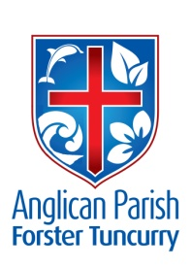
PARISH NEWS

28th May 2017
SEVENTH SUNDAY OF EASTER

‘Go and make disciples of all nations,’ Jesus commands;
‘I am with you always, to the close of the age.’
Matthew 28.19–20

COMBINED CHURCH SERVICE – 18th June, 2017
There will be an additional combined service on Sunday 18th June, 2017 commencing at 9.30am at St Nicholas. This will be the only service that will be held in our parish on that weekend. After the service, at approximately 11.15am, there will be a special parish meeting in order to conduct a ‘Think Tank’ – explained elsewhere in this bulletin. Although this service and meeting is a few weeks off, it would be great to put it into your calendars and make an effort to attend the special meeting afterwards!

CANCER MORNING TEA
We are now registered with The Cancer Council to hold our morning tea on Saturday, June 17th from 10.00am at St Nicholas’ Church, Tuncurry.
Can you help with:
- A slice for morning tea
- Items for a stall
- Items for a raffle or a voucher
- Transport for our friends or your friends
- Set up, wash, up, tidy up!
Please come to the meeting Wednesday, June 7th, 10.00am at St Nicholas’ Church – or phone 0419-996-594.
Helen Barber (for Friendship Group)
MEN’S DINNER – CHANGE OF SPEAKER
Tuesday 6th June 2017
6.00pm for 6.30pm St Albans Forster
Speaker: Mike O’Halloran. Subject: Marine Rescue---What is new in its operation.
Cost $12 ph for 2 course dinner. Drinks available.
Lists at Forster & Tuncurry Churches or phone Clive Davies 0412 653061

ANGLICAN WOMEN’S ANNUAL SERVICE 2017
The Anglican Women’s Annual Service will be at
Christ Church Cathedral, Church Street, Newcastle on Tuesday, 6th June.
- Morning tea from 9.45 am.
- Holy Eucharist 10.30 am. Celebrant: Rt Rev Dr Peter Stuart. Preacher: The Ven Canon Sonia Roulston.
- 11.45 am Guest Speaker: Rt Rev Kay Goldsworthy, Bishop of Gippsland.
- BYO lunch, coffee and tea provided.
- 1.15 pm The Rev Di Langham, Chaplain, Cessnock Gaol.
Ring Marg Gogerly 6554-6708 or Helen Barber 0419-996-594 if you would like to come.

NEW COUNTERS NEEDED
St Alban’s is looking for 2-3 parishioners who could assist in counting the offertory collections after the services at St Alban’s on a Sunday. Please contact either Clive or Judy at the Parish Office – or at church - if you could assist in this aspect of Parish work.

SAMARITANS FOOD
June – Winter cereals, porridge, rolled oats and savoury biscuits.
In Our Prayers:

Our Parish:
- ABM Projects
- Please continue to pray for people with ongoing needs in your prayers each day.

If you would like to add someone to the Parish Prayer list, be sure to obtain permission from the person concerned and then contact the Parish Office.

Our Diocese:
- Assistant Bishop Peter
- Church Missionary Society
- Anglican Care
- Retired Clergy
- Hospitals and Medical Centres
- The Scottish Episcopal Church

The World:
- The Anglican Centre in Rome
- Liz Burns (CMS Tanzania)

We commend to God’s keeping those who have recently died and we pray for those who mourn their passing. We remember with thanks those whom we have loved whose anniversary occurs at this time: Marcia Mason, Keith Allen, Lillian Underwood, Jan Mazaraki, Joan Williams and Alan Crawley.

COURTHOUSE ROSTER
7th June Heather Milligan & Patricia Dastidar
21st June Frances McPherson & Bev Christensen

CONTACT DETAILS
Parish Priest: The Reverend Mark Harris 6555 4200
revmarkharris@icloud.com
Priest in Local Mission The Reverend Bill Green 6555 4200
Parish Office: St. Alban’s Anglican Church: 6555 4200
info@forsteranglican.com
Parish Secretary Judy Hall 0400 890 728
Op Shop: Head St Car park 6555 4267 Enquiries: 6555 4200
Book Shop bookshop@forsteranglican.com 6555 4272
Parish Website: www.forsteranglican.com

Items for Parish News:
Email: PN@forsteranglican.com or phone Janet 6554 5981 or parish office 6555 4200 by 12noon Wednesday.

Our Bank Details: BSB: 705 077 Account: 000400710
Acc Name: Anglican Parish of Forster/Tuncurry

MEN’S WEEKEND AT TAHLEE
Phillip Castle & Clive Davies had a most enjoyable & fruitful time at the 2017 Anglican Men’s Weekend at Tahlee last weekend. 70 men from 14 parishes plus others heard from many young clergy from the diocese, all passionate about allowing the gospel to transform every part of our lives. As well we had much delicious food and sang many songs with gusto. Many of those present were under the age of 40 including most of the speakers. At a time when the Diocese is feeling much pain it was a joy to see first-hand many positive things that are happening in the Diocese. That one Anglican parish in a Newcastle suburb had 200 parishioners at their weekend away at Tahlee recently was fantastic to hear.
It will be on again next year at the same time. If you are a male put it in your diary now.
Clive & Phillip.

PARIS COUNCIL REPORT
There have already been two meetings of the 2017 Parish Council. Current matters that we are working on include: securing a ‘families’ minister for our parish, upgrading the kitchen facilities at St Albans, addressing audit recommend- dations, St James, Bungwahl and reviewing monetary systems – as well as the general maintenance issues pertaining to all churches. Some details are as follows:
- securing a ‘families’ minister for our parish. We are looking at ways to better involve parishioners in helping to identify ways that we can fund this. On June 18, there will be an extraordinary combined service at St Nicholas (9.30) with a ‘Think Tank Meeting’ to follow (start at 11.15am) The purpose of the Think Tank will be to get ideas from parishioners on how to fund this.
- upgrading the kitchen facilities at St Albans. We have received one quote for this and are now sourcing others – as well as investigating how to fix flooring where the new dishwater and benches will be installed.
- addressing audit recommendations. A meeting with the auditors has been arranged for June 28th. The purpose is to investigate ways for implementing recommendations and reducing the cost of audit.
d) reviewing monetary systems. We have looked at ensuring that our counting systems of offertory collections are aligned with diocesan requirements, as well as being able to distinguish the offerings made at each centre where multiple services are held within the one week. This is in addition to other things such as security, having sufficient signatories to accounts and how to best monitor our finances.
FOR SALE

Pews
There are 4 wooden pews in the hall attached to
St Alban’s which Parish Council is going to sell. These quality wooden pews are solidly constructed and are available for purchase @$500. Please contact Clive or Judy at the Parish Office, if interested.

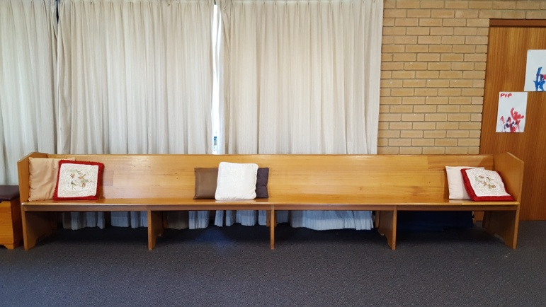

Gas Heater
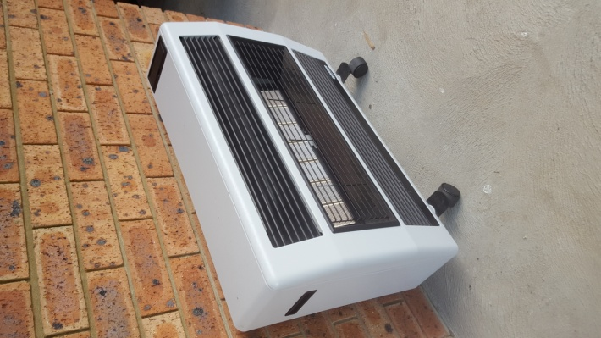
We also have a gas heater for sale. This is in good quality and similar 2nd hand models are currently selling on e-Bay for $300. Again, please contact Clive or Judy at the Parish Office, if interested.

