Forster-Tuncurry Anglican Parish

Autumn Program, 2017

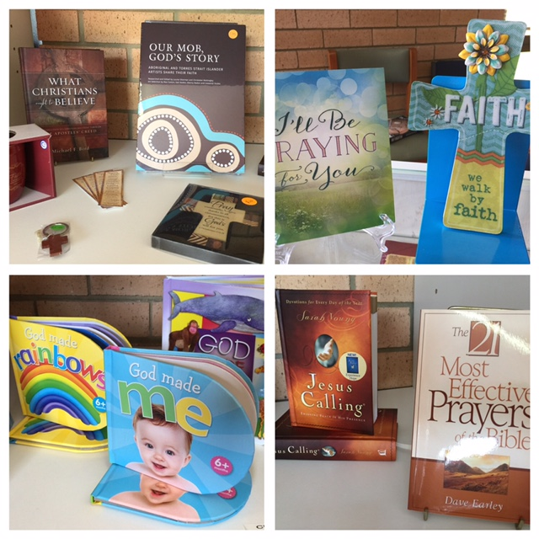

Something Special Christian Bookshop

*“We will connect meaningfully with our community in order to inspire hope and transformed lives through faith in Jesus.”*



6 St Alban’s Place Phone: (02) 6555 4200

FORSTER 2428 www.forsteranglican.com

Office open Mon – Fri e-mail: info@forsteranglican.com

9.00 am – 12 noon Facebook: Anglican Parish of Forster-Tuncurry

Printed *Wednesday, 14 June 2017*

⌘ TERM PROGRAM ⌘

Traditional Services

|  |  |  |  |
| --- | --- | --- | --- |
| **Date** | **Old Testament** | **Epistle/letter** | **Gospel** |
| 7th May | Acts 2.42-47 | 1 Peter 2.1-10 | *John 10.1-16* |
| 14th May | Acts 7.55-60 | 1 Peter 2.11-25 | *John 14.1-14* |
| 21st May | Acts 17.22-31 | 1 Peter 3.8-22 | *John 14.15-21* |
| 28th May | 1 Peter 5 | *Acts 1.1-26* | John 17.1-11 |
| 4th June Pentecost | 1 Cor 12.1-13 | *Acts 2.1-21* | John 20.19-23 |
| 11th June Trinity | Ex 34.1-8 | *Acts 2.22-41* | Matt 28.16-20 |
| 18th June | Gen 18.1-15 | *Acts 2.42-47* | Matt 9.35-10.8 |
| 25th June | Gen 21.8-21 | *Acts 3.1-26* | Matt 10.24-39 |
| 2nd July | Gen 22.1-14 | *Acts 4:1-31* | Matt 10:40-42 |
| 9th July | Gen 2434-38,42-49, 58-67 | *Acts 4.32 - 5.16* | Matt 11.15-19, 25-30 |
| 16th July | Gen 25.19-34 | *Acts 5.17 - 6.7* | Matt 13.1-9, 18-23 |
| 23rd July | Gen 28.10-19a | *Acts 6.8-15,7.48-8.1a* | Matt 13.24-30, 36-43 |
| 30th July Combined - F | Gen 29.15-28 | Rom 8.26-39 | *Matthew 13:44-58* |
| 6th August | Gen 32.22-31 | Rom 9.1-8 | *Matthew 14.13-21* |
| 13th August | Gen 37.1-4, 12-28 | Rom 10.4-15 | *Matthew 14.22-36* |
| 20th August | Gen 45.1-15 | Rom 11.13-22 | *Matthew 15.21-28* |
| 27th August | Ex 1.8-2.10 | Rom 12.1-8 | *Matthew 16.13-26* |
|  |  |  |  |

Contemporary services

|  |  |  |
| --- | --- | --- |
| **Date** | **Focus passage** | **Topic** |
| 7th May | John 10.1-16 | The Good Shepherd |
| 14th May | John 14.1-14 | The way & The truth and The life |
| 21st May | John 14.15-21 | Love one another |
| 28th May | Acts 1.1-26 | Ascension |
| 4th June Pentecost | Acts 2.1-21 | Pentecost |
| 11th June Trinity | Acts 2.22-41 | Gift of the Spirit |
| 18th June | Acts 2.42-47 | The living church |
| 25th June | Acts 3.1-26 | Peter empowered to heal |
| 2nd July | Acts 4:1-31 | They spoke the Word of God boldly |
| 9th July | Acts 4.32 - 5.16 | Unity in the Body of Christ |
| 16th July | Acts 5.17 - 6.7 | Persecution, preaching and price |
| 23rd July | Acts 6.8 - 15, 7.48 - 8.1a | Stephen the Radical |
| 30th July Combined - F | Matthew 13:44-58 | The Kingdom of heaven is like … |
| 6th August | Matthew 14.13-21 | Feeding the 5000 |
| 13th August | Matthew 14.22-36 | Jesus walks on the water |
| 20th August | Matthew 15.21-28 | Great is your faith! |
| 27th August | Matthew 16.13-26 | The Son of the Living God |

⌘ GROWTH GROUPS ⌘ - During School term

**K.Y.B. KRAMBACH 1st & 3rd Mondays** @ 1.30pm Contact **Peg Sawyer**

**Doug Dowling Tuesdays** @ 5.00pm.Contact **Doug Dowling**

**St Paul’s NABIAC Alt. Tuesday** @ 6.00-7.00pm. Contact **Geraldine Carson**

**St Nicholas Thursdays** @ 10.30am. Contact **Rev Bill** Contact **Rev Bill**

**St Alban’s Thursdays** @2.00-3.00pm. Contact **Heather Dwyer**

**Clive and Lyn Fridays** at 1.00-3.00pm. Contact **Clive Davies**

⌘ KIDS CONNECT ⌘ - During School term

**Toddler Time** (0-5yrs + Parents/carers) **Mondays** @ 9.30am St Alban’s Church Hall

Contact **Trisha Harris**

**Special Religious Education (SRE), Fridays** Forster & Tuncurry,9.30am - 11.30am

Contact **Rev Mark**

**SRE, Fridays** Krambach,9.30am & 10.00amContact **Dennis Ang**

**Scripture in Forster – Tuncurry (SIFT) Committee** Chairperson **Dennis Ang**

⌘ FOCUS ON PRAYER ⌘- During School term

**Wednesday** 8.45am St. Alban’s after Tea, toast & Theology

**Prayer Chain** Contact the Parish office

⌘ FOCUS EVENTS! ⌘

**5th August Working Bee Parish Hall – more details later**

**Men’s Dinner 1st Tuesday** 6pm bi-monthly @ St Alban’s Hall from June 6th

**Anglican men’s weekend “Tahlee” 19th-21st May** contact [jamiefyoung3@gmail.com](mailto:jamiefyoung3@gmail.com)

**Games afternoon 2nd Saturday** 1pm @ St Nicholas from May 13th

⌘ VITAL GROUPS ⌘

**Op-Shop –** Monday to Friday 9am - 4pm; Saturday 9am to 12.30pm

**Book-Shop –** Monday to Friday 9am - 12pm

**Gardening Group –** St Alban’s Tuesday mornings 9am

**Walking Group –** meet at St Alban’s carpark each 1st & 3rd Monday morning

**Court-care – Twice monthly –** Contact Suellen Belton for more info…

**Rugrats – Tuesday** @ 10.00 am St Alban’s Hall.

**Parish Council** 2nd **Tuesday** of each month @ 4.00 pm St Alban’s Hall.

**Mini-Lunch 2nd Wednesday** of each month @ 11.30 am St Alban’s Hall.

**Tea, Toast & Theology** every Wednesday @ 8 - 8:45am St Alban’s Hall.

**Pastoral Partners -** Contact Clive Davies for more info…

⌘ ST. ALBANS SERVICES ⌘

Saturdays: 5.30 pm Contemporary *+ Communion*

Sundays: 8.00 am *Holy Communion* ***\*\****

9.30 am Contemporary (Communion on the last Sunday) *\*\**

⌘ GATHERINGS AT OTHER CENTRES ⌘

**Tuncurry, St. Nicholas** *9.30pm Every Sunday – Holy Communion* ***\*\****

*9.30pm Every Thursday – Holy Communion*

**Nabiac, St. Paul’s** 11.30am Contemporary – 1st Sunday

*11.30am Holy Communion*  **–** *3rd Sunday*

**Dyers Crossing** 11.30am Contemporary – 2nd Sunday

*11.30am Holy Communion – 4th Sunday*

***\*\*The parish combines (5th Sunday) at St Alban’s on 30th July @ 9.30am***

⌘ RETIREMENT VILLAGES ⌘

Estia Forster 10.30am 1st Friday of the month – Rev Bill

Estia Tuncurry 10.30am 1st arr. by ministers Fraternal – Pat Sanderson

Glaica 3.00pm 1st Wednesday of the month – Rev Bill

Kularoo 2.00pm 3rd Wednesday of the month – Rev Bill

⌘ FORSTER-TUNCURRY LEADERSHIP ⌘

Rev Mark Harris – Senior Minister/Rector…………….Office Ph: 6555 4200

(Day of rest – either Thursday or Friday) Email: rev[markharris@icloud.com](mailto:markharris@icloud.com)

Rev Bill Green – Priest in Local Mission…………………… Office Ph: 6555 4200

(On Duty Wednesday-Friday and Sunday) Email: wpgreen5@bigpond.com

Lay Ministry Team:

Helen Quinn Clive Davies Pat Sanderson Phillip Castle Dennis Ang

Home Visitation:

Rev Mark Rev Bill Pat Sanderson

Parish Council Executive:

Clive Davies – Rectors Warden Kit Carson – Peoples Warden

Judy Hall – Peoples Warden Peter Board – Parish Treasurer

– Parish Secretary Phillip Castle – Assist. Treasurer & Secretary

Parish Councillors:

Dennis Ang Suellen Belton John Sanderson Heather Dwyer Barry Levick

Heather Webster – Safety Delegate Doreen Ovens – Missions Secretary