Forster-Tuncurry Anglican Parish

Spring Program, 2017
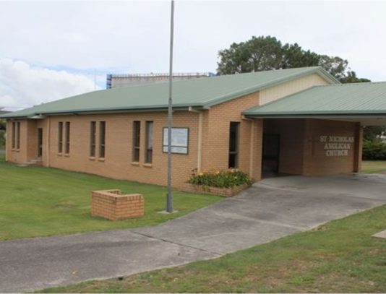
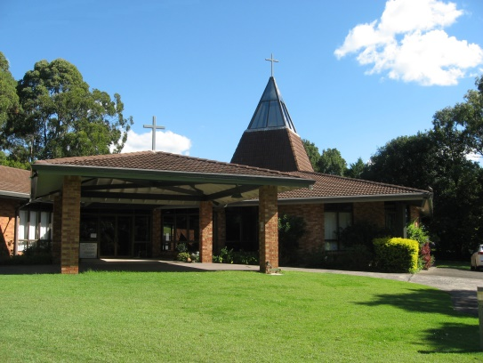

One Parish – Four Centres

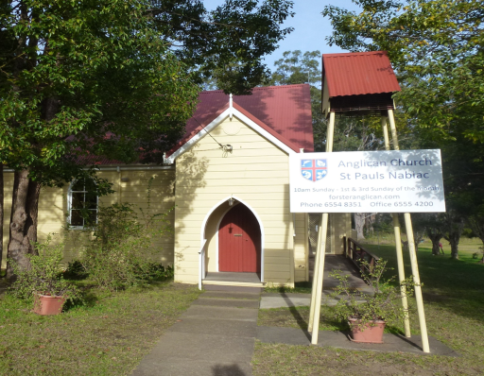
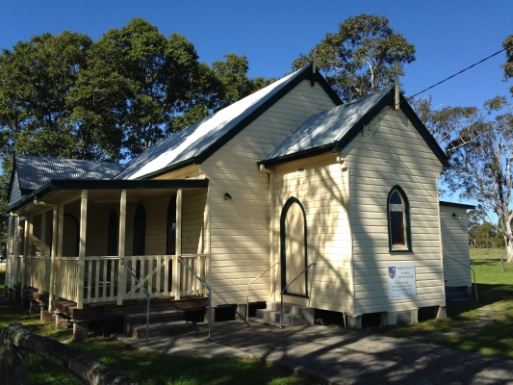

“We will connect meaningfully with our community in order to inspire hope and transformed lives through faith in Jesus.”

6 St Alban’s Place Phone: (02) 6555 4200
FORSTER 2428 www.forsteranglican.com
Office open Mon – Fri e-mail: info@forsteranglican.com
9.00 am – 12 noon Facebook: Anglican Parish of Forster-Tuncurry

Printed Wednesday, 11 October 2017
TERM PROGRAM
Traditional Services
Date | OT/reading | Epistle/reading | Gospel/reading
3rd Sep | Ex 3.1-5 | Rom 12.9-21 | Matt 16.21-28
10th Sep | Ex 12.1-14 | Rom 13.1-10 | Matt 18.10-20
17th Sep | Ex 14.19-31 | Rom 14.1-14 | Matt 18.21-35
24th Sep | Ex 16.2-15 | Phil 1 | Matt 20.1-16
1st Oct | Ex 17.1-7 | Phil 2 | Matt 21.23-32
8th Oct | Ex 20.1-4, 7-9, 12-20 | Phil 3 | Matt 21.33-46
15th Oct | Ex 32.1-14 | Phil 4 | Matt 22.1-14
22nd Oct | Ex 33.12-23 | 1 Thess 1.1-10 | Matt 22.15-33
29th Oct ^{Combined Ref DVD} | Romans 1.14-23 | Romans 3.8-26 | Romans 5.1-10
5th Nov ^{Reformation DVD2} | Ephesians 2.1-10 | Titus 2.11-14 | Luke 18.9-14
12th Nov ^{Reformation DVD3} | Acts 20.32,1 Cor 10.11-12,  Heb 4.12,2 Peter 1.20-21 | 2 Tim 3.14-17 | Psalm 19
19th Nov ^{Reformation DVD 4} | Heb 9.1-28 | 1 Cor 11.23-34 | Heb 4.14-16
26th Nov | Ezek 34.11-16, 20-24 | Eph 1.15-23 | Matthew 25.31-46
3rd Dec | Isa 64.1-9 | 1 Cor 1.1-9 | Mark 13.24-37
10th Dec | Isa 40.1-11 | 2 Peter 3.8-15a | Mark 1.1-8
17th Dec | Isa 61.1-4, 8-11 | 1 Thess 5.12-28 | John 1.6-8, 19-28
24th Dec | 2 Sam 7.1-11, 16 | Ps 89.1-4, 19-27 | Luke 1.26-38
Contemporary services
Date | Focus passage | Topic
3rd Sep | Matt 16.21-28 | Following Jesus
10th Sep | Matt 18.10-20 | “Sheep on the fringe”
17th Sep | Matt 18.21-35 | “A forgiving church”
24th Sep | Philippians 1 | A life worthy of the Gospel
1st Oct | Philippians 2 | Being Saved
8th Oct | Philippians 3 | The goal of the heavenly prize
15th Oct | Philippians 4 | Stand firm and rejoice!
22nd Oct | Acts 3.1-26 | Peter empowered to heal
29th Oct ^{Combined Ref DVD} | See the full list | Faith Alone – Martin Luther
5th Nov ^{Reformation DVD2} | in the Traditional | Grace Alone – John Calvin
12th Nov ^{Reformation DVD3} | services | Bible Alone – William Tyndale
19th Nov ^{Reformation DVD4} | above. | Christ Alone – Thomas Cranmer
26th Nov | Matthew 25.31-46 | Christ the King!
3rd Dec | Mark 13.24-37 | Advent 1: Keep Awake!
10th Dec | 2 Peter 3.8-15a | Advent 2: The truth of scripture
17th Dec | 1 Thess 5.12-28 | Advent 3: Until the Lord returns
24th Dec | Luke 1.26-38 | Advent 4: A blessing from God

It’s the 500 year anniversary of the reformation, so a special DVD series on the reformation will be shown during the services shown above.
GROWTH GROUPS - During School term

K.Y.B. KRAMBACH 1st & 3rd Mondays @ 1.30pm Contact Peg Sawyer
Doug Dowling Tuesdays @ 5.00pm. Contact Doug Dowling
St Paul’s NABIAC Alt. Tuesday @ 6.00-7.00pm. Contact Geraldine Carson
St Nicholas Thursdays @ 10.30am. Contact Rev Bill Contact Rev Bill
St Alban’s Thursdays @2.00-3.00pm. Contact Heather Dwyer
Clive and Lyn Fridays at 1.00-3.00pm. Contact Clive Davies

KIDS CONNECT - During School term

Toddler Time (0-5yrs + Parents/carers) Mondays @ 9.30am St Alban’s Church Hall
Contact Trisha Harris
Special Religious Education (SRE), Fridays Forster & Tuncurry, 9.30am - 11.30am
Contact Rev Mark
SRE, Fridays Krambach, 9.30am & 10.00am Contact Dennis Ang
Scripture in Forster – Tuncurry (SIFT) Committee Chairperson Dennis Ang

FOCUS ON PRAYER - During School term

Wednesday 8.45am St. Alban’s after Tea, toast & Theology
Prayer Chain Contact the Parish office

FOCUS EVENTS!

Working Bee Parish Hall – more details later
Men’s Dinner Tuesday 3rd October 6pm @ St Alban’s Hall
Games afternoon 2nd Saturday 1pm @ St Nicholas

VITAL GROUPS

Op-Shop – Monday to Friday 9am - 4pm; Saturday 9am to 12.30pm
Book-Shop – Monday to Wednesday & Friday 9am - 12pm. Saturday 10am-1pm
Gardening Group – St Alban’s Tuesday mornings 9am
Walking Group – meet at St Alban’s carpark each 1st & 3rd Monday morning
Court-care – Twice monthly – Contact Suellen Belton for more info…
Rugrats – Tuesday @ 10.00 am St Alban’s Hall.
Parish Council 2nd Tuesday of each month @ 4.00 pm St Alban’s Hall.
Mini-Lunch 2nd Wednesday of each month @ 11.30 am St Alban’s Hall.
Tea, Toast & Theology every Wednesday @ 8 - 8:45am St Alban’s Hall.
Pastoral Partners - Contact Clive Davies for more info…

ST. ALBANS SERVICES

Saturdays: 5.30 pm Contemporary + Communion
Sundays: 8.00 am Holy Communion **
9.30 am Contemporary (Communion on the last Sunday) **

GATHERINGS AT OTHER CENTRES

Tuncurry, St. Nicholas 9.30pm Every Sunday – Holy Communion **
9.30pm Every Thursday – Holy Communion
Nabiac, St. Paul’s 11.30am Contemporary – 1st Sunday
11.30am Holy Communion – 3rd Sunday
Dyers Crossing 11.30am Contemporary – 2nd Sunday
11.30am Holy Communion – 4th Sunday

**The parish combines (5th Sunday) at St Alban’s on 29th October @ 9.30am

RETIREMENT VILLAGES

Estia Forster 10.30am 1st Friday of the month – Rev Bill
Estia Tuncurry 10.30am 1st arr. by ministers Fraternal – Pat Sanderson
Glaica 3.00pm 1st Wednesday of the month – Rev Bill
Kularoo 2.00pm 3rd Wednesday of the month – Rev Bill

LEADERSHIP

Rev Mark Harris – Senior Minister/Rector……………. Ph: 0425 265 547
(Day of rest – either Thursday or Friday) Email: revmarkharris@icloud.com
Rev Bill Green – Priest in Local Mission…………………… Ph: 0488 570 028
(On Duty Wednesday-Friday and Sunday) Email: wpgreen5@bigpond.com
Rev Helen Quinn – Deacon in Local Mission………….Ph: 0427 592 723
(On duty by arrangement) Email: rqu783662@bigpond.com

Lay Ministry Team:
Clive Davies Pat Sanderson Phillip Castle Dennis Ang

Home Visitation:
Rev Mark Rev Bill Rev Helen Pat Sanderson

Parish Council Executive:
Clive Davies – Rectors Warden Kit Carson – Peoples Warden
Judy Hall – Peoples Warden and Parish Secretary
Phillip Castle – Acting Treasurer

Parish Councillors:
Dennis Ang Suellen Belton Peter Board John Sanderson
Heather Dwyer Barry Levick Heather Webster – Safety Delegate

