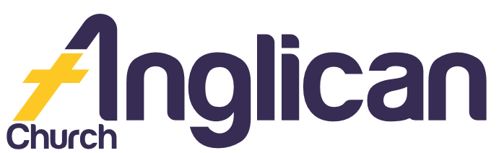

PARISH NEWS

FORSTER AND NABIAC
4th August 2019

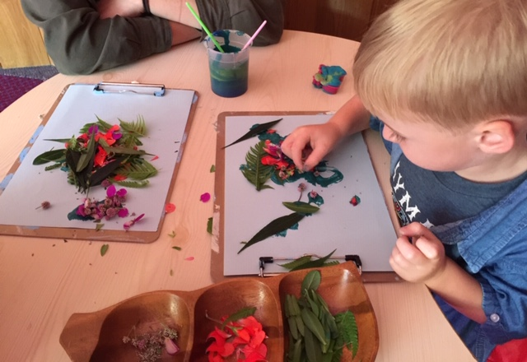
Happy Mothers Day 2019!

Connecting Meaningfully.
Inspiring Hope. Transforming Lives.
Through Faith in Jesus.

New in Nabiac!

What an encouraging new start to worship services in Nabiac! A huge thank you to everyone who has contributed to the amazing transformation of the building so far! Watch this space for more updates!

Men’s Dinner

Connect with us on Tuesday 6 August 6pm for a delicious dinner! Only $15! Come and hear Rev Rod share about his life and work with Bush Church Aid [BCA]. RSVP to Clive on
0412 653 061.

Seniors Lunch

Join us on Wednesday 14 August at 11.30 am for Light Lunch in the Church Hall! Only $8.00! A group you can really belong to!

Pray Always …

Beryl A, Ella E, George M, Jenny L, Keith R, Lyn T, Margaret B, Marion & Peter R, Peg S, and the Pearson family.

Our Christian Bookshop

Come in and be inspired by our awesome new books, cards and gift ware! All proceeds go to GLECCA and SIFT!

Bunnings BBQ

Join us on Saturday 17th August! Add your name to the list in the Hall and join us for a fun time, and make meaningful connections with our wonderful community!

Shine Your Light

Thank you for your support of the Church Missionary Society! They are able to share God’s love globally because of your prayers and financial support!
BY SUELLEN B

Explore Your Faith!
Come and explore what it means to be a believer in the Christian faith in 2019! Join us for
Christianity Explored!
Wednesdays at 9:30am. Ph: Soph on 0425 213 082.
Thursdays at 2pm.
Ph: James on 0411 335 087.

Womens Spring Event

We would love you to connect with us on Tuesday 3rd December at 10am for our Anglican Womens Event! Be inspired by Rebecca Wilson as she explores how “By grace [we] have been saved through faith”. BYO lunch. For more info Ph: Lorraine on 0419 277 294.

Volunteer Today

Op Shop………………….Heather D ……………………6555 4267

Book Shop……………….Phillip or Deb ………………..5543 7683
bookshop@forsteranglican.com

Items for Parish News……………trishaharris10@gmail.com
or Parish Office 5543 7683 by noon Wednesday

Connect With Us

Church Office ……… Clive Davies ………….…… 5543 7683
info@forsteranglican.com

………………….. Forster Anglican Church Community

Parish Website ………………… www.forsteranglican.com

Senior Minister ………. Rev Mark Harris ………0425 265 547
revmarkharris@icloud.com
Family Minister …..…..Rev James Brooks ………0411 335 087
jamesftac@gmail.com
Local Mission Minister …. Rev Helen Quinn …….0427 592 723
rqu783662@bigpond.com

For Direct Debit Giving

Account name: Anglican Parish of Forster/Tuncurry
BSB: 705077 Account: 000400710

Thank You For Your Generous Hearts!

