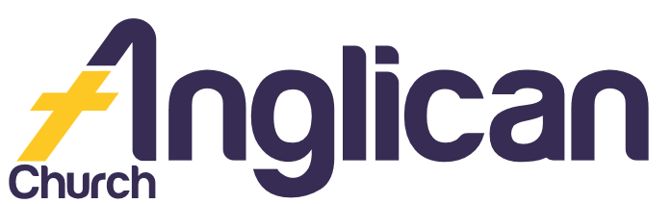
11th August 2019

PARISH NEWS

FORSTER AND NABIAC
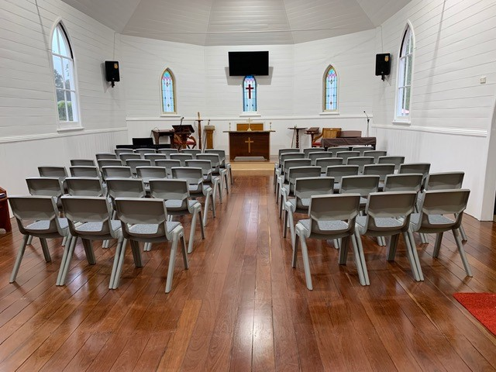
Happy Mothers Day 2019!

Connecting Meaningfully.
Inspiring Hope. Transforming Lives.
Through Faith in Jesus.

Spring Event!

Connect with us on Tuesday 3rd September at 10am for our Anglican Diocesan Womens Event! Come and hear Rebecca Wilson explore how “By grace [we] have been saved through faith”. BYO lunch. For more info Ph: Lorraine on 0419 277 294.

Light Lunch

Join us this Wednesday 14 August at 11.30 am for Light Lunch in the Church Hall! Only $8.00! A group you can really belong to!

Men’s Dinner

A fabulous night of connecting and encouragement! Thank you to Rod Oldfield for sharing about his life! And thank you to all our amazing chefs!

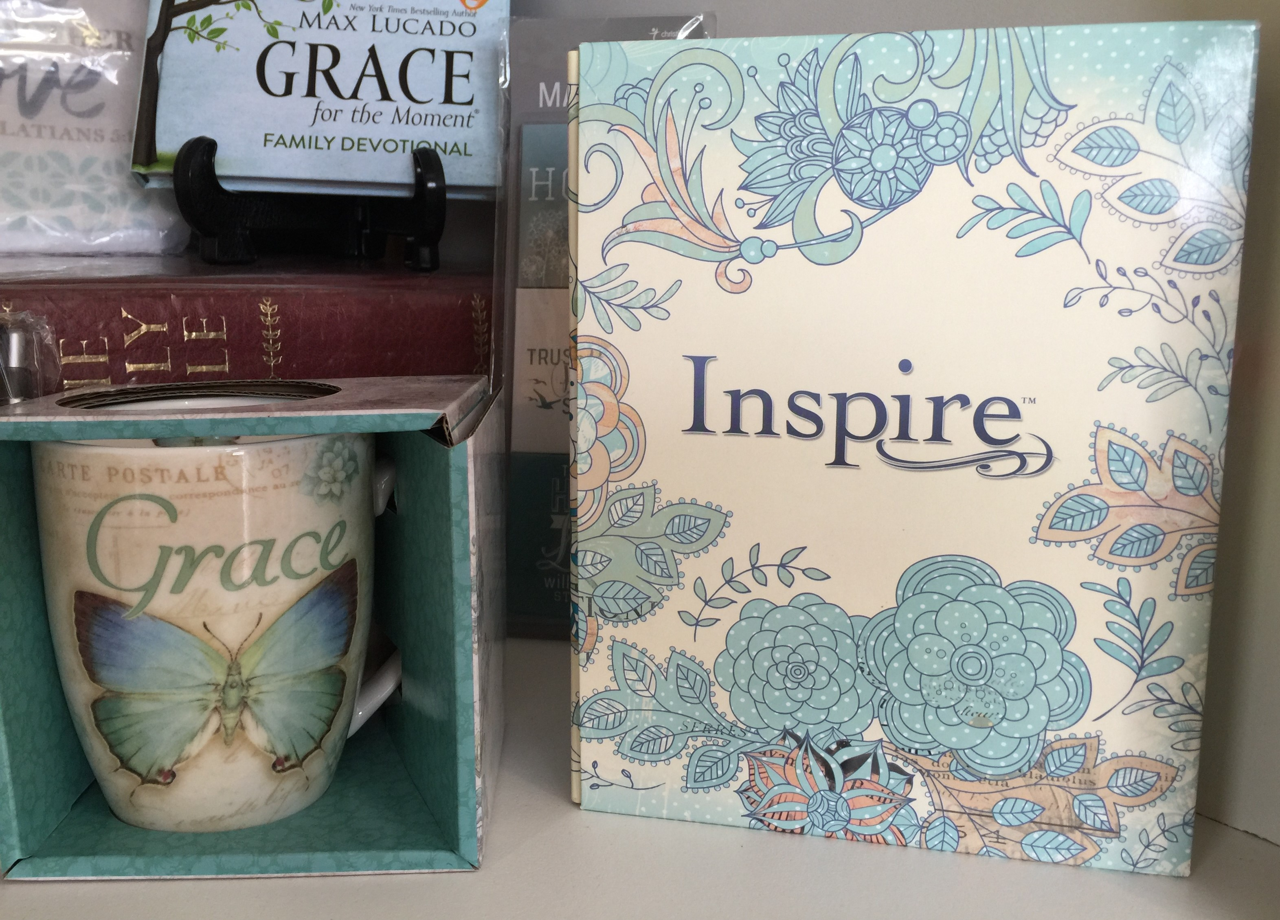
Pray From Your Heart …

Beryl A, Ella E, George M, Jenny L, Keith R, Lyn T, Margaret B, Marion & Peter R, Peg S, and the Pearson family.
Bunnings BBQ

Thank you to all the wonderful volunteers who have signed up to help on Saturday 17th August! Come along on the day, connect with us and with our wonderful community!

Our Bookshop

Come in and be inspired by our awesome new books, cards and gift ware! Thank you for supporting SRE in Forster Tuncurry Schools!

Be Mission-Minded
Support Mission to Seafarers this month! They support 1.5 million workers who face daily danger to keep our global economy afloat! Pray. Connect. Give. www.mts.org.au

Group of the Week …
Rugrats are making beautiful beanies for those doing it tough this winter! If you like creating with your hands and helping others, come and connect with this lovely group!

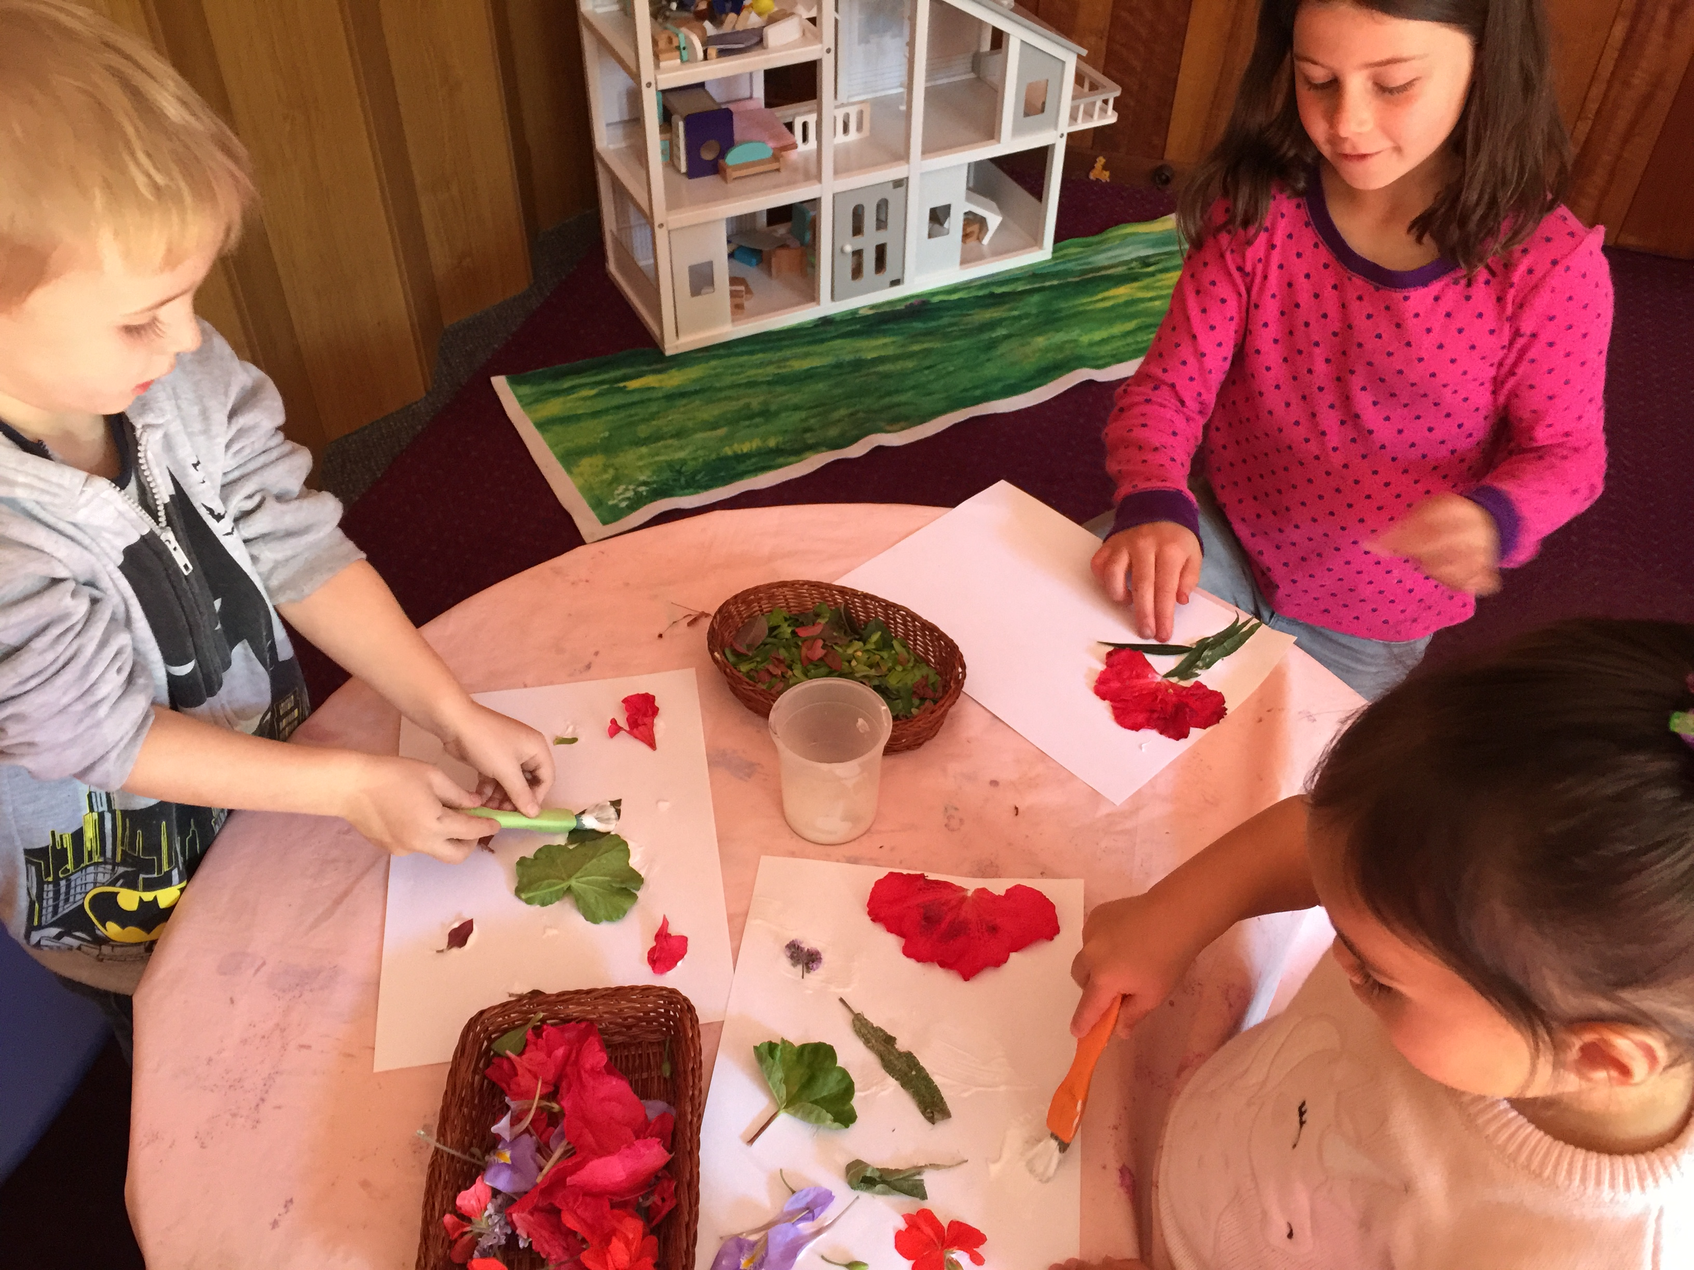

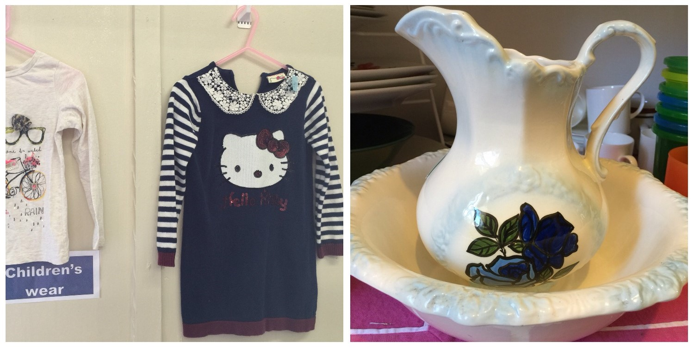

Connect With Us

Church Office ……… Clive Davies ………….…… 5543 7683
info@forsteranglican.com

………………….. Forster Anglican Church Community

Parish Website ………………… www.forsteranglican.com

Parish News……………trishaharris10@gmail.com
or Parish Office 5543 7683 by noon Wednesday

Volunteer With Us

Book Shop……………….Phillip or Deb ………………..5543 7683
bookshop@forsteranglican.com

Op Shop………………….Heather D ……………………6555 4267

For Direct Debit Giving

Account name: Anglican Parish of Forster/Tuncurry
BSB: 705077 Account: 000400710

Thank You For Your Generous Hearts!

