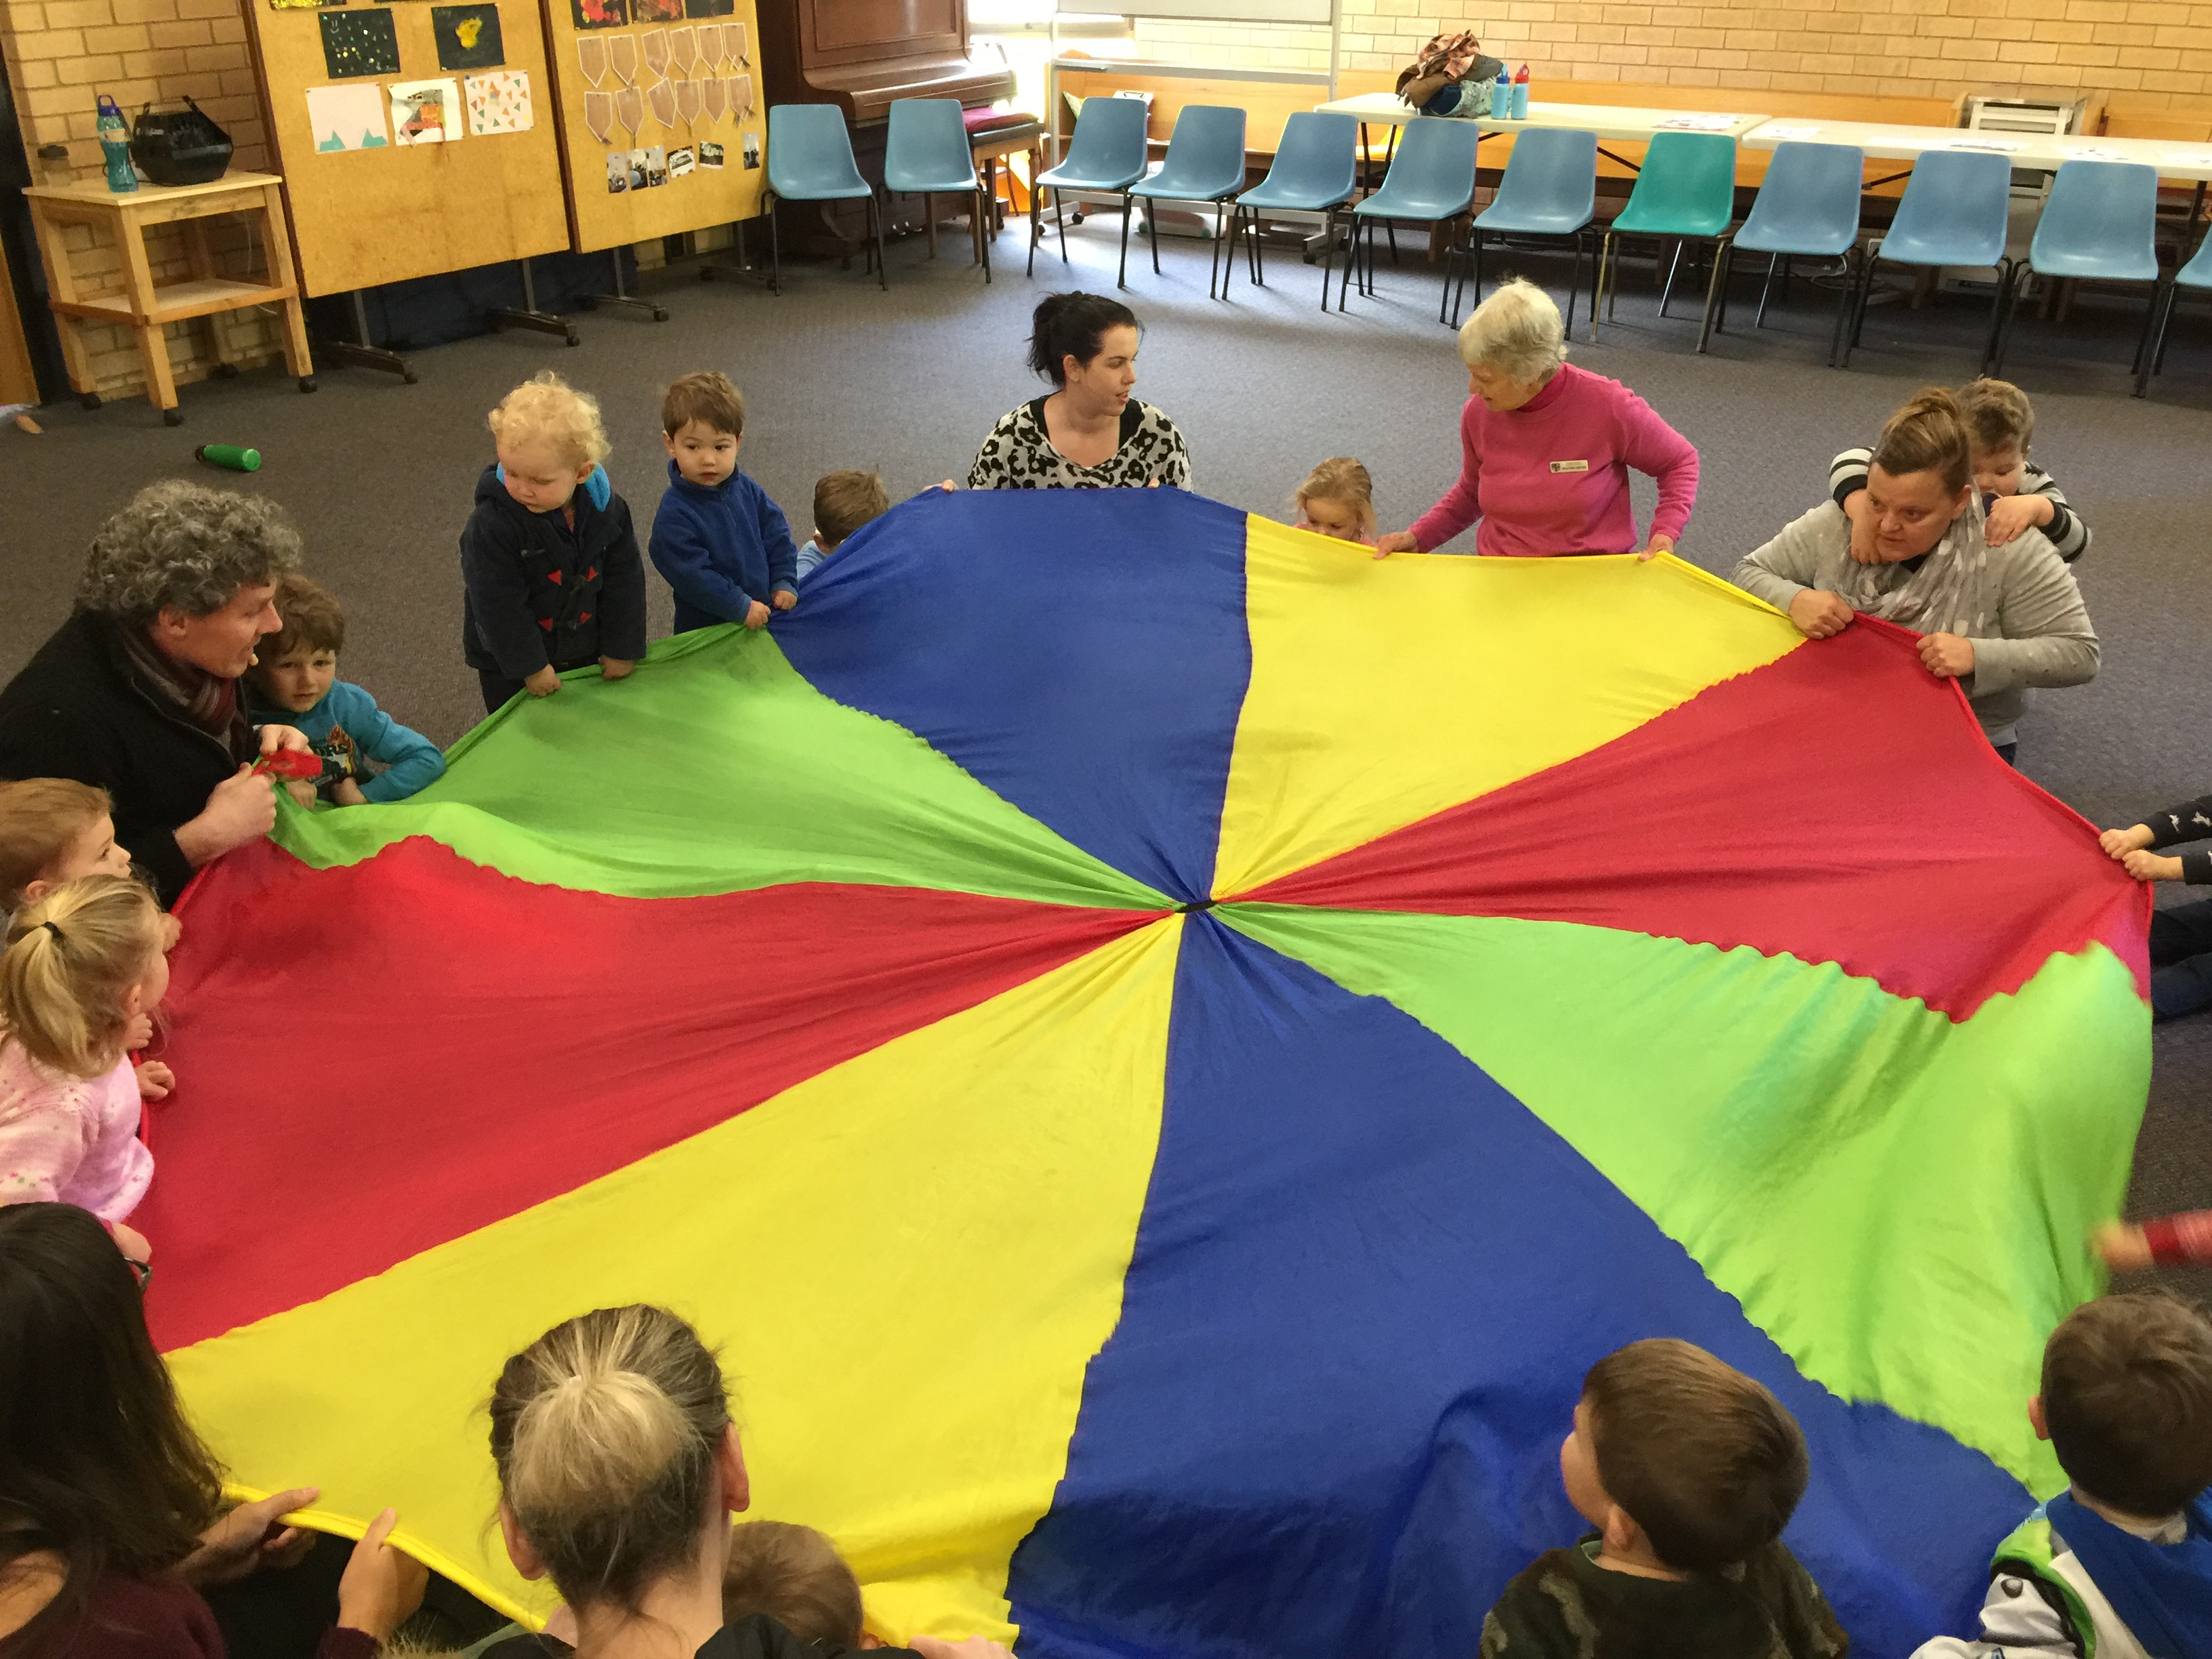
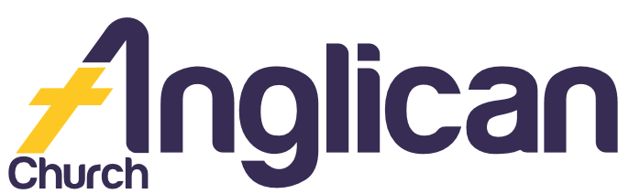
18th August 2019

PARISH NEWS

FORSTER AND NABIAC

Happy Mothers Day 2019!

Photo Credit: Isaac Harris

Connect.
Inspire. Transform.
Through Faith in Jesus.

ToddlerTime!

We love our wonderful playgroup! We connect every Monday 9.30-11.30am during school term! We enjoy exciting and educational art, story time, gardening, music, dance and more!
We’ll be performing at our October Fete!
Looking forward to seeing you there!
Rugrats Request

If you love to crochet, and help others, the ‘Rugrats’ need you! We need you to take home pre-made squares and crochet them into rugs for our local Nursing Homes! If you can help, see Coralie or call her on 6554 8892.

Lids4Kids

Support kids with disabilities! Bring your plastic bottle lids to Penny. Envision Hands turns them into hand and arm mobility aids!

Pray Deeply ...
Beryl A, Ella E, George M, Jenny L, Keith R, Lyn T, Marion & Peter R, Margaret B, and Peg S.
Bunnings BBQ

Thank you to all our amazing BBQ volunteers! We couldn’t have done it without you! We made so many wonderful community connections! And raised much needed funds for ToddlerTime! Thank you!

Womens Spring Event!

Connect with us on Tuesday 3rd September at 10am for our Anglican Diocesan Womens Event! Hear Rebecca Wilson explore how “By grace [we] have been saved through faith”. BYO lunch. For more info Ph: Lorraine
on 0419 277 294.

Bush Church Aid
Support BCA in Tasmania this month! Pray for workers and their families, especially the Bester and Duff families! And pray for communities to come to know and honour their Creator God!
Connect. Pray. Give.

Womens Craft Event
You are invited to Christian Women Communicating [CWCI] on Saturday 7 September at 2pm! Come and hear Roberta Hodgson share about her quilting and her faith in Jesus! Taree Presbyterian Hall. For more info
Ph: Diane on 6553 3133.

God’s Message
‘We also thank God continually because, when you received the word of God … you accepted it not as a human word, but as it actually is, the word of God’. 1 Thess 2¹³

Samaritans
Help those doing it tough! Your shopping list for August –
- Tinned Tuna/Salmon
- Complete meals in packets/bottles.
Thank you!
Save The Date
For the Fete!
Saturday 12th October
8am – 1pm!

Volunteer With Us

Book Shop……………….Phillip or Deb ………………..5543 7683
bookshop@forsteranglican.com

Op Shop………………….Heather D ……………………6555 4267

For Direct Debit Giving

Account name: Anglican Parish of Forster/Tuncurry
BSB: 705077 Account: 000400710

Thank You For Your Generous Hearts!

Connect With Us

Church Office ……… Clive Davies ………….…… 5543 7683
info@forsteranglican.com

………………….. Forster Anglican Church Community

Parish Website ………………… www.forsteranglican.com

Parish News……………trishaharris10@gmail.com
or Parish Office 5543 7683 by noon Wednesday

