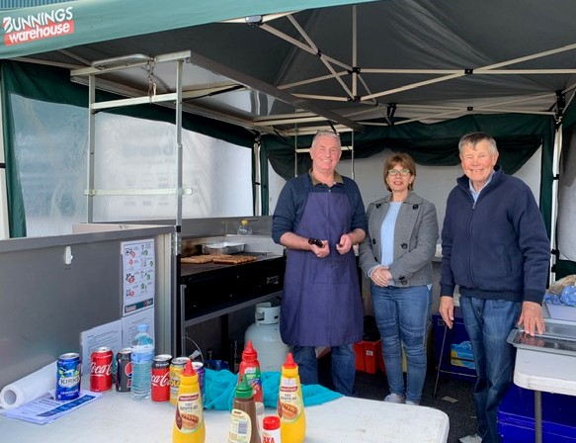
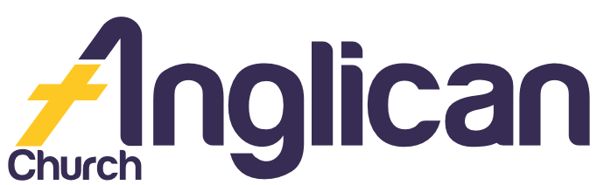

FORSTER AND NABIAC
25th August 2019

PARISH NEWS

Happy Mothers Day 2019!

Photo Credit: Isaac Harris
Thank you to ALL our volunteers!

Connect.
Inspire. Transform.
Through Faith in Jesus.

October Fete!

Our Fete meeting is on Wednesday 28 August at 10am! We need you! See Rev Mark if you’d like to be a stallholder on –

Bookshop; Cakes; Coffee; Craft; Devonshire Tea; Dolls; Kids Art; Plants; 2nd Hand Books; or White Elephant! Look forward to seeing you there!

Bunnings BBQ

Thank you to all our amazing BBQ volunteers! We really appreciate you! Thank you for helping us raise funds for ToddlerTime!

Rugrats Request

If you love to crochet, and help others, the ‘Rugrats’ need you! We need you to take home pre-made squares and crochet them into rugs for our local Nursing Homes! If you can help, see Coralie or call her on 6554 8892.

‘You are our glory and joy!’
1 Thess 2²⁰

Pray ...
Beryl A, Ella E, George M, Jenny L, Keith R, Lyn T, Marion & Peter R, Margaret B, and Peg S.

Lids4Kids

Support kids with disabilities! Bring your plastic bottle lids to Penny. Envision Hands turns them into hand and arm mobility aids!

Group of the Week …
A huge thank you to ALL our amazing gardening team! You do a fabulous job of caring for our beautiful environment!

Bush Church Aid

Support BCA this month! Pray for workers and their families, especially the Rogers-Smith and Buchanan families! And/or give financially! Your support is greatly appreciated!
Connect. Pray. Give.

Samaritans
Help those doing it tough! Your shopping list for the rest of August –
- Tinned Tuna/Salmon
- Complete meals in packets/bottles.
Thank you!

Womens Event

You are invited to Christian Women Communicating [CWCI] on Saturday 7 September at 2pm! Come and hear Roberta Hodgson share about her quilting and her faith in Jesus! Taree Presbyterian Hall. For more info
Ph: Diane on 6553 3133.

Fathers Day

Come into our Christian Bookshop and browse our awesome Fathers Day gift ideas!
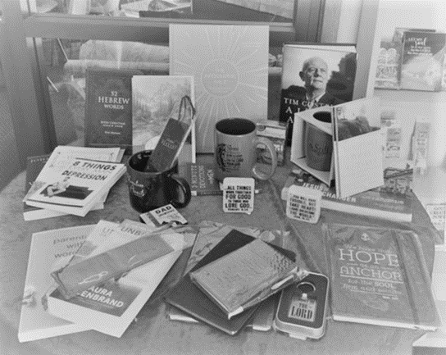
Save The Date
For the Fete!
Saturday 12th October
8am – 1pm!

Connect With Us

Church Office ……… Clive Davies ………….…… 5543 7683
info@forsteranglican.com

………………….. Forster Anglican Church Community

Parish Website ………………… www.forsteranglican.com

September Parish News ……………clivelyn46@gmail.com
or Parish Office 5543 7683 by noon Wednesday

Thank You Volunteers!

Book Shop……………….Phillip or Deb ………………..5543 7683
bookshop@forsteranglican.com

Op Shop………………….Heather D ……………………6555 4267

For Direct Debit Giving

Account name: Anglican Parish of Forster/Tuncurry
BSB: 705077 Account: 000400710

Thank You For Your Generous Hearts!

