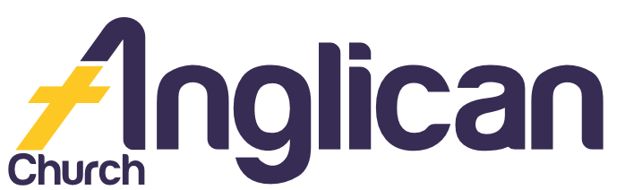

PARISH NEWS

FORSTER TUNCURRY NABIAC
26th May 2019

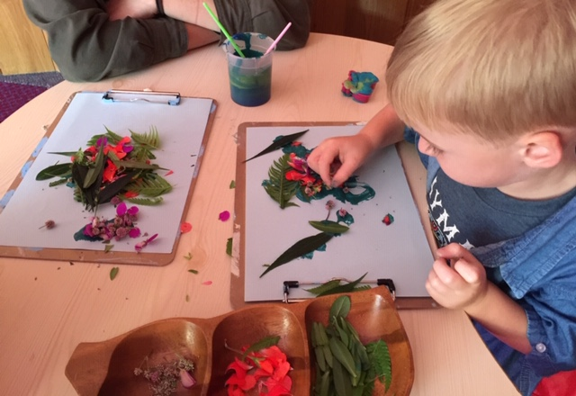
Happy Mothers Day 2019!

“You shall be my treasured possession!”
Exodus 19:5

Master Builders

A huge thank you to our marvellous Ministers! They’ve done an amazing job renovating the floor of Nabiac church!

Country Church

Join us at Dyers Crossing Church for worship services until the amazing renovation is completed at Nabiac! BY KIT C

Men’s Dinner

Join us on Tuesday 4 June for a delicious meal! Only $15! Come and hear Rev James share his faith journey. RSVP to Clive on 0412 653 061.

Seniors Events

Join us on Wednesday 5 June at 10am for a Cuppa and Chat! And on Wed 12 June at 11.30 for Light Lunch in the Church Hall! Only $8.00!
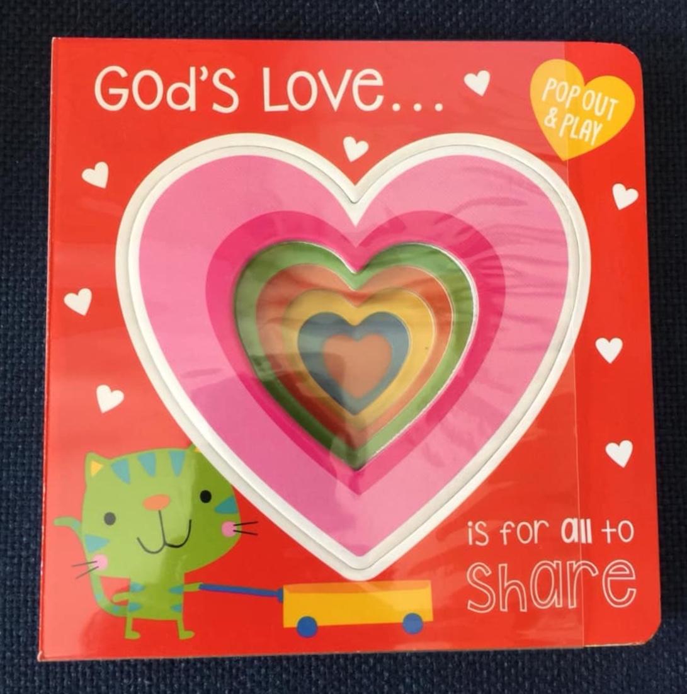
BY HELEN B

June News

During June, all items for Parish News to Lyn D – clivelyn46@gmail.com

Pray Always …

The Pearson family, Ella E, Jenny L, George H, Keith R, Michelle, Nadia M, Lyn T, Marion & Peter R, Margaret B, and Laurie M.

Bookshop

A huge thank you to Phil and Deb for their hard work and enthusiasm for our Great Lakes Christian Bookshop! All proceeds go to GLECCA and SIFT!

Fundraiser

A huge thank you to all our wonderful Bunnings BBQ volunteers! Our ToddlerTime group really appreciates your help!

Shine Your Light

Thank you for your support of the Church Missionary Society! They are able to share God’s love globally because of your prayers and financial support!
BY SUELLEN B

New Groups!
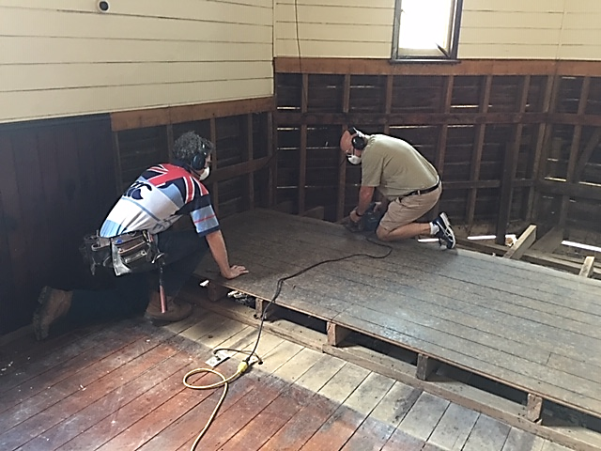
Our 2 new Christianity Explored groups kicked off really well last Wednesday at 9:30am, and last Thursday at 2pm! We’d love you to join us! Ph: Soph on 0425 213 082

Masterchefs

We would love you to create some delicious pumpkin soup (cater for 6) for our Light Lunch! For more info please contact Helen B on 0419 996 594.

GLECCA

We enjoyed a lovely afternoon of music by the Sydney Male Voice Choir! We raised $1200 for a computer for the Great Lakes College chaplain – Jose V! Thank you for your support! HEATHER W

Volunteer Today

Op Shop………………….Heather D ……………………6555 4267

Book Shop……………….Phillip or Deb ………………..5543 7683
bookshop@forsteranglican.com

Items for Parish News……………clivelyn46@gmail.com
or Parish Office 5543 7683 by noon Wednesday

Connect With Us

Church Office ……… Clive Davies ………….…… 5543 7683
info@forsteranglican.com

……………… Forster Anglican Church Community

Parish Website ………………… www.forsteranglican.com

For Direct Debit Giving

Account name: Anglican Parish of Forster/Tuncurry
BSB: 705077 Account: 000400710

Thank You For Your Generous Hearts!

