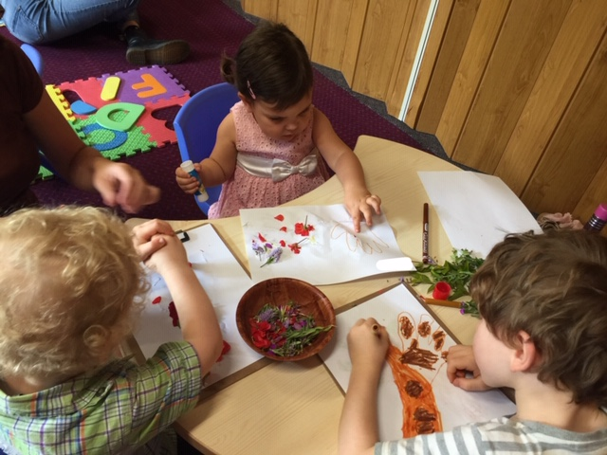
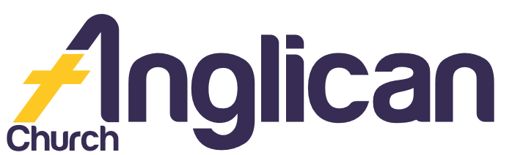

FORSTER-TUNCURRY AND NABIAC

PARISH NEWS

19th Jan 2020

Connecting Community. Inspiring Hope.
Transforming Lives.
Through Faith in Jesus.

Bushfire/Drought Relief Prayer!
Thank you to all those who connected through prayer last Wednesday! And thank you God for sending rain!

New Monthly Prayer
Come along the 3rd Wednesday each month at 5pm at St Alban’s to pray for our church, our community and our world!

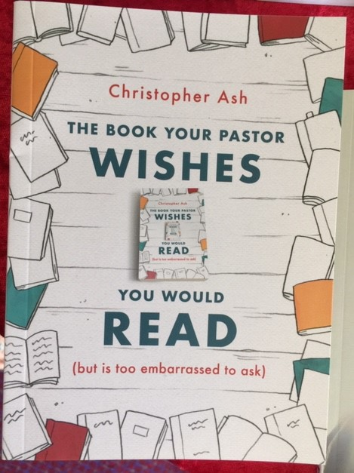
Bookshop News
Inspiring new books in store now –
Read The Book Your Pastor Wishes You Would Read and discover new ways you can support your Ministers!
Read Building a Family That Lasts and discover great strategies for navigating the ever-changing waters of family life!

Bunnings BBQ
Come along to our next BBQ – Saturday 25 January! Connect with our wonderful local community over the Australia Day long weekend!

Kids Church
Our kids are growing and learning so much! We need more helpers! If you have a current WWCC and would like to be part of a great team, see Rev Mark or Rev James for more details!

Mens Dinner
Come along Tuesday 4 February at 6pm at the church hall. Only $15 pp! Be inspired as Barry L shares ‘His life so far’! Add your name to the list at church or
call Clive D on 0412 653 061.
‘… respect those who labour among you … esteem them very highly in love because of their work’ 1 Thessalonians 5:12-13

Op Shop Volunteers
Op Shop meeting with afternoon tea - Wednesday 22 January 4pm at the church hall! RSVP to Heather D on 0418 718 110 or Janet on 0448 502 684.
If you can volunteer Saturday mornings once/week, once/month or on a casual basis, let Heather or Janet know! We’d love you to be part of the team!

Pray Deeply ...
for our friends and family members - Ella E, Keith R, Lyn T, Marion & Peter R, Michelle, Rachael, Margaret B, Zac L, and Aileen G.

ToddlerTime Meeting
ToddlerTime meeting with morning tea - Monday 20 Jan 9:30am at St Alban’s hall!

‘Remember your leaders who taught you the Word of God. … follow the example of their faith!’ Hebrews 13:7

Direct Debit Giving

Account name: Anglican Parish of Forster/Tuncurry
BSB: 705077 Account: 000400710

Thank You For Your Support!

Connect With Us

Church Office ……… Clive Davies ………….…… 5543 7683
Email ….. info@forsteranglican.com

Facebook Page …………….. Forster Anglican Church Community

Parish Website ………………… www.forsteranglican.com

Book Shop……………….Phillip or Deb ………………..5543 7683
bookshop@forsteranglican.com

Op Shop………………….Heather D ……………………6555 4267

Our Leadership Team
Senior Minister: Rev Mark Harris 0425 265 547
Families Minister: Rev James Brooks 0411 335 087
Priest in Local Mission: Rev Helen Quinn 0427 592 723

