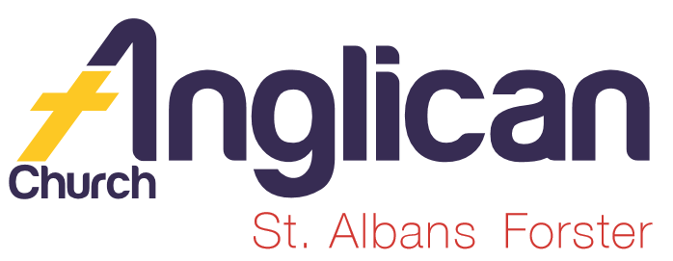
PARISH NEWS

FORSTER-TUNCURRY & NABIAC 1st MARCH, 2020.

COMBINED PARISH WORSHIP, SUNDAY 15TH MARCH, 9.30AM.
As we join together to worship our great God, let’s spend time reconnecting with friends from St. Paul’s that we may not have seen for sometime.
As always when we get together, we ask that a few extra parishioners bring along a “small” plate of food to share before the AGM. Thanks.

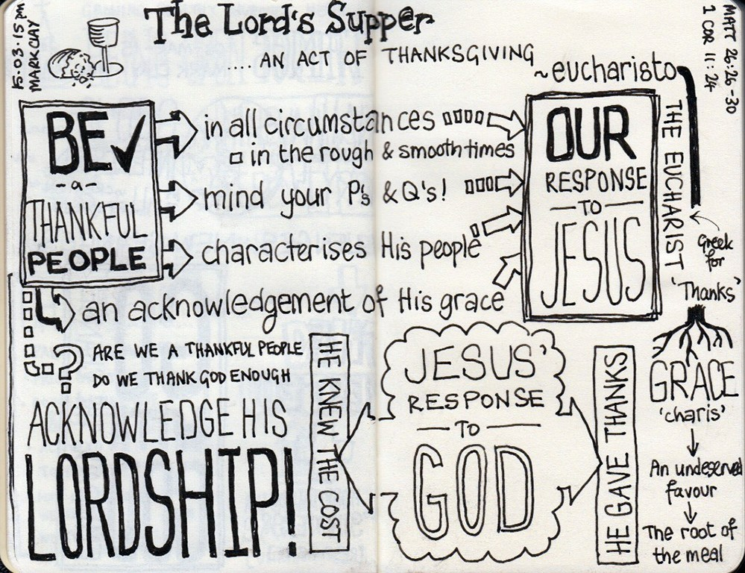

OUR LEADERSHIP TEAM:
Senior Minister: Rev. Mark Harris 0425 265 547
Families Minister: Rev. James Brooks 0411 335 087
Priest in Local Mission:Rev.Helen Quinn 0427 592 723
WORLD DAY OF PRAYER 2020- ZIMBABWE
“Rise! Take your mat and walk!”
The Forster Baptist Church will be presenting this year’s World Day – Friday, 6th March, 2pm.
Jan Long from FBC asks that we come along and join with folk from churches in our area on this day. Barbara Hughes will be Leader No. 3 on the day. Barbara would value your support.

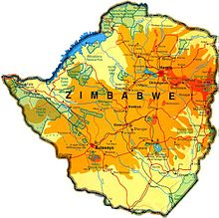

A NOTE FROM PARISH SECRETARY, JUDY HALL.
Our AGM is set down for March 15th and I would be grateful if all reports could be in by Friday, 6th March. It would be great to have some other parishioners join us on Parish Council. Nomination forms are in the foyer of both churches. Also, don’t forget about checking your info for our parish directory and/or completing an enrolment form.

Please submit in writing to myself as parish secretary, any Agenda Items, including questions, notice of motions, vote of thanks, etc. one week prior to our AGM on March 15th.

At its most recent meeting, Parish Council checked the proposed budget for 2020 (thanks to Sandra Martin and Phillip Castle for your work in preparing this). We also looked at our readiness state to meet diocesan requirements for volunteers. Both Clive and Reverend Mark have been busy ensuring that we will be able to meet our requirement by February 29th. We also have commenced looking at what will be required in setting up the St Nicholas site as an Op Shop.

CONNECT WITH US
FACEBOOK ………………… Forster Anglican Church Community
PARISH WEBSITE………… www.forsteranglican.com
CHURCH OFFICE ………… info@forsteranglican.com 5543 7683

PRAYERS FOR THE SICK AND RECOVERING
Ella E, Keith R, Lyn T,Marion & Peter R, Michelle, Rachael, Margaret B,Zac L, Aileen G, Vicki L.
OUR PARISH VISION
Connecting Community. Inspiring Hope
Transforming Lives.
Through Faith in Jesus.

THOUGHTFUL GIFTS TO THE SAMARITANS FOR THOSE LESS FORTUNATE THAN OURSELVES –
A new thought – CLEANING GEAR – when the rep. collected the goodies from February – for which, as always, she was immensely thankful, I asked if there was anything in particular that would be particularly useful – yes please, cleaning gear! So the idea is anything you use yourself for cleaning your own homes would be beneficial. BUT! As always whatever you would be pleased to donate will be accepted with great enthusiasm.

THE ACTS OF PRAYFUL THOUGHTS
A – ADORATION - Tell God how wonderful He is; worship Him.
C – CONFESSION – Admit your sins, cry out your brokenness, ask for forgiveness.
T – THANKSGIVING – Say “thank you” for all God has done in your life.
S – SUPPLICATION – Make your requests to God – for yourself and for others.
OUR BOOKSHOP has a an interesting selection of books on prayer –
100 Prayers for a Hopeful Heart $7.99, Pray Big $16.99, A Prayer Life $19.99, New Testament Prayer for Everyone $13.99, Prayer & The Voice of God $15.99, Moving Mountains $19.99, Praying with Paul $19.99, Prayer $21.99, Dangerous Prayer $10, Knowing God through Prayer $17.99, An Insider’s Guide to Praying for the World $17.99

A LENT STUDY – Lessons From the Life of the Early Church for 21st Century Christians. Produced by the Anglican Diocese of Newcastle.
Copies available in both churches – daily readings and reflections during the season of Lent. It would be thoughtful if when collecting your copy you could give a small amount (maybe $2 - or more if you’re able) to assist in offsetting costs to the parish. Great reading!!

BCA-BUSH CHURCH AID IS OUR MISSION FOCUS FOR MARCH.
BCA began in 1919, with a pioneering spirit and Suellen has asked that our BCA boxes be returned for processing during March, to assist BCA with their ongoing pioneering spirit. To-day we offer prayers for the National Office in Sydney, praying for wisdom and discernment over their decision making.

PRAYER & PRAISE UPDATE FROM JOSE VERAGA – Pastoral Care in the Great Laks College.
- Praise God for the willingness of the Chill Out Breakfast volunteers to sacrifice their time on Tuesday and Thursday mornings, and for what this breakfast means to the students and staff at Forster Campus.
- Pray that the Holy Spirit would direct Jose & Tamara, so they continue to be in the right place at the right time.

Copies of the Update are available in both churches – amazing praise and prayer points. Our GLECCA rep. is Heather Webster.

AN AFTERNOON AT THE MOVIES- GLECCA
Mark the date – Sunday, 22nd March, 2pm at the Great Lakes Theatre, Tuncurry. Tickets will be available next week $20.each.’I STILL BELIEVE’

Items for the Parish News for March to Lyn Davies via phone 0491 136 455, text or call. Email: clivelyn46@gmail.com by noon Wednesday. With thanks to the many parishioners who are supporting the parish news with reports/ideas, etc.

