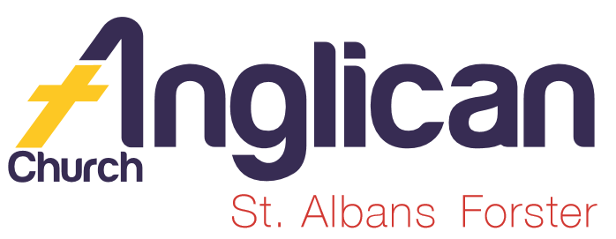
PARISH NEWS

FORSTER & NABIAC 1st December, 2019.

ADVENT 1 – THE COMING DAY OF THE LORD
LET US LIGHT THE CANDLE OF HOPE.

Come, let us go up to the mountain of the Lord, to the house of the God of Jacob; that he may teach us his ways and that we may walk in his paths. Isaiah 2.^{3a}

OUR MISSION FOCUS FOR DECEMBER IS THE CHRISTMAS BOWL

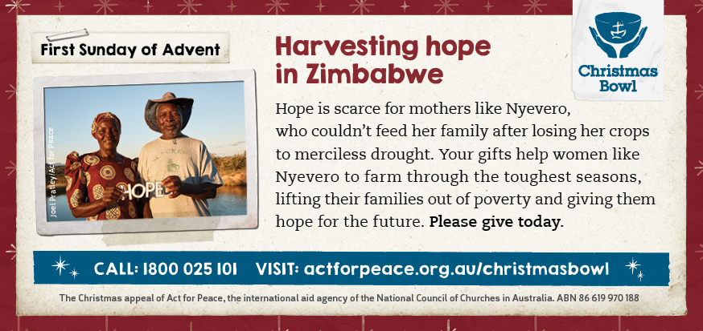

THE GENERAL CONFESSION
As we say the General Confession this morning take time to remember Rev. James’ comment last Sunday at St. Alban’s – really look at the words and with courage and humility ask for forgiveness.

OUR LEADERSHIP TEAM
Senior Minister: Rev. Mark Harris 0425 265 547
Families Minister: Rev. James Brooks 0411 335 087
Priest in Local Mission:Rev.Helen Quinn 0427 592 723
MEN’S DINNER
The next Men’s Dinner is this Tuesday, 3rd December, at St. Alban’s. The speaker is Captain Paula Glover, newly arrived Salvation Army Officer, and her topic is “My Life and Calling”. 6pm for 6.30pm $15 each. List in both churches or call Clive 0412 653 061.

BUNNINGS BBQ FOR TODDLERTIME
Next Saturday, 7th December, there’s a worksheet in the parish hall. Always keen to have different parishioners help out! The list still has a few spaces!

SAMARITANS DONATIONS
For December we usually go “Back to Basics” thinking of holiday food for the kids, kid’s drinks, even morning tea or lunch foods for school in the new year. You can choose absolutely anything that you know wil be helpful to those in need, not necessarily for the “kids”!!

NATIVITY DISPLAY
This display is being held in the Tuncurry Uniting Church, this afternnon, from 1pm to 4pm. Gold coin entry to display, and Devonshire tea available $5.00.

CONNECT WITH US
FACEBOOK ………………… Forster Anglican Church Community
PARISH WEBSITE………… www.forsteranglican.com
CHURCH OFFICE ………… info@forsteranglican.com 5543 7683

DIRECT DEBIT GIVING the account name is:
Anglican Parish of Forster/Tuncurry, BSB:705077, Account:000400710.
– cheerful givers!!!

OUR PARISH VISION
Connecting Meaningfully. Inspiring Hope. Transforming
Lives. Through faith in JESUS.
PRAYERS FOR THE SICK AND RECOVERING
Ella E, Jenny L, Keith R, Lyn T,Marion & Peter R, Michelle, Rachael,Max S, Margaret B, Prescilla F.

ADVENT STUDY SERIES DECEMBER 2019
“The coming of the KING” study 2 covers this week’s readings. If you missed out on your copy last week, then please collect one to-day. The studies are for personal or growth groups, and cover old and new testament readings.

CAROLS BY CANDLELIGHT
The Rotary Club of Tuncurry-Forster Inc. are in the 45th presentation of carols. Monday, 16th December – 6.30pm, John Wright Park, Tuncurry. I mention this as Rev. James will be giving the Children’s Talk on the night, a great community connection, and I’m sure Rev. James would appreciate your prayers for the occasion.

OUR BOOKSHOP – reviews from one of our bookshop volunteers.
GOD SHOWS ME THE WAY – Join the Playdate Pals in these simple stories, written to help young children explore their behaviours in a biblical way. Each story includes notes to encourage further discussion with children. $13.00
Plenty of titles in the “Lost Sheep” range and “I Can Read” range at $6.99 each.
“FOR THE JOY” – 21 Australian Missionary Mother Stories on cross-cultural parenting and life. “For the Joy” is a powerful compilation of honest hearts. Honestly written, sad and joyful in equal measure, this collection offers insight into the complexities of parenting children while serving God far from home.

DECEMBER COPIES OF VARIOUS MONTHLY MAGS
On the table as you enter St. Alban’s the Summer 2019/20 “SOWER” from the Bible Society, “Jesus” A Radicial Advent from Anglican Overseas Aid, A Prayer & Praise Update from Jose Veraga, envelopes for the Christmas Bowl Appeal, and of course, extra copies of the current study “The Coming of the King” – all free!!

VOLUNTEERS NEEDED – A REPORT FROM DEBORAH
SAMARITANS
When Josephine Snowdon visited our parish a few weeks ago, she suggested one way we could assist is to volunteer for emergency relief. Parish Council has accepted Deborah Laurie’s offer to be our Parish Link for Samaritans.
If you would like to help or need further info please contact Deborah (0402 359780). You must have a current working with children check.

PARISH OP SHOP
A note from Heather Dwyer & Janet Lawrence – 2019 has been a great year at the Op Shop. A wonderful way of “Connecting Meaningfully” with people as they come to our shop. A big, big, thank you to all our helpers, permanent and not so permanent. And all this happens because of the generous donations received from parishioners and local folk. Interested?? Chat to Heather or Janet.

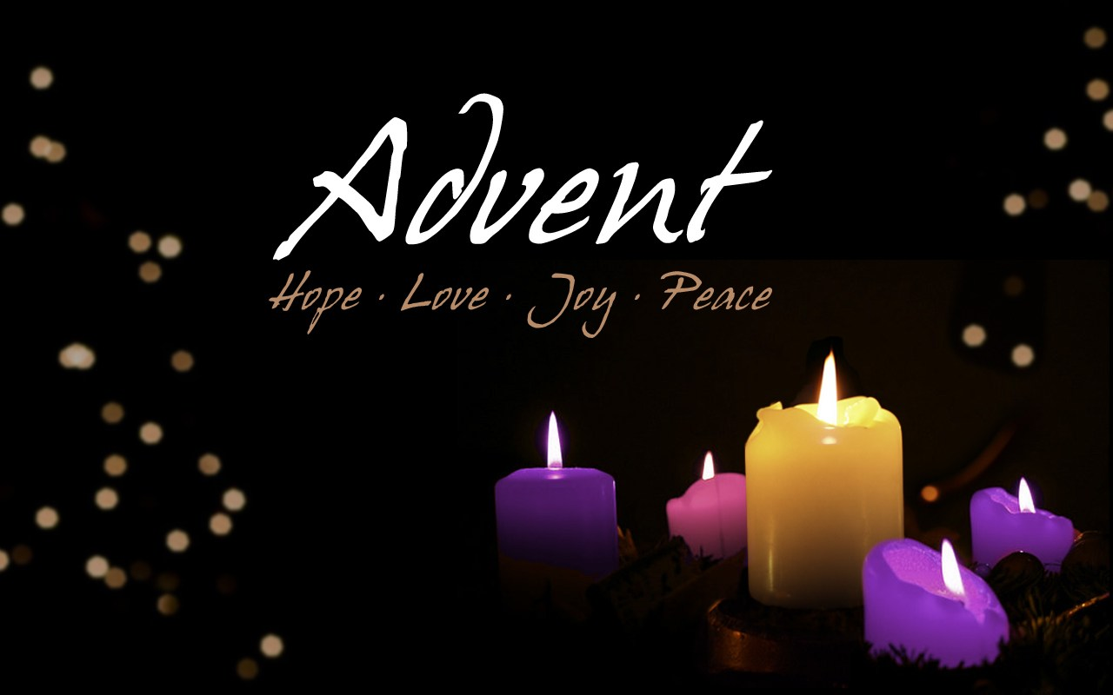

Items for the Parish News till the end of 2019 to Lyn Davies via phone
0491 136 455, text or call. Email: clivelyn46@gmail.com by 12noon Wednesday, thanks. -

