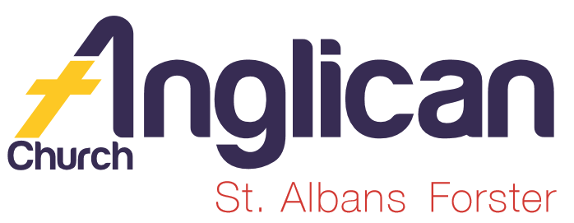
PARISH NEWS

FORSTER-TUNCURRY & NABIAC 2nd FEBRUARY, 2020.

OUR MISSION FOCUS FOR FEBRUARY IS CHURCH MISSIONARY SOCIETY

The Church Missionary Society (CMS) is a fellowship of Christian people and churches committed to global mission. We work with churches to set apart long-term workers who cross cultures to share the gospel of our Lord Jesus Christ.

MONTHLY PRAYER MEETING.
What a great joy to have so many parishioners come along to the first evening prayer meeting that was held a few weeks ago. The meeting in February will be at 5pm Wednesday, 19th at St. Alban’s.
Our prayer focus this month will be the drought and the year ahead.
“Be joyful always; pray continually; give thanks in all circumstances, for this is God’s will for you in Christ Jesus” 1 Thess. 5:¹⁶⁻¹⁸

OUR LEADERSHIP TEAM
Senior Minister: Rev. Mark Harris 0425 265 547
Families Minister: Rev. James Brooks 0411 335 087
Priest in Local Mission:Rev.Helen Quinn 0427 592 723

MEN’S DINNER
The next Men’s Dinner is this Tuesday, 4th February, at St. Alban’s. The speaker is Barry Levick, parishioner, peoples’ warden, parish councillor, Barry’s topic “My Life So Far”. 6pm for 6.30pm $15 each. List in both churches or phone Clive 0412 653 061.

OUR OP SHOP EXPANSION!
Have you thought about volunteering for the Tuncurry Op Shop?
OUR NEXT BUNNINGS BBQ
We have been given Saturday, 23rd May, 2020 for the next BBQ.
Final nett profit from the 25th is $552.30 – well done to all the helpers on such a very, very, HOT…HOT….HOT day. A big THANK YOU!

SAMARITANS DONATIONS
Each year in February we think about TINS – now that really leaves a great variety of food to purchase – fruit, vegies, spread for lunches – look along the shelves during your next shop and see what you think will be useful as a donation. Always an excellent and easy way to care for others.

CONNECT WITH US
FACEBOOK ………………… Forster Anglican Church Community
PARISH WEBSITE………… www.forsteranglican.com
CHURCH OFFICE ………… info@forsteranglican.com 5543 7683

PRAYERS FOR THE SICK AND RECOVERING
Ella E, Keith R, Lyn T,Marion & Peter R, Michelle, Rachael, Margaret B,Zac L, Aileen G.
We remember with thanks those whom we have loved whose anniversary occurs this month – Lynelle Boyd, Bazil Stockdale, Gwen Tate, Shirley Ashton, Molly Christie, Leo Tate, Jim Harris.
WORKING BEE – NEXT SATURDAY, 8TH FEBRUARY, 2020
We will start at 8.30am but join in when you can! Please join us as we spruce up, clean out and maintain our church property in Forster. There will be jobs for people of all skill and ability.
Contact the office on 5543 7683 or speak to a Warden – Clive Davies or Barry Levick – for more information.

KID’S CHURCH UPDATE. From JUDY HALL (Coordinator)

We are about to commence our 2020 Term 1 Teaching Program and will again focus on concepts being addressed in the adult services. We have two groups that operate each Sunday at the 10am service: one for the 0-5 year olds (this term being led by Sophie Brooks with help from Judy) and the other for 5-12 year olds (this term being led by Trisha Harris).

Safe Church requires that we have two adults with each group, so we are looking for 4-5 volunteers to assist Trisha with the older group for this term. This means we would be able to have a roster of one helper per month. Please let me (Judy) know if you can help out in this area of ministry. You will need to have your Working With Children Check and Safe Church Training.
We usually have 12 children at the 10am service – 7 in the pre-school group and 5 in the older group.

ON-LINE SAFE MINISTRY TRAINING

It is a good idea to have completed your Safe Ministry Training. This is particularly important for anyone wishing to work with children’s ministry such as Toddler Time, Kids Church and Scripture in Schools.

To do the on-line training course, you should have some working knowledge of computers and access to the internet.

Details are as follows:

Cost $30.

To access the SMR eTraining through Open Learning visit:
www.openlearning.com/courses/safe-ministry-online-induction
(Please download the SMR Safe Ministry etraining User Guide if you need assistance.

Items for the Parish News for February to Lyn Davies via phone 0491 136 455, text or call. Email: clivelyn46@gmail.com by noon Wednesday, thanks.

OUR PARISH VISION Connecting Meaningfully.

Inspiring Hope.
Transforming Lives
Through faith in JESUS.

FEBRUARY IS HERE!! YIKES- WHERE DID JANUARY GO??
Pick up a copy of the PARISH SUMMER PROGRAM 2020 – so much info – Growth Groups (if you’re not yet in a group NOW is a great time to join) contacts names and phone numbers page 3.
I guess most groups will be starting up again this week – check the Summer Program and join a group.

