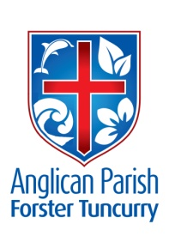
PENTECOST 15- LIVING UNDER GOD’S PROTECTION.
2nd SEPTEMBER, 2018.

Every generous act of giving, with every perfect gift, is from above, coming down from the Father of lights, with whom
there is no variation or shadow due to change. James ^{1:17}

OUR PARISH VISION –
“We will connect meaningfully with our community in order to inspire hope
and transformed lives through faith in Jesus.”

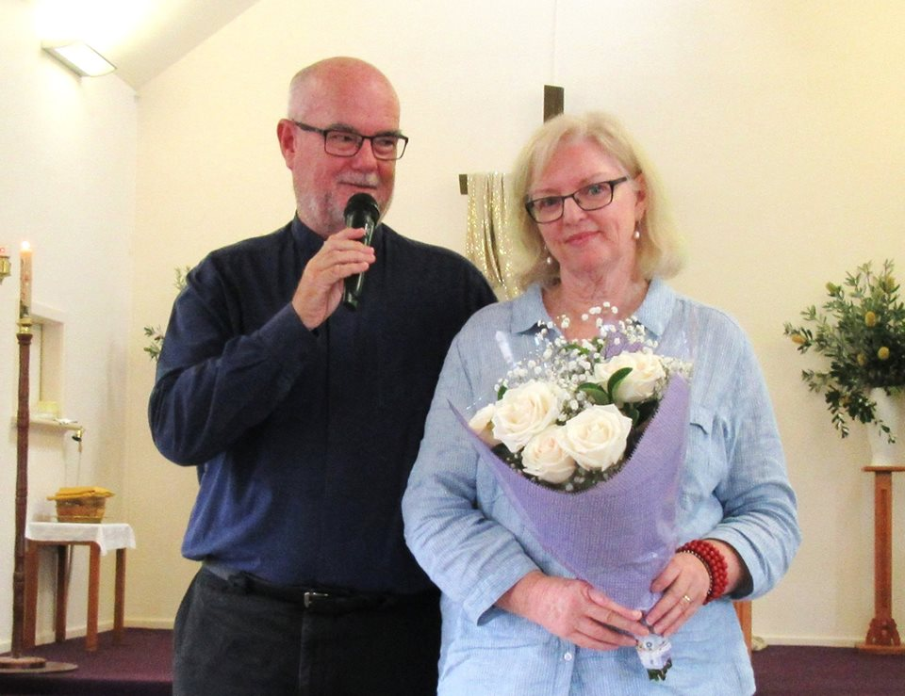

We welcome
Rev’d. Les Forester
to our parish this weekend. This photo, with his wife Jennifer, was taken when Les “retired”!!

OUR MISSION FOCUS FOR SEPTEMBER –
BCA -BUSH CHURCH AID – Reaching Australia for Christ since 1919 – Going the distance by bringing the gospel of Christ to the outermost parts of Australia. Developing a new generation of culturally diverse Christian leaders, supporting ministry by Aboriginal and Torres Strait Islander people, planting and renewing sustainable churches, equipping local leaders for fruitful ministry, providing care in Christ’s name.
September is “BCA Box opening month” – please send your boxes to Suellen Belton via your church “boxes”.
Parish Offertory Envelopes -are now available at all centres.

UPCOMING EVENTS-
Monday, 3rd September – Anglican Women Spring Celebration at Wingham
Friday, 28th September – Annual Fashion Parade, Dyer’s Crossing.
Sunday, 30th September – 5th Sunday, Parish Service 9.30am St. Alban’s,
Followed by our Parish Luncheon at Club Forster.
Saturday, 20th October – Parish Fete at St. Alban’s.
PLUS all the usual – toddler time, strolling group, rug rats, games, culture and Christ, gardening group, court care, op-shop, bookshop.
Wednesday, 5th September – Friendship Group, St. Nicholas – 10am
Service at Estia, Forster, 10.30am
Tuesday, 11th September – Parish Council Meeting, 4pm St. Alban’s
Wednesday, 12th September – Mini lunch, St. Alban’s
Wednesday, 19th September – Service at Baptist Care, Forster, 11am

SEPTEMBER THOUGHTS FOR THE SAMARITANS –
Thinking that it will soon be much warmer and salad time - how about we try salad veggies – pineapple, beetroot, corn – all types of food that you use to make a salad – even some mayonnaise – so many different varieties available. See what you can find – your donations are always very much appreciated.
.
OUR PARISH LUNCHEON –
From Suellen – Our Luncheon is being held at Club Forster on Sunday, 30th September – a fifth Sunday – one parish service at 9.30am at St. Alban’s – then just down the road to Club Forster.
The cost is $26.00 and from today Suellen will be taking names and cash at Forster, Pat Sanderson is the one to talk to at Tuncurry and Helen Martin will be looking after Nabiac and Dyer’s Crossing.
Always a delightful occasion – no cooking, no washing up – and talking to other friends that we only know by sight – that’s what it’s about – caring for each other.

AS WE WORSHIP OUR GOD WE INCLUDE IN OUR PRAYERS THIS WEEK:
Bishop Peter’s Prayer and our prayer for a Families Minister.
Bishop Peter & Nicki
Asst. Bishop Charlie Murry & Melissa
Asst. Bishop Sonia Roulston
Rev’d. Les Forester & Jennifer
All who are suffering as a result of the drought.
MEMBERS OF OUR CHURCH COMMUNITY WITH ONGOING NEEDS –
Hugo Walmsley, Alan Winston, Rosalyn Ferris, Ella Engel, Jenny Lawson, Maureen Armstrong, George Hodgson, Louise, Dianne Hardin, Keith Roach, Helen Cole, Paul McIntosh, Michelle, Max Kennedy.
If you would like to add someone to the Parish Prayer list, be sure to obtain permission from the person concerned and then contact the Parish Office.

ST. JOHN’S, DYER’S CROSSING –
This year the fashions will be from Margo’s, Centrepoint, Taree. Friday, 28th September is the date. Always a great day – details to come.

PARISH FETE – POTS, PLANTS –
If you need pots – some small, some large – then Robin Tight may be able to assist – give her a call on 0403 924 693.

PHOTOS FOR INCLUSION IN OUR WEEKLY “NEWS”-
Think about emailing a photo of your church group activity – it’s helpful to actually “see” just what is happening around the parish.

GALATIONS 1:¹⁰ - Am I now trying to win the approval of men, or of God? Or am I trying to please men? If I were still trying to please men, I would not be a servant of Christ.

ST. ALBAN’S NEW KITCHEN –
Total cost of kitchen - $41,570 (ex GST)
Expenses: Plumber $4,057
Electrician $1,362
Tiler $2,758
Flooring $3,182

Donations: Parishioner $15,000
Stove $ 2,750 (numerous donations)
Fridges $ 1,829
HWS $ 800
Microwave $ 249
Trolleys $ 331 Total donations $20,959

Leaving $20,611 to be met by the Parish. Further donations will be very welcome. Talk to Clive or Judy – or place a “marked” offering on the plate.

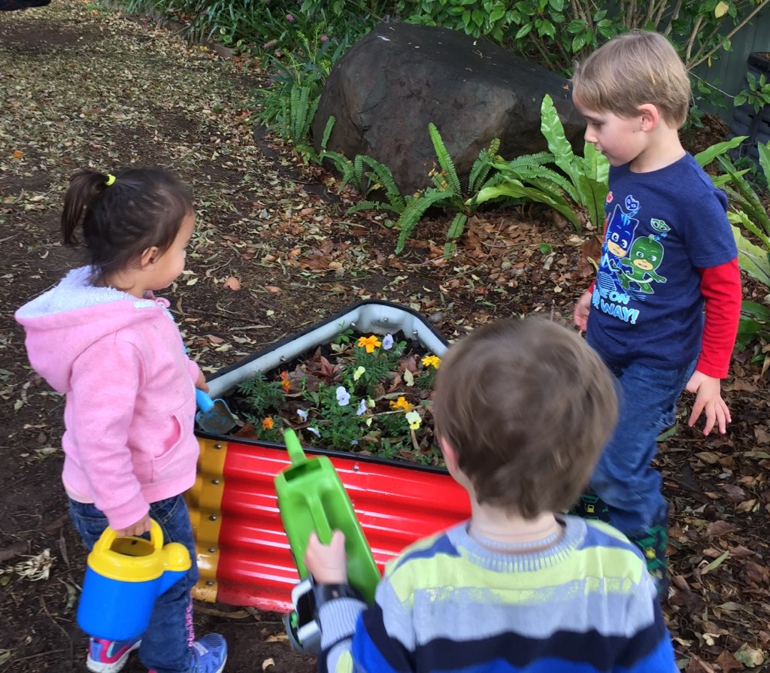

Toddler Time –
23 toddlers!! Wow!!

Photo 1 – they so enjoy the parachute.
Photo 2 – the gardeners – it’s great to be outdoors.
Photo 3 – thoughtful craft –
“Dad – you rock.”
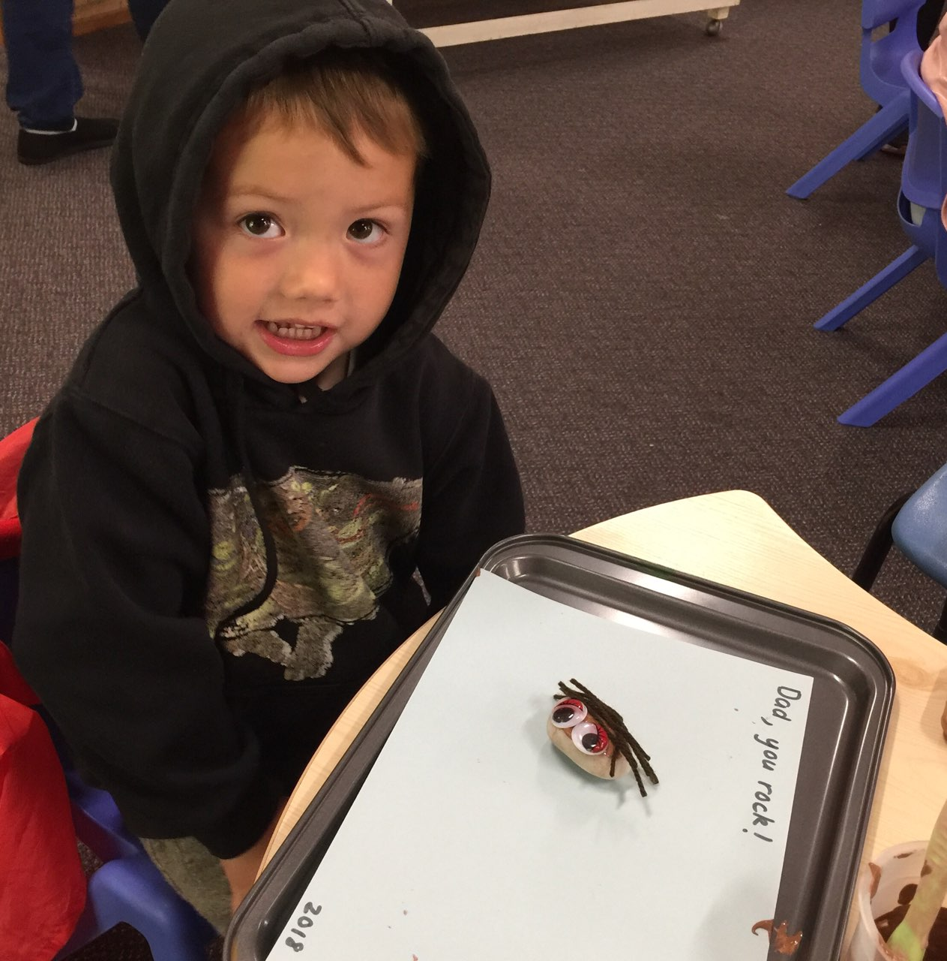

CONTACT DETAILS
Senior Minister/Rector: Rev’d Mark Harris 0425 265 547
revmarkharris@icloud.com
Priest in Local Mission: Rev Helen Quinn 0427 592 723
Parish Office: St. Alban’s Anglican Church: 5543 7683
info@forsteranglican.com
Parish Secretary: Judy Hall 0400 890 728
Op Shop: Head St Car park 6555 4267
Book Shop: bookshop@forsteranglican.com 5543 7683
Parish Website: www.forsteranglican.com
Items for Parish News: Phone Lyn Davies 0491 136 455 or text, email clivelyn46@gmail.com, or Parish Office 5543 7683 by noon Wed, thanks.
Our bank details: BSB 705077 Account 000400710
Account name: Anglican Parish of Forster/Tuncurry

