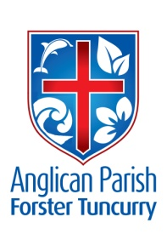
ADVENT 1 – SIGNS OF THE END
2nd DECEMBER, 2018.

Stand up and raise your heads; your redemption is drawing near. Luke 21.¹⁸

OUR PARISH VISION:
We will connect meaningfully with our community in order to inspire hope and transformed lives through faith in Jesus.

OUR MISSION FOCUS FOR DECEMBER IS THE CHRISTMAS BOWL.

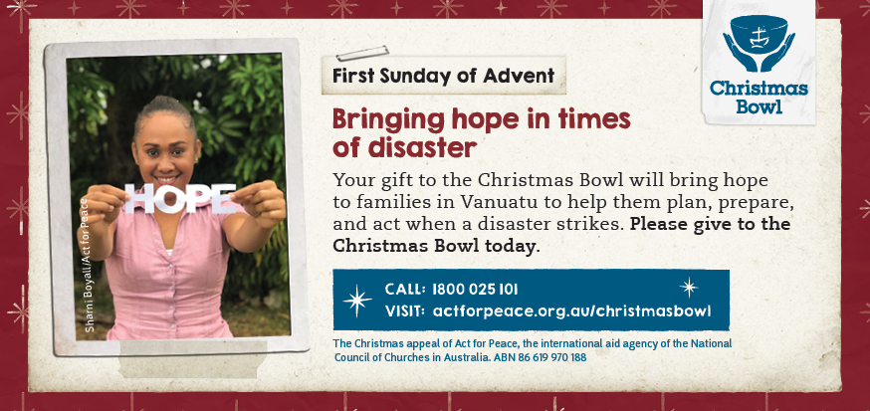
When your home and livelihood are destroyed, how do you find the strength to start over? You need hope – the ability to trust in God’s love and the goodness of His plan for your life. This is what your Christmas Bowl gifts bring to women in Vanuatu, who are struggling to keep their families resilient through worsening natural disasters.

SHARE GOD’S LOVE THROUGH THE CHRISTMAS BOWL: Posters in all churches. Take time to read the history of the Christmas Bowl and if you would like to order a free cardboard bowl to decorate and place on your table during the Christmas season, please phone 1800 025 101 or email info@actforpeace.org.au.
CHRISTMAS DINNER – THIS COMING FRIDAY, 7th DECEMBER
The Combined Churches of Forster Tuncurry invite you to their Annual Christmas Dinner, 6pm Friday, 7th December at the Forster Bowling Club. Tickets: Adults $20, Kids $10. (Drinks not included). The evening will include an opportunity to give towards SIFT (scripture in our high schools). Colourful posters in all churches with extra information. Tickets available in our Book Shop.

MEMBERS OF OUR CHURCH COMMUNITY AND FRIENDS WITH ONGOING NEEDS
Ella Engel, Jenny Lawson, Maureen Armstrong, George Hodgson, Louise, Keith Roach, Michelle, Max Kennedy and Beryl Allen, Nadia Maybury, Sue Hollis, Lyn Thompson, Marion & Peter Roberts.

If you would like to add someone to the Parish Prayer list, be sure to obtain permission from the person concerned and then contact the Parish Office.

We commend to God’s keeping those who have recently died and we pray for those who mourn their passing.
We remember with thanks those whom we have loved whose anniversary occurs at this time, John Charles Thacker, George Belton.

A MESSAGE FROM HELEN BARBER & WILMA STEAIN
We invite you to attend the Friendship “Meeting” to be held this WEDNESDAY, DECEMBER 5th at 10.00am held in St. Nicholas’ church, Tuncurry. Morning Tea is shared and plenty of chatter.
We are hoping there will be offers of help for our December Mini Lunch (Wednesday 12th December) and cooking for the December Trading Table.
All parishioners are invited to come along to the Mini Lunch cost is $8.00 for a two-course meal plus tea or coffee.
More information and offers of help: Wilma Steain 6554 8163, Helen Barber 0419 996 594.

SERVICE TIMES FOR 2019
As of the first Sunday in 2019 (6th January) service times will change. They will be as follows:
- St. Alban’s 8.30am, 10am and 5.30pm
- St. Paul’s & St. John’s 10am

SIX STEPS TO LOVING YOUR CHURCH
Which step are you practicing today?
- This Sunday, in the first few minutes after the service, look for a way to practically serve another person (e.g. get a coffee for someone) look around to ensure someone is not being “left out”

There are two DVD’s of Six Steps to loving your Church available for borrowing and workbooks are still available at our bookshop. ‘phone Clive 0412 653 061 or call the office 5543 7683.

OUR PARISH BOOKSHOP
Two Daily Readings for Advent- Book 1 – “The One True Gift” by Tim Chester $9.99. Book 2 – “Waiting Here for your Advent Journey of Hope by Louie Giglio %12.00.
Great place to find gifts for the family for Christmas. Many colourful calendars, diaries, Christmas cards, DVD’s, CD’s, children’s books you really have to call and check it out.

ADVENT IN AUSTRALIA
An Advent Reflection by Anglican Overseas Aid available at all churches.
A reflection on showing HOPE:
- How do we affirm Christmas as a sacred time in an increasingly secular society?
- In what practical and action-oriented ways can we share that Jesus is hope for the world?
- Why is the Christian faith in serious statistical decline in Australia if it really is such Good News?

MEN’S DINNER, THIS TUESDAY
Tuesday, 4th December at the Parish Hall, 6pm for 6.30pm. $15 per head and the speaker is our very own Alan Winston speaking of the five years he and Trish spent in Saudi Arabia. List at all churches or phone Clive.

WELCOME HOME Rev’d Mark & Trisha
You were greatly missed and we are delighted to hear that you had a great holiday.
Thank you to those who very ably looked after the parish in your absence Rev’d Helen Quinn, Dennis Ang, Phillip Castle and Clive Davies.

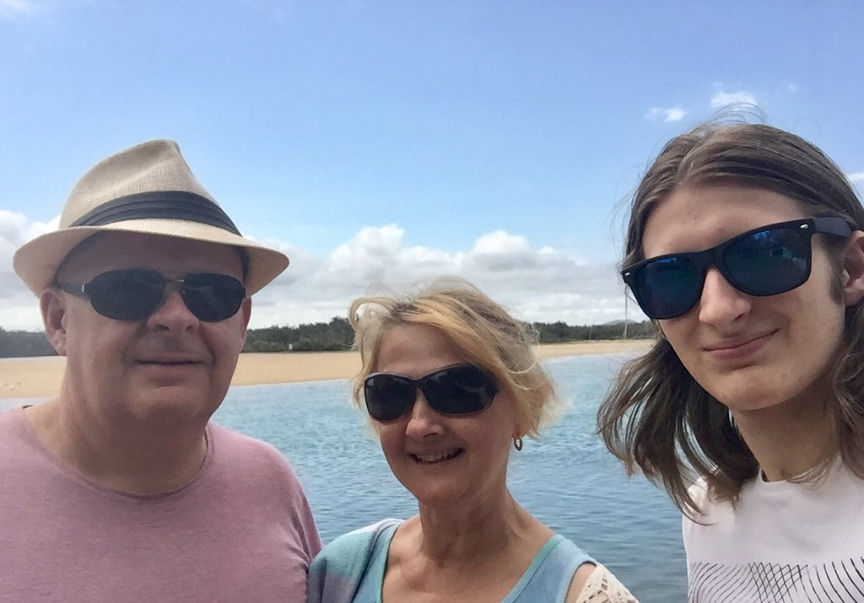
Rev’d Mark, Trisha and youngest son, Isaac.

Senior Minister/Rector: Rev’d Mark Harris 0425 265 547
revmarkharris@icloud.com
Priest in Local Mission: Rev Helen Quinn 0427 592 723
Parish Office: St. Alban’s Anglican Church: 5543 7683
info@forsteranglican.com
Parish Secretary: Judy Hall 0400 890 728
Op Shop: Head St Car park 6555 4267
Book Shop: bookshop@forsteranglican.com 5543 7683
Parish Website: www.forsteranglican.com
Fb: Anglican Parish of Forster-Tuncurry.
Items for Parish News: Lyn Davies 0491 136 455. Parish Office 5543 7683 by noon Wed, Thanks.
Our bank details: BSB 705077 Account 000400710
Account name: Anglican Parish of Forster/Tuncurry

