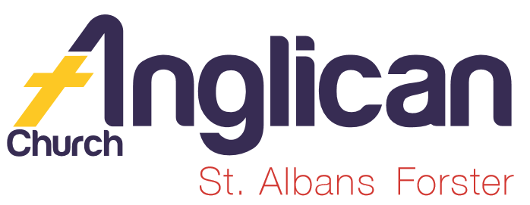
PARISH NEWS

FORSTER & NABIAC 5th January, 2020.

EPIPHANY – THE WORD BECAME FLESH

“God has destined us for adoption as his chidren through Jesus Christ to the praise of his glorious grace that he freely bestowed
on us in the Beloved.” Ephesians 1.¹⁵⁻¹⁶

SUMMER LIFE – SCRIPTURE UNION
How encouraging to see these young people giving up their time to share their passion and love for Jesus. To inspire other young people to give their lives to Christ, as they have.

During our 10am service at St. Alban’s, two team members did the bible readings, Rev James interviewed the Team Leaders and one of the boys gave his testimony and the singing was sensational!

OUR LEADERSHIP TEAM
Senior Minister: Rev. Mark Harris 0425 265 547
Families Minister: Rev. James Brooks 0411 335 087
Priest in Local Mission:Rev.Helen Quinn 0427 592 723

BOOKSHOP NEWS
The Bookshop has been able to donate $1,500 each to GLECCA (for the school chaplains) and SIFT (to support scripture teaching at Great Lakes College), from sales in 2019.
The Bookshop will reopen Monday January 6th. In 2020 it will again open each Monday to Friday 9am to noon.

Would you like to help in the Bookshop in 2020? Volunteers are welcome on a weekly, monthly or ad hoc basis. Training will be provided. Please speak to me if interested. Phillip Castle.

FRIENDSHIP GROUP & JANUARY LIGHT LUNCH
The Frienship Group will meet at St. Alban’s Hall on Tuesday, 7th January at 10am for a chat and a cuppa. The Light Lunch will be on Wednesday, January 8th, $8.00 each, 11.30am for noon in the Parish Hall. Everyone invited to both functions. Helen Barber

BUNNINGS BBQ
Our first date for 2020 is Saturday, 25th January. As this is part of the Australia Day long weekend it would be great to see if we have sufficient volunteers, otherwise we will need to cancel. List in the parish hall, please be thoughtful of this connection with the community.

MISSION GIVING
The total amount donated during December for the mission of the month, the Christmas Bowl appeal, was $541.95. the Christmas Bowl is part of a global network of aid organisations working in over 140 countries. Phillip Castle.
JANUARY MISSION FOCUS -AUSTRALIAN BOARD OF MISSION
To give to the mission of the month you can use the “Mission” side of the regular envelopes or give through the wooden boxes at the entrance to the church buildings. Phillip Castle.

PRAYERS FOR THE SICK AND RECOVERING
Ella E, Keith R, Lyn T, Marion & Peter R, Michelle, Rachael, Margaret B,
Zac L, Aileen G.
We remember with thanks those whom we have loved whose anniversary occurs during January: Alex Campbell, Annie Leckie Wright, Victor George Godwin, Joan Winter, Noel Hannabus, Frank Williams, Keith Dee.

BIBLE READINGS
The New International Version (NIV) is now being used in our services. The pew bibles at St. Alban’s are NIV (a slightly older version).

SAMARITANS
Great donations coming in each week, well done.
AT LAST – THE NEW CHURCH SIGN AT ST. ALBAN’S
If you haven’t had a chance to check the sign out as yet, then it’s worth the effort. Well done. Other new signs around the parish at the Op Shop, Nabiac and Tuncurry.

DIRECT DEBIT GIVING
Such a fuss free way to ensure your offering is received WEEKLY
Acount Name: Anglican Parish of Forster/Tuncurry.
BSB: 705077 Account: 000400710
for God loves a cheerful giver. 2 Cor.9:⁷

PRAYER OF ST FRANCIS (Prayer No 51 – ‘500 Prayers’)
This prayer is attributed to St. Francis of Assisi, who lived in the thirteenth century, although no early copies of it now exist. The language is a bit old-fashioned in places, but I’ve included it because it’s such an amazing mission statement for any Christian to sign up to. By praying this prayer, we’re asking God to help us to be a force for good in the world – in our homes, school and communities.

Lord, make me an instrument of your peace.
Where there is hatred, let me sow love.
Where there is injury, pardon.
Where there is doubt, faith.
Where there is despair, hope.
Where there is darkness, light.
Where there is sadness, joy.

O Divine Master,
Grant that I may not so much seek to be consold, as to console;
To be understood, as to understand;
To be loved, as to love.
For it is in giving that we receive.
It is in pardoning that we are pardoned,
And it is in dying that we are born to eternal life. Amen.
ROMANS 13:⁸⁻¹⁰ LOVE, FOR THE DAY IS NEAR
“Let no debt remain outstanding, except the continuing debt to love one another, for he who loves his fellowman has fulfilled the law. The commandments,”Do not commit adultery,” “Do not murder,” Do not steal,” “Do not covet,” and whatever other commandments there may be, are summed up in this one rule: “Love your neighbor as yourself.” Love does no harm to its neighbor. Therefore love is the fulfillment of the law.”
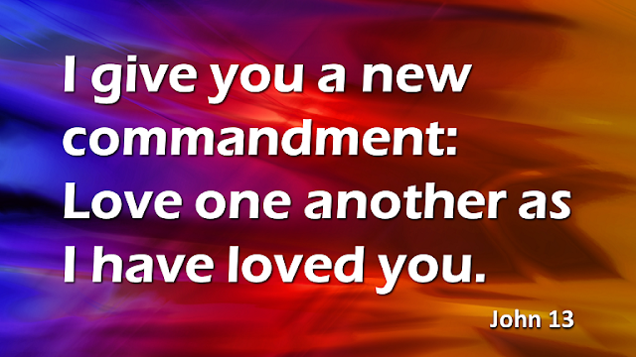

JOHN
This Photo by Unknown Author is licensed under CC BY-SA-NC

JOHN 13:³⁴ JESUS PREDICTS PETER’S DENIAL
“A new command I give you: Love one another. As I have loved you, so you must love one another. By this all men will know that you are my disciples, if you love one another.

ROMANS 12.¹⁻² LIVING SACRIFICES
“Therefore, I urge you, brothers, in view of God’s mercy, to offer your bodies as living sacrifices, holy and pleasing to God-this is your spiritual act of worship. Do not conform any longer to the pattern of this world, but be transformed by the renewing of your mind. Then you will be able to test and approve what God’s will is-his good, pleasing and perfect will.”

Items for the Parish News for January, 2020 to Trisha Harris by 12 noon Wednesday, thanks. Email trishaharris10@gmail.com .

