PARISH NEWS
PENTECOST 11- BELONGING IN GOD’S FAMILY
5th AUGUST, 2018.
Why do you spend your money for that which is not bread, and your labour for that which does not satisfy? Eat what is good and delight yourself in rich food. Isaiah 55²

OUR PARISH VISION –
“We will connect meaningfully with our community in order to inspire hope and transformed lives through faith in Jesus.”

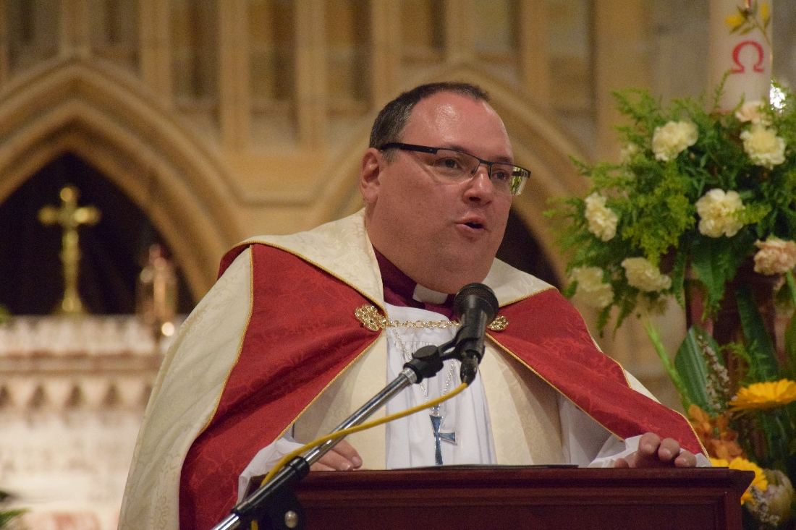

We welcome Assistant Bishop Charlie Murry to our combined parish service at St. Alban’s.
After our 9.30am service we will meet in the parish hall and enjoy morning tea together, giving us a chance to reflect on all that is happening in the Diocese and in our parish at the present time.
Parish Councillors will then meet with Assistant Bishop Charlie.
A free sausage sizzle will be available thus giving extra time to share God’s love with one another.

1 THESSALONIANS 5:16-18 – Be joyful always; pray continually, give thanks in all circumstances, for this is God’s will for you in Christ Jesus.
BISHOP PETER invites all Anglicans to pray that God will guide us with wisdom and insight we need by regularly praying this prayer: -

Come Holy Spirit of God,
restore the lives which, without you, are lifeless and dead;
kindle the hearts, which without you, are cold and dull;
enlighten the minds which, without you, are dark and blind;
fill the church which, without you, is an empty room;
teach us how to praise and pray
that we may grow together in love
and have courage to make wise decisions
as servants, messengers and ambassadors of God’s reign,
all this we ask in the name of Jesus Christ, our Lord. Amen.

OUR MISSION FOCUS FOR AUGUST –
Anglican Board of Mission (ABM) – working for Love, Hope & Justice – is our central thought for mission this month.

PARISH FETE -
Saturday, 20th October. We are holding a “Fete Meeting” this coming Tuesday, 7th August, at 2pm in the parish hall to consolidate our plans. Check out the list of stalls and add your name – now!
Preparation time – especially for planting, and craft items and looking up Christmas cake and pudding recipes, whatever your field of endeavor is now is the time to begin the process.

MEN’S DINNER –
This Tuesday, 7th August, 6.00pm for 6.30pm. Cost $15.00 each, plus drinks. The guest speaker for this occasion if Pastor Geoff Battle from the Uniting Church, Forster. Lists at all churches or phone the parish office.

MINI LUNCH – After missing the July lunch let’s make sure we remind all our friends and neighbours that the August mini lunch will be on this Wednesday, 8th August, 11.30am for 12 noon start. $7.00 each.

THE SOMETHING SPECIAL CHRISTIAN BOOKSHOP –
Phillip and Deborah travelled to Port Macquarie last Friday to select new stock from Koorong, a good idea to look through the stock to-day.
MEMBERS OF OUR CHURCH COMMUNITY WITH ONGOING NEEDS –
Hugo Walmsley, Elaine Latta, Alan Winston, Nina Learmond, Rosalyn Ferris, Ella Engel, Jenny Lawson, Maureen Armstrong, George Hodgson, Louise, Dianne Hardin, Wayne Thompson, Keith Roach.
If you would like to add someone to the Parish Prayer list, be sure to obtain permission from the person concerned and then contact the Parish Office.

OP SHOP – BOOKS are now in short supply, if you can help that would be appreciated. And shortly we will all need to go through our last year’s spring gear and the Op Shop is always delighted to accept your donations.

BUNNINGS BBQ FOR TODDLERTIME PLAYGROUP -
Thanks to all who assisted on the day. The final profit for the day (money wise) $708.65. 13 packets of 1.8kg thin sausages were cooked, placed on 30 loaves bread, sauced and enjoyed. Plus fizzy drinks.
The next BBQ date at Bunnings is Saturday, 6th October.

8am WELCOME ROSTER FOR ST. ALBAN’S –
Patricia Dastidar 0400 655 880 has asked if someone from the early traditional service at St. Alban’s would put their hand up for this purpose. Give Patricia a ring to discuss details.

PARISH LUNCHEON –
Save the date - the fifth Sunday in September – 30th September – Suellen has the plans in hand – details shortly.

OUR SPECIAL PRAYER FOR A FAMILIES MINISTER –

Loving and Generous God:
We bring before you all who minister in your name in this parish and we pray for the need for a families’ minister. Please give wisdom and guidance on the raising of finance to support this outreach. May we approach this with the generosity of Spirit you show us. Give to those who will be tasked with this selection, courage, guidance, sensitivity and discernment in the implementation of this ministry initiative. We ask these things through your Son our Saviour, Jesus Christ our Lord. Amen.

SAMARITANS DONATIONS OF FOOD FOR AUGUST –
Cans fish – tuna, salmon, sardines – plus packets and bottles to make a complete meal with the tinned fish – protein rich. If the “fishy” idea isn’t your genre then check out the ½ price specials – any ideas that you have and know they will be helpful to those in need will be greatly appreciated.

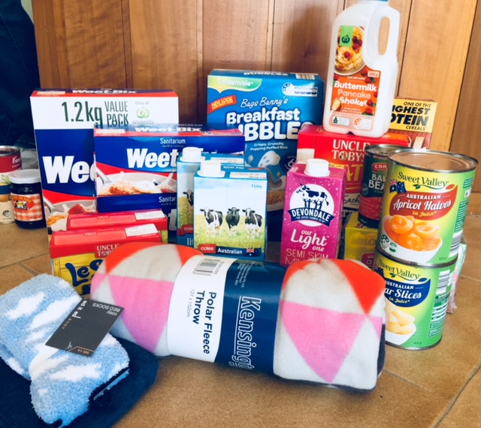

This photo shows quite a small selection of the breakfast foods and warm gear that has been collected for the Samaritans to assist those less fortunate than ourselves.

CONTACT DETAILS
Senior Minister/Rector: Rev’d Mark Harris 0425 265 547
revmarkharris@icloud.com
Priest in Local Mission: Rev Helen Quinn 0427 592 723
Parish Office: St. Alban’s Anglican Church: 5543 7683
info@forsteranglican.com
Parish Secretary: Judy Hall 0400 890 728
Op Shop: Head St Car park 6555 4267
Book Shop: bookshop@forsteranglican.com 5543 7683
Parish Website: www.forsteranglican.com
Items for Parish News: Phone Lyn Davies 0491 136455 or email: clivelyn46@gmail.com or Parish Office 5543 7683 by noon Wed, or text, thanks.
Our bank details: BSB 705077 Account 000400710
Account name: Anglican Parish of Forster/Tuncurry

