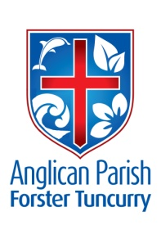
PARISH NEWS
FOURTH SUNDAY AFTER PENTECOST

7th July 2019

The harvest is plentiful, but the labourers are few; ask therefore the Lord of the harvest to send out labourers into his harvest. Luke 10.2

MONTHLY LIGHT LUNCH
Wednesday, 10th July 11.30 for 12 noon. All welcome and please Bring a Friend! $8 for 2 courses.
The Friendship Group are asking for help with the dishwasher after the above lunch on 10th July.
Helen Barber (for Friendship Group) 0419-996-594

GAMES AFTERNOON
Looking for something to activate the brain? Why not come to a Games Afternoon with a wide variety of board games, cards, and jigsaws. Saturday 13th July 1-4 pm. Gold coin donation. Children most welcome (with adult, please).
Contact: Penny Jude 6555-6389 or 0414-776-535, or pennyjude@bigpond.com

DEMENTIA WORKSHOP
The Uniting Church is running a workshop “Discussing Dementia” on Saturday, 27th July, 9.30am – 12 noon, at the Forster Uniting Church in Lake Street. Speaker is Rev Frank Van Der Korput, a Uniting Church minister who currently serves as an aged care chaplain and has studied dementia for many years. There will be a special emphasis on the role of music. Cost $10 includes notes and morning tea. For enquiries and bookings please call either Jen Pulling 0425-365-889 or Geoff Battle 6555-8573. Bookings should be made by 22nd July so that seminar notes can be printed.
MEMBERS OF OUR CHURCH COMMUNITY AND FRIENDS WITH ONGOING NEEDS
Ella Engel, Jenny Lawson, Keith Roach, Nadia Maybury, Lyn Thompson, Marion & Peter Roberts, Margaret Burrows, the Pearson family, Peg Sawyer and George Mazaraki.

We remember particularly: Laurie Medcalf and those whom we have loved whose anniversary occurs at this time: Jean Ollivier, Shirley Berridge, George Griffis, Toby Saxby and Denby John Campbell.

NAIDOC WEEK We celebrate with our first peoples this historic week with history, culture and achievements of Aboriginal and Torres Strait Islander peoples.
NAIDOC is celebrated not only in indigenous communities, but by Australians from all walks of life.
The week is a great opportunity to participate in a range of activities and to support your local Aboriginal and Torres Strait Islander community.
We are one community but we are many members. Let us walk together with mutual respect and harmony to make this town strong!
Posters in both churches with ideas of how YOU can participate.
Rev Helen.

DON’T FORGET TO VOTE IN THE MY COMMUNITY PROJECT!

FINANCE UPDATE TO END OF MAY

 | ACTUAL | YEAR TO DATE BUDGET | VARIANCE
OFFERTORIES (IN PLATE PLUS ELECTRONIC) | $50,398 | $58,750 | $8,352  under budget
OP SHOP TAKINGS | $25,125 | $25,000 | $125  over budget
MISSION GIVING | $3,403 | $3,333 | $70  over budget

Offertories to the end of May are $8,352 or 17% below the budget. If this level continues for the year there will be a $20,000 shortfall. Op Shop takings and Mission Giving are very close to budget. Well done!
Expenditure items are on budget. Expenditure on improvements on St Paul’s Nabiac is sourced from a portion of the proceeds from the sale of the Bungwahl property which, according to Diocesan rules, must be for capital improvements rather then regular ongoing costs. About $35,000 has been committed so far.

OP SHOP APPEAL
Sales have been very good at the Op Shop recently and, as a result, our stock is very low. Clothes, kitchenware, linen, small electrical appliances all welcome. Any queries, speak to Heather 6557-5454 or Janet 6554-5981. (As usual, we are looking for more helpers!)

BUNNINGS BBQ FOR TODDLER TIME
Saturday, 13th July - volunteers needed to assist for two hour shifts. Check the notice board and see if you can help out. New volunteers are needed. Further dates for this year – Saturday, 17th August and Saturday 7th December

SAMARITANS – Breakfast foods this month.

OUR MISSION FOR JULY – Anglican Board Of Mission. Working for Love, Hope and Justice.

CLOSING OF ST JOHN’S, DYERS CROSSING
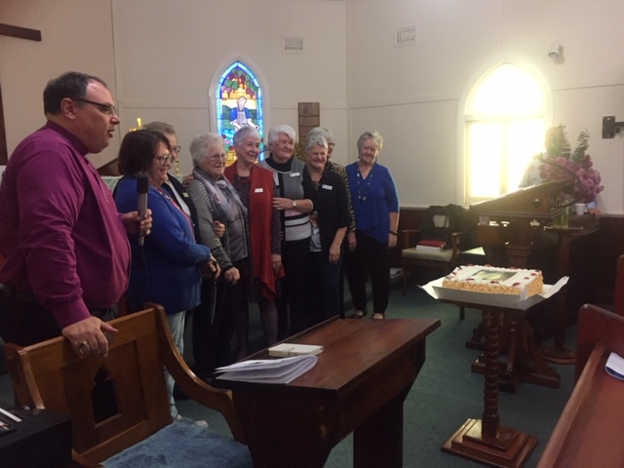

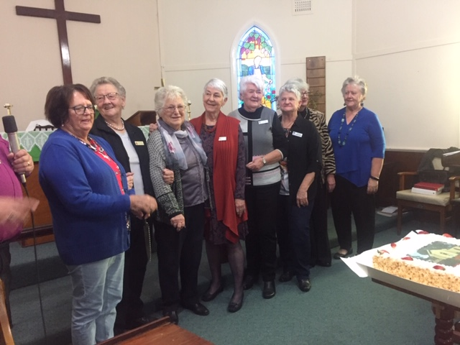

ST. PAUL’S, NABIAC
As from this Sunday, 7th July, services will be held every Sunday. The first and third will be All Age, and the second and fourth will be Traditional - all services will be at 10am.

Senior Minister/Rector: Rev’d Mark Harris 0425 265 547
revmarkharris@icloud.com
Family Minister: Rev’d James Brooks 0411 335 087
jamesknac@gmail.com
Priest in Local Mission: Rev Helen Quinn 0427 592 723
rqu783662@bigpond.com
Parish Office: St. Alban’s Anglican Church: 5543 7683
info@forsteranglican.com
Parish Secretary: Judy Hall 0400 890 728
Op Shop: Head St Car park 6555 4267
Book Shop: bookshop@forsteranglican.com 5543 7683
Parish Website: www.forsteranglican.com
Fb: Anglican Parish of Forster-Tuncurry.
Items for Parish News: Janet Lawrence, email: jan2max@bigpond.net.au, 6554-5981 or
0448-502-684 or Parish Office 5543-7683 by noon Wednesday.

Opportunity To Give
For direct credit offertories:
BSB: 705077 Account: 000400710
Account name: Anglican Parish of Forster/Tuncurry

