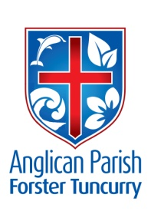
PENTECOST 20 – WORTHY OF THE GOSPEL
7th OCTOBER, 2018.

Whoever does not receive the kingdom of God as a little child will never enter it. Mark 10.¹⁵

OUR PARISH VISION:
“We will connect meaningfully with our community in order to inspire hope
and transformed lives through faith in Jesus.”

OUR PARISH FETE 2 weeks to go!!
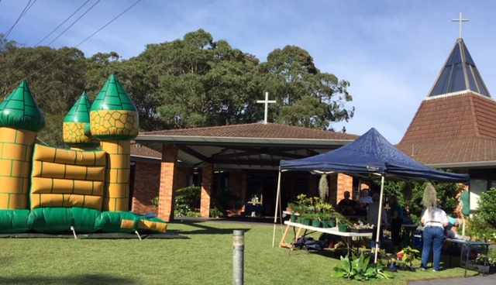

Our “Follow-up” meeting was held last Tuesday, and we have included the Parish Fete leaflet for you to check out the info and make sure you have the details such as - when to deliver saleable goods and that date has arrived Monday 8th October – to-morrow. The back of the parish hall is the site.

Toddler Time will be using the hall for their get together on Monday, 15th October and will be testing the new jumping castle.
Beautifully designed pamphlets are available for you to give to your friends, neighbours, rellies, everyone in your street. Note the White Elephant contact is now Heather Dwyer 6557 5454.
There is a map of Forster/Tuncurry PLEASE highlight where you will make pamphlet deliveries and write your name next to your area. Thank you.
Toddler Time will be staring at 11am with bubbles, parachute, followed by delightful singing/movement/as only 0-5 years are confident enough to engage in!
Immediately following, Rev. Mark will auction two stunning items made by the Rug Rats a quilt and a double bed rug. There will be a reserve placed on these items.
AS WE WORSHIP OUR GOD WE INCLUDE IN OUR PRAYERS THIS WEEK:
Bishop Peter’s prayer
Our prayer for a Families Minister
Bishop Peter & Nicki
Asst. Bishop Charlie Murry & Melissa
Asst. Bishop Sonia Roulston
Rev. Mark & Trisha
Rev. Helen & Dick

MEMBERS OF OUR CHURCH COMMUNITY WITH ONGOING NEEDS
Alan Winston, Ella Engel, Jenny Lawson, Maureen Armstrong, George Hodgson, Louise, Keith Roach, Paul McIntosh, Michelle, Max Kennedy,

If you would like to add someone to the Parish Prayer list, be sure to obtain permission from the person concerned and then contact the Parish Office.

OUR MISSION FOCUS FOR OCTOBER IS LIZ BURNS, Church Missionary Society serving the Lord in Dodoma, Tanzania.
“I live by faith in the Son of God who loved me and gave himself up for me.” Galatians 2:²⁰

UPCOMING EVENTS:
Tuesday, 9th October – Parish Council, 4pm
Wednesday, 10th October – Mini Lunch, 11.30am for noon
Saturday, 13th October – 8am-11.30am Working Bee at St. Alban’s
Saturday, 20th October – Parish Fete at St. Alban’s

PEWS AND SCONCES. All the pews have been sold and there are only two sconces still to be sold @ $150.00 each. Well done. Just received a text from Clive as I type and now only one sconce left @ $100.

COURTHOUSE CUPPA MINISTRY
Owing to changes at the Forster Courthouse the Courthouse cuppa ministry has now ceased. On behalf of the Parish I would like to thank all those who have been involved in this ministry over the past 30+ years. Suellen.
The Parish in return, thank Suellen for her involvement in this ministry.

BUNNINGS BBQ’s
Bunnings have advised us of two further BBQ dates for Toddler Time, Saturday, 17th November and Saturday, 19th January. These days are a great way of connecting with the community.

PARISH BOOKSHOP
There will be a week’s sale of 10% off all stock commencing on the day of the Parish Fete, Saturday, 20th October thru to Friday 26th October.

CAPPUCINO DRINKERS
A further $112. Has been forwarded to the Chaplaincy, thanks to Keith B. and Rosa.

WORKING BEE AT ST. ALBAN’S
Set down for next Saturday, 13th October – no volunteers as yet.

THOUGHTS ON SAMARITAN DONATIONS FOR OCTOBER AND NOVEMBER
During the next two months we are asking for CHRISTMAS FARE, from food to gifts for the whole family. The gifts do not require wrapping as the Samaritans find it more helpful to actually see the items before distribution.

ITEMS FOR THE PARISH NEWS
Janet Lawrence will once again step in and keep the parish up to date with events for the next three weeks – Sundays 14th, 21st & 28th.
Phone 6554 5981, 0448 502 684. Email jan2max@bigpond.net.au with your requests or phone the parish office 5543 7683 by noon Wednesday. Thanks.

Senior Minister/Rector: Rev’d Mark Harris 0425 265 547
revmarkharris@icloud.com
Priest in Local Mission: Rev Helen Quinn 0427 592 723
Parish Office: St. Alban’s Anglican Church: 5543 7683
info@forsteranglican.com
Parish Secretary: Judy Hall 0400 890 728
Op Shop: Head St Car park 6555 4267
Book Shop: bookshop@forsteranglican.com 5543 7683
Parish Website: www.forsteranglican.com
Fb: Anglican Parish of Forster-Tuncurry.
Items for Parish News: Parish Office 5543 7683 by noon Wed.
Our bank details: BSB 705077 Account 000400710
Account name: Anglican Parish of Forster/Tuncurry

SIX STEPS TO LOVING YOUR CHURCH.
From the Ministry of the Few to the Ministry of the Pew.

This Photo by Unknown Author is licensed under CC BY-SA-NC

The assignment for the first Sunday: don’t sit in your ‘normal’ seat (if you have one). Pray about where to sit, and sit next to someone different.

The assignment for the second Sunday: After the service to look for a way to practically serve another person. Have a conversation with someone after
church. Ask them how their week has been, and ask what you could pray for them.
The assignment for the third Sunday: Choose at least one new thing you could do during church to encourage and help others, and put it into practice.

The assignment for the fourth Sunday: a conversation about some specific point in the sermon, praying with someone, swapping stories of conversion with someone.

The assignment for to-day: Think of two or three people you could invite to church. Start praying and thinking about when and how you might invite them.

Our Bookshop has copies of the accompanying workbook @ $8.00 each. The workbook enables us to go through each step at our own pace and helps to really think about our feelings about Sunday church gatherings.

