PARISH NEWS

FORSTER-TUNCURRY & NABIAC 8th MARCH, 2020

COMBINED PARISH WORKSHOP, NEXT SUNDAY, 15th MARCH, 9.30AM
Come along to St. Alban’s Church, next Sunday, and enjoy undivided love as we gather to worship our great God. After morning tea our Annual General Meeting will commence at 11.30am.
If you’re able to bring along a “small” plate of food to share at morning tea, that would be much appreciated.

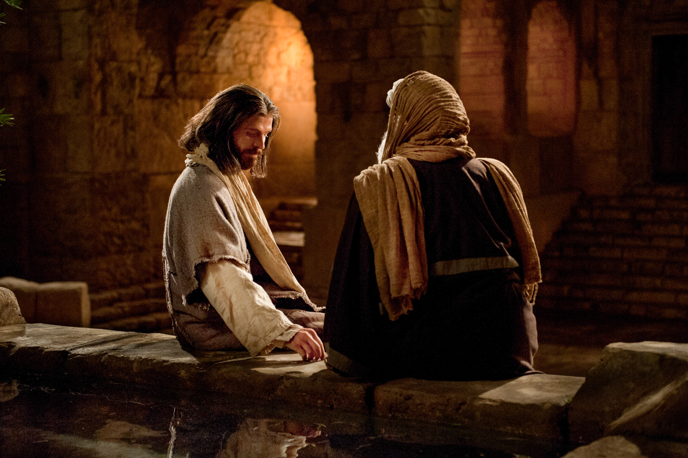

AS THE SPIRIT LEADS- Learnings for Life, A Lenten Reflection.
In John 3 is the marvellous story of Nicodemus, a teacher and leader of the Jews, who comes to Jesus at night. He literally steps into the light. Jesus explains that all who enter the kingdom of heaven must be born from above. It is the Spirit of God who guides, renews and transforms. Nicodemus has trouble understanding all this.
Read the complete story. Copies in both churches.

CONNECT WITH US
FACEBOOK ………………… Forster Anglican Church Community
PARISH WEBSITE………… www.forsteranglican.com
CHURCH OFFICE ………… info@forsteranglican.com 5543 7683

PRAYERS FOR THE SICK AND RECOVERING
Ella E, Keith R, Lyn T,Marion & Peter R, Michelle, Rachael, Margaret B,
Zac L, Aileen G, Vicki L, Charlotte T, Peter B.
We remember with thanks those whom we have loved whose anniversary occurs this month – John Griffis, Harry Murray, May Newton, Barbara Conroy, Nellie Avery, Gwenda Kidd, Terry Bowd, Rhonda Groves, Ben Ferris.
OUR PARISH VISION
Connecting Community. Inspiring Hope
Transforming Lives
Through Faith in Jesus

THOUGHTFUL GIFTS FOR THE SAMARITANS -
A new thought – CLEANING GEAR – anything you find useful when you clean your own home. As always your choice of gifts.

A LENT STUDY – Lessons From the Life of the Early Church for 21st Century Christians. Produced by the Anglican Diocese of Newcastle.
Copies available in both churches – daily readings and reflections during the season of Lent. It would be thoughtful if when collecting your copy you could give a small amount (maybe $2 - or more if you’re able) to assist in offsetting costs to the parish. Copies still available!

ANOTHER WAY TO RECORD YOUR WWCC.
If you have a smart phone, enter your WWCC number as a contact – too easy! Or any other important number that is needed from time to time.

BCA-BUSH CHURCH AID IS OUR MISSION FOCUS FOR MARCH.
March is the month we bring our BCA boxes in for Suellen to open and count all the monies we have been putting aside. Monies will be sent to BCA for their ongoing work in the Australian bush. Don’t have a BCA box? Speak to Suellen, she will be delighted that you intend joining in this missionary work.
Also, as you walk into the foyer at St. Alban’s there is always a mission box so that you can drop in a donation for the mission of the month OR you can use the “mission” side of your giving envelope.
As we pray for BCA missionaries we include – Steve & Lyn Davis, Debbie Edwards at SA/NT Regional office and for their support of regional BCA workers.

PRAYER & PRAISE UPDATE FROM JOSE VERAGA – Pastoral Care in the Great Lakes College.
Copies of the Update are available in both churches – amazing praise and prayer points. Our GLECCA rep. is Heather Webster.

AN AFTERNOON AT THE MOVIES- GLECCA- “I STILL BELIEVE”
Mark the date – Sunday, 22nd March, 2pm at the Great Lakes Theatre, Tuncurry. Tickets are available at our bookshop, also available today from Heather Webster, $20.each. Supper and a chat will be provided after the movie to give time to mingle with other Christians in the area.

DATE FOR THE NEXT MEN’S DINNER
Tuesday, 7th April, at St. Alban’s Forster – 6pm for 6.30pm. The speaker on this occasion is Bill France a retired BCA missionary from North Western Australia. $15.00ph. lists at both churches or phone Clive 0412 653 061. Another opportunity to introduce interested men friends to our church.

A REVIEW FROM ONE OF OUR BOOKSHOP VOLUNTEERS
Good News Bible – The Psalms. A dyslexia-friendly edition printed on cream coloured matt paper to minimise reflection, with comfortable sized print. $5.00.
DIRECT DEBIT GIVING
ANGLICAN PARISH OF FORSTER/TUNCURRY
BSB: 705077
ACCOUNT: 000400710.
God loves a cheerful giver

WEDNESDAY, 11th- LIGHT LUNCH, in St. Alban’s Hall.
An easy way to introduce friends to our church. This monthly light lunch is $8.each, 11.30am for midday. A chance to talk to old friends and make new friends. A trading table available and you are invited to bring along items for sale.

DISASTER TRAINING RECOVERY
Held in Taree 29th February. The parish hall was full to overflowing with parishioners including a contingent from our parish. It was an informative day and a guide to how we can prepare for a disaster.

ONE WEEK TILL OUR AGM
Today is the last day to submit in writing any Agenda Items, including questions, notice of motions, vote of thanks, etc. to the Parish secretary, Judy Hall.

OUR LEADERSHIP TEAM:
Senior Minister: Rev. Mark Harris 0425 265 547
Families Minister: Rev. James Brooks 0411 335 087
Priest in Local Mission:Rev.Helen Quinn 0427 592 723

Items for the Parish News for March to Lyn Davies via phone 0491 136 455, text or call. Email: clivelyn46@gmail.com by noon Wednesday, thanks.

