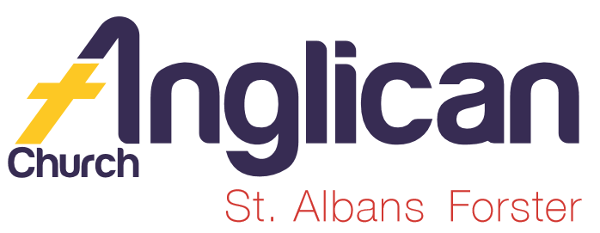
PARISH NEWSHEET

FORSTER & NABIAC 8th September, 2019
PENTECOST 13 – WHEN CHRISTIANS DIE

SIFT (SCRIPTURE IN FORSTER TUNCURRY)
“OVERCOMER” – movie posters in both churches. A different way to raise monies for SIFT. Sunday, 15th September, 2pm, at Great Lakes Cinemas, Tuncurry. $20 per ticket. Tickets are available, this morning at Forster, see Phillip at the bookshop during the week.

SURGE 100 x 20 This morning at our All-Age Service at 10am in Forster, Rev’d James will be speaking with Jose . We will receive a copy of the leaflet teling us how we can “keep scripture in our high schools” this means employing a teacher. Interested? Listen and learn how this can be achieved. Rev.James will speak on this subject over the next two weeks.

OUR PARISH VISION. Connecting Meaningfully.
Inspiring Hope.
Transforming Lives. Through faith in Jesus.

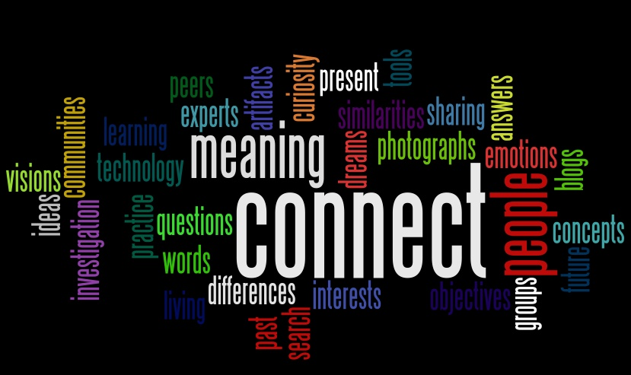

THE ENVELOPE SYSTEM OF GIVING Envelopes have arrived and you are welcome to collect a set for your generous giving.
DIRECT DEBIT GIVING the account name is: Anglican Parish of Forster/Tuncurry, BSB:705077, Account:000400710.

OUR MISSION FOCUS FOR THE MONTH OF SEPTEMBER is BUSH CHURCH AID. September is the month that we bring in or send in our BCA boxes. If you would like more info or a BCA box please see Suellen.

SAMARITANS DONATIONS For September we’re thinking of tins of salad vegies, mayonnaise, etc. as you shop just buy a few extras to help those less fortunate than ourselves.

PARISH LUNCH – SAVE THE DATE Saturday 4th November, is ithe date and the parish will meet at Club Forster. $26pp. More details later on. Suellen.

OUR PRAYERS FOR THE SICK AND RECOVERING
Ella E, Jenny L, Keith R, Lyn T, Marion & Peter R, Margaret B, Michelle.
(it is a Diocesan requirement that surnames not be used, as this info appears on our website)

BOOK REVIEWS by one of our Bookshop Volunteers
BIOGRAPHY “NOT FORGOTTEN” – Kenneth Bae
“The True Story of My Imprisonment in North Korea”
Bae reveals his version of these events and shines the spotlight on those whom he hopes his supporters will remember: the people of North Korea. This book is a riveting account of one man’s sacrificial love for a forgotten people suffering under a brutal dictator. $19.99

BIBLE INFOGRAPHICS for KIDS 8-12years
This craz-mazing collection of infographics depicts the Bible’s key concepts, important people, unusual facts in a new and exciting way. So dive in and explore the Bible like never before. $19.99

OUR OP SHOP Spring has sprung!! As you go through your collection of spring and summer clothes remember our Op Shop and your opportunity to help others.

GREAT LAKES RURAL AUSTRALIANS FOR REFUGEES
RRyyMore
Writer, author, community worker & researcher, Mark Isaacs will be sharing his stories on Wednesday, September 11th, 6.30pm-8pm at the Midcoast Council Committee Room. Mark’s new book “The Kabul Peace House” will be on sale on the night. Posters in both churches.

CMS COASTAL MISSION DAY 2019- THE MISSION OF PRAYER an event where mission-hearted Christians can engage with how God is at work around the world.
Saturday, 19th October, 9.30am-3pm, EV Church, Erina. Leaflets available. Register online $10. cms.org.au/cmd

CMS SUMMER SCHOOL 2020. THE GOD WHO SEEKS
Messages to God’s church from 1 Timothy. 4th-10th January,2020, Katoomba. Handouts at both churches. “This is good, and pleases God our Saviour, who wants all people to be saved and to come to a knowledge of the truth” 1 Timothy 2:3-4

RUGRATS received a letter of thanks from Baptist Care (Kularoo Gardens) Forster, for their generous gifts lovingly made by hand. See photo. Coralie is looking for crocheters to make “squares”into rugs.

LIGHT LUNCH at St. Alban’s this Wednesday, 11th September, 11.30am for 12 noon start. A gentle way to introduce your friends to our church in Forster, plus a delicious lunch for $8, trading table, friends.

GAMES AFTERNOON Saturday, 14th September, 1pm till 3pm at St.Alban’s Hall. Another opportunity to bring along a friend or two, always a cuppa and a chat.
ANGLICAN WOMEN from Rev. Helen
Five parishioners travelled to St. Peters, East Maitland last Tuesday for the Spring Celebration. Assistant Bishop Charlie Murry celebrated Holy Communion and was followed by guest speaker, Rebekah Wilson, Donor Relations Officer for the Hunter Medical Research Institute.
In 2020 the HMRI will be the beneficiary of the “Thank You” boxes. These boxes, as always, can be collected at both churches.
Diary dates, 2020, for all women in the Dioces of Newcastle: Silent Lenten Retreat 1 at Rathmines – 28th &29th Feb and Sun 1st March. Silent Lenten Retreat 2 at Rathmines – 3rd, 4^{th &} 5th March. Rev’d Jan Deaves Retreat Conductor. Tuesday, 1st September, Spring Celebration, 2020.

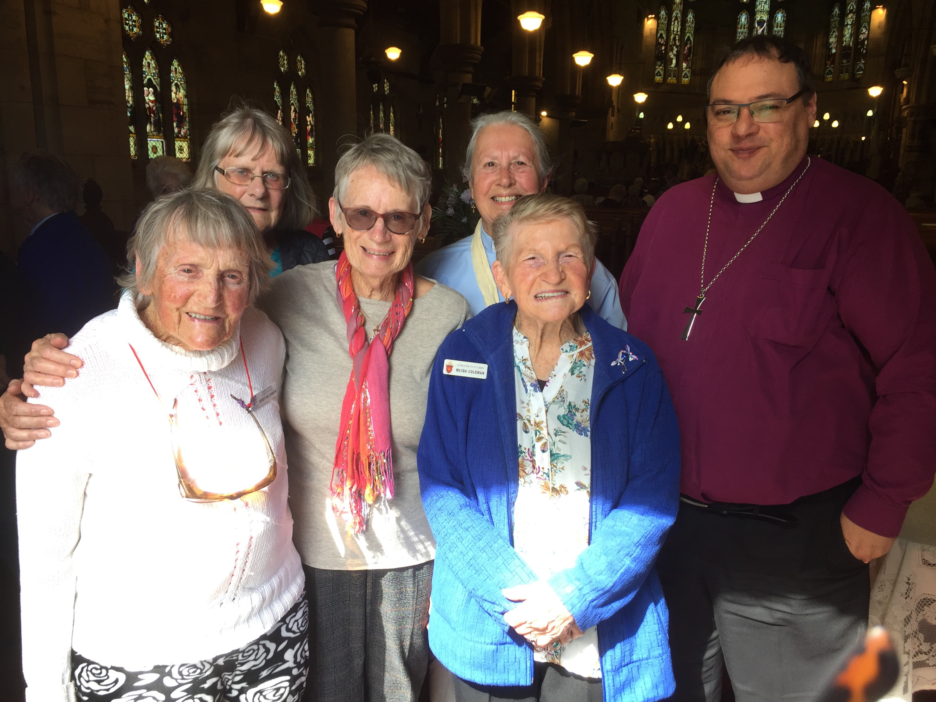
Wendy Williamson, Dianna O’Keefe, Lynette Underwood, Rev’d. Helen, Moida Coleman, Asst. Bishop Charlie Murry.

OUR LEADERSHIP TEAM:
Senior Minister: Rev. Mark Harris 0425 265 547
Families Minister: Rev. James Brooks 0411 335 087
Priest in Local Mission: Rev. Helen Quinn 0427 592 723

Items for the Parish News for September to Lyn Davies via phone
0491 136 455, text or call. Email: clivelyn46@gmail.com by 12noon Wednesday, thanks.

