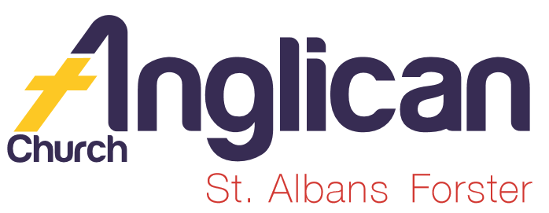
PARISH NEWS

FORSTER & NABIAC 8th December, 2019.

ADVENT 2 – THE KING WILL BRING JUSTICE,
BUT WILL WE BE READY?
LET US LIGHT THE CANDLE OF LOVE/ LIGHT

The time is fulfilled, and the Kingdom of God has come near; repent, and believe the good news. Mark 1.¹⁵

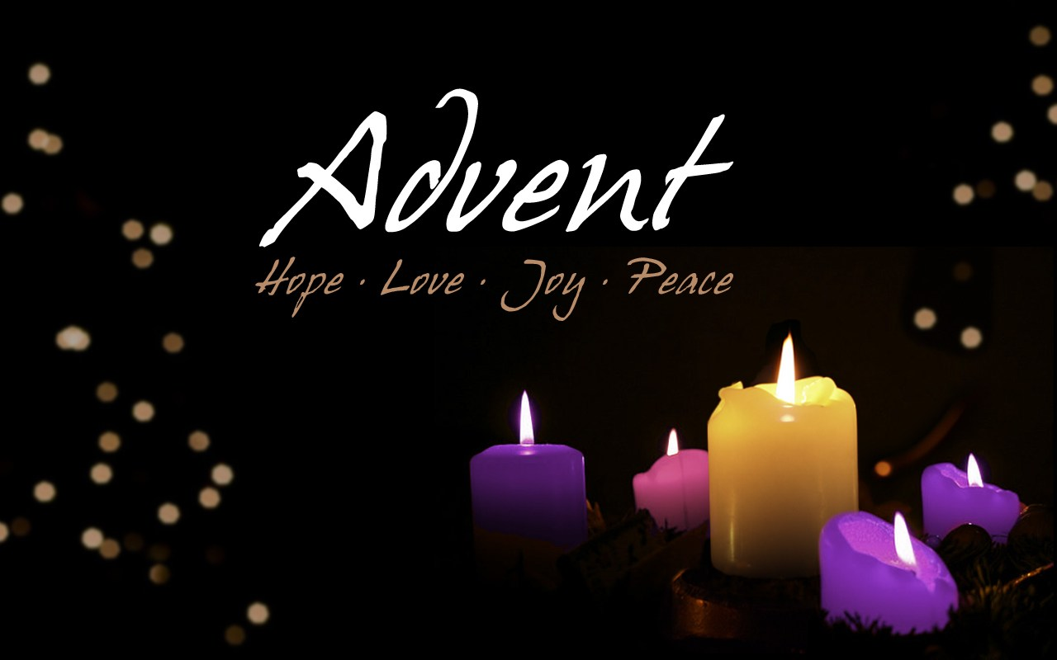

WHAT IS ADVENT?
Advent is that vital season in the church calendar when Christians focus on the coming birth of Jesus. It is more than simply waiting- marking time – perhaps by crossing the days off an Advent calendar. This is a snippet from JESUS – a Radical Advent – grab a copy and read more….

OUR LEADERSHIP TEAM
Senior Minister: Rev. Mark Harris 0425 265 547
Families Minister: Rev. James Brooks 0411 335 087
Priest in Local Mission:Rev.Helen Quinn 0427 592 723

CHRISTMAS SERVICES
Christmas Eve - Forster 11pm. Nabiac 7pm.
Christmas Day - Forster, 9.00am. Nabiac 10.00am.
SAMARITANS DONATIONS
What an amazing amount of donations came in last Sunday, thank you so much for taking notice of the comment in the parish news re collection dates. As always these gifts will be distributed among those most in need, whether fire victims, homeless, child abuse, etc. the list of those in need is always endless and at this time of the year when we remember receiving the “greatest gift” it’s a wonderful community connection through the Samaritans. Well done!

PRAYERS FOR THE SICK AND RECOVERING
Ella E, Jenny L, Keith R, Lyn T,Marion & Peter R, Michelle, Rachael,Max S, Margaret B, Prescilla F.
We remember with thanks those whom we have loved whose anniversary occurs this month – John Charles Thacker, George Belton, Harry Underwood, Colin Ellison, Trevor Humphries, Simon Allon, Doris Humphries, Philip Frank Ovens.

DYER’S CROSSING CHURCH
Passed in at auction, now on the market for $199,00.00 – breaking news sold, as yet not exchanged.

ADVENT STUDY SERIES DECEMBER 2019
The KING will bring justice, but will we be ready? study 3 covers this week’s readings. If you haven’t a copy of the study, then please collect one to-day. The studies are for personal or growth groups, and cover old and new testament readings.

OUR BOOKSHOP – reviews from one of our bookshop volunteers.
CHILDREN’S BOOKS –
DINOSAUR DEVOTIONS – 77 Dino Discoveries, bible truths, fun facts and more. A great way to find out more about your favourite dinos and discover more about our amazing God who created everything. $17.99
GOD MADE ME AWESOME – fun activities and devotions for girls. Have fun completing these activities and be filled with joy as you are reminded of how God made you awesome!! $9.99
BOOKSHOP NEWS: Phillip and Deborah travelled to Port Macquarie to Koorong during the week – so, what’s new in stock? Worth checking out great gift ideas for the whole family. Credit card facilities available.

DECEMBER COPIES OF VARIOUS MONTHLY MAGS
On the table as you enter St. Alban’s the Summer 2019/20 “SOWER” from the Bible Society, “Jesus” A Radicial Advent from Anglican Overseas Aid, A Prayer & Praise Update from Jose Veraga, envelopes for the Christmas Bowl Appeal, and of course, extra copies of the current study “The Coming of the King” .

CHRISTMAS LUNCH
Wednesday, 11th December, the Friendship Group will serve a Christmas Lunch and everyone is invited. 11.30am for 12 noon $8.00 each. Names and numbers would be helpful but NOT essential. A list in the Parish Hall. Baraya Wakulda (Sing as One) Choir will entertain us.

A THOUGHT – BE READY FOR A CRISIS (a follow-up to RFS)
Chris Manger had a chat with Heather Webster re being prepared – always ensure that your vehicle has a good amount of fuel. You may need to make a long journey.

TEN TIMES OUT OF TEN – Edward Everett Hale
I’m only one, but I am one.
I can’t do everything, but I can do something.
What I can do, I ought to do.
And what I ought to do by the grace of God I will do.

And if that is true of an individual Christian, how much greater an impact should the church be able to make! P152, The Living Church, John Stott

Items for the Parish News till the end of 2019 to Lyn Davies by 12 noon Wednesday, thanks. Phone 0491 136 455 text or call or email
clivelyn46@gmail.com

OUR DECEMBER MISSION FOCUS –THE CHRISTMAS BOWL
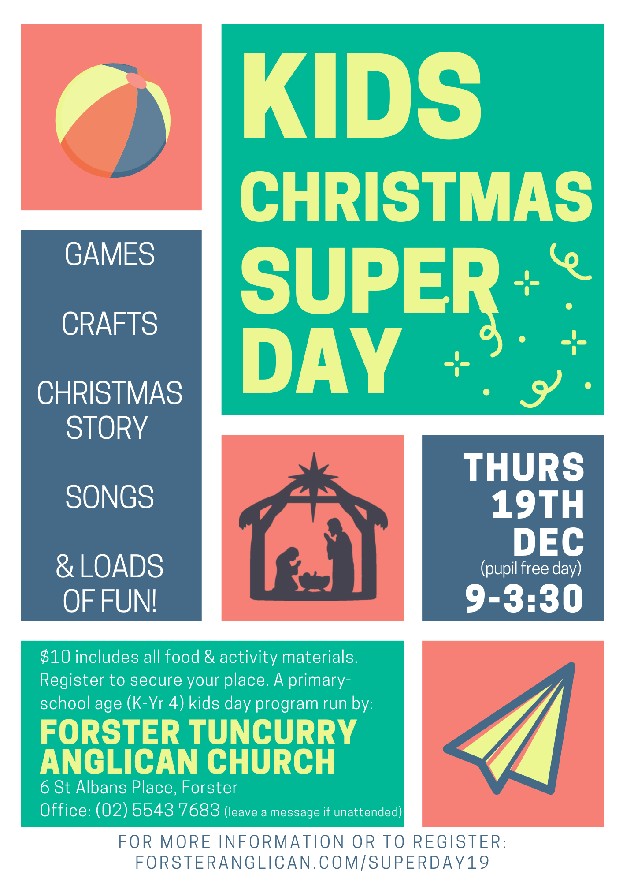

GAFCON Advent Devotions
During the month of Dec,
You can receive weekday
devotions in your email
inbox from the Global
Fellowship of Confessing
Anglicans. Just visit
www.gafcon.org/devotion
and enter your name and
email address.

