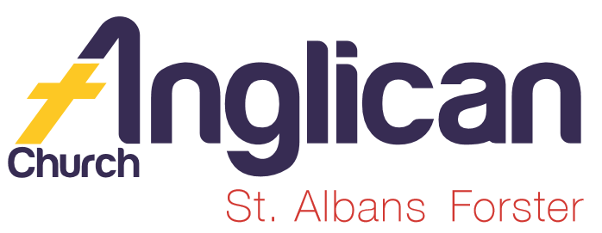
PARISH NEWS

FORSTER-TUNCURRY & NABIAC 9th FEBRUARY, 2020.

PARISH ELECTORAL ROLL
Lists of those on our Electoral Roll are at the back of both Forster & Nabiac churches.
If you would like to vote at the Annual General Meting (AGM) in March this year you need to be on the Electoral Roll.
Please fill in and sign an Electoral Roll form if you are not on the roll. Please give the completed form to me or place in the collection . Thanks Clive Davies 0412 653 061

MONTHLY PRAYER MEETING.
Our February meeting will be at 5pm Wednesday, 19th at St. Alban’s.
Our prayer focus this month will be the drought and the year ahead.

Senior Minister: Rev. Mark Harris 0425 265 547
Families Minister: Rev. James Brooks 0411 335 087
Priest in Local Mission:Rev.Helen Quinn 0427 592 723

PARISH SUMMER/AUTUMN PROGRAM 2020.
“Our Generous God!!” – pick up your copy today!

ANGLICAN WOMEN SILENT LENTEN RETREATS
2020 Theme “For by grace you have bee saved through faith, and that is not your own doing; it is the gift of God”. Retreat Conductor Rev. Jan Deaves, Retreat 1:Fri 28/02-Sun 01/03. Retreat 2: Tues 03/03-Thurs 05/03. Leafets available at both churches. Phone Rev. Helen Quinn if you would like further info. 0427 592 723.

OUR OP SHOP EXPANSION!
Have you thought about volunteering for the Tuncurry Op Shop?

SAMARITANS DONATIONS – FEBRUARY IS “TIN” MONTH

CONNECT WITH US
FACEBOOK ………………… Forster Anglican Church Community
PARISH WEBSITE………… www.forsteranglican.com
CHURCH OFFICE ………… info@forsteranglican.com 5543 7683

PRAYERS FOR THE SICK AND RECOVERING
Ella E, Keith R, Lyn T,Marion & Peter R, Michelle, Rachael, Margaret B,Zac L, Aileen G, Vicki L.

KID’S CHURCH UPDATE. From JUDY HALL (Coordinator)
We have commenced our 2020 Term 1 Teaching Program and will again focus on concepts being addressed in the adult services. We have two groups that operate each Sunday at the 10am service: one for the 0-5 year olds (this term being led by Sophie Brooks with help from Judy) and the other for 5-12 year olds (this term being led by Trisha Harris).

Safe Church requires that we have two adults with each group, so we are looking for *2-3 volunteers to assist Trisha with the older group for this term. This means we would be able to have a roster of one helper each week per month. Please let me (Judy) know if you can help out in this area of ministry. You will need to have your Working With Children Check and Safe Church Training.
We usually have 12 children at the 10am service – 7 in the pre-school group and 5 in the older group.
*A BIG THANK-YOU TO THOSE WHO HAVE OFFERED TO ASSIST WITH KID’S CHURCH – WELL DONE – ONLY 2 OR 3 MORE NEEDED!!!!!

This Photo by Unknown Author is licensed under CC BY-NC

ON-LINE SAFE MINISTRY TRAINING

It is a good idea to have completed your Safe Ministry Training. This is particularly important for anyone wishing to work with children’s ministry such as Toddler Time, Kids Church and Scripture in Schools.

To do the on-line training course, you should have some working knowledge of computers and access to the internet.

Details are as follows: Cost: $30.

To access the SMR eTraining through Open Learning visit:
www.openlearning.com/courses/safe-ministry-online-induction
(Please download the SMR Safe Ministry etraining User Guide if you need assistance.
THE PARISH CRAFT GROUP aka RUG RATS
Our Craft Ladies have commenced a new project called “FISH & CHIP” BABY JUMPER/VEST. These articles are for new born African babies going home from hospital, otherwise the babies are wrapped in newspaper. Coralie

How are these distributed? How do they arrive in Africa? Which part of Africa? Come along on Tuesday morning at 10am and maybe get involved with this amazing project.

OUR PARISH VISION
As you read the parish news you will envision our vision as we connect with our community, inspire hope, transform lives, through faith in Jesus!!

LITTLE LUNCH WEDNESDAY, 12TH February, 2020.
Come along and join us at St. Alban’s Hall, commencing at 12 noon, cost $8. A friendly group who are always eager to welcome newcomers.
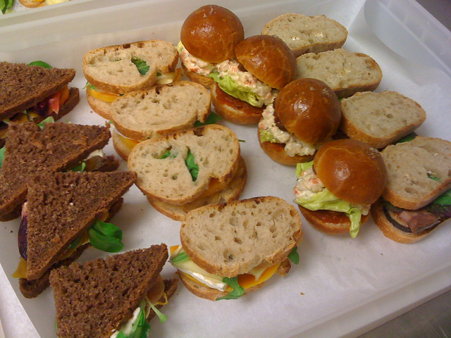
A SPECIAL LUNCH
Wednesday, 19th February 2020 at
ST. ALBAN’S
This Photo by Unknown Author is licensed under CC BY-NC-ND
We will be welcoming guests from the country town of Gloucester. This is an exceptional chance to meet some “country cousins” find out just how the drought, fires, etc. are effecting them.
This group is arriving in a mini-bus and we anticipate a great reception from our parishioners.
Our book shop will be opening longer hours for our visitors, and there will be a trading table. The food will be served at midday on the dot. And for this particular lunch, numbers will be necessary. A list in St. Alban’s hall, and Helen Barber is asking that payment be made in advance and she is happy to collect $10.pp either this Sunday or next.

OUR MISSION FOCUS FOR FEBRUARY IS CHURCH MISSIONARY SOCIETY

The Church Missionary Society (CMS) is led by Peter Rodgers as International Director. He works with our Regional Mission Directors for the placement and care of CMS missionaries on location, as well as overseeing the development of relationships with our interntional mission partners around the world, and the day-to-day work of the CMS Australia office.
What can we do? PRAY and as we pray for CMS this week we ask that you pray especially for David & Elizabeth, Derk & Susan, Judy Gerber @ Katmandu and Pakistan.
GIVE – as you walk into St. Alban’s you will see a mission box to place your gift in OR you can to use the “mission” side of your envelope.

Items for the Parish News for February to Lyn Davies via phone 0491 136 455, text or call. Email: clivelyn46@gmail.com by noon Wednesday, thanks.

