PENTECOST 16 – HE HAS DONE EVERTHING WELL!!
9TH SEPTEMBER, 2018.

So speak and so act as those who are to be judged by
the law of liberty. James 2:¹³

OUR PARISH VISION –
“We will connect meaningfully with our community in order to inspire hope
and transformed lives through faith in Jesus.”

Let’s celebrate with
ST. JOHN’S LADIES GUILD, DYERS CROSSING
In the Nabiac Agricultural Hall, NABIAC
Friday, 28th September, 2018 – 11.15am
For their
ANNUAL SPRING LUNCHEON & FASHION PARADE
From Margo’s Boutique, Taree.
Delicious lunch, tea & coffee. Trading table.
$20.00 per person
RSVP before 24th Sept. Helen 6550 2383, Moya 6559 1265, Aileen 6559 1541

This Photo by Unknown Author is licensed under CC BY-NC-SA
OUR MISSION FOCUS FOR SEPTEMBER –
BCA -BUSH CHURCH AID – Reaching Australia for Christ since 1919 – Going the distance by bringing the gospel of Christ to the outermost parts of Australia.
September is “BCA Box opening month” – please send your boxes to Suellen Belton via your church “boxes”.

PARISH OFFETORY ENVELOPES - are now available at all centres.

UPCOMING EVENTS-
Tuesday, 11th September – Parish Council Meeting, 4pm St. Alban’s
Wednesday, 12th September – Mini lunch, St. Alban’s
Wednesday, 19th September – Service at Baptist Care, Forster, 11am
Friday, 28th September – Annual Fashion Parade, Dyer’s Crossing.
Sunday, 30th September – 5th Sunday, Parish Service 9.30am St. Alban’s,
Followed by our Parish Luncheon at Club Forster.
Saturday, 20th October – Parish Fete at St. Alban’s.

SEPTEMBER THOUGHTS FOR THE SAMARITANS –

Spring has sprung!! It will soon be much warmer and salad time - how about we try salad veggies – pineapple, beetroot, corn – all types of food that you use to make a salad – even some mayonnaise – so many different varieties available. See what you can find – your donations are always very much appreciated, and it’s great to see such a variation in the donations – well done!
.
OUR PARISH LUNCHEON –

From Suellen – Our Luncheon is being held at Club Forster on Sunday, 30th September – a fifth Sunday – one parish service at 9.30am at St. Alban’s – then just down the road to Club Forster.
The cost is $26.00 and from today Suellen will be taking names and cash at Forster, Pat Sanderson is the one to talk to at Tuncurry and Helen Martin will be looking after Nabiac and Dyer’s Crossing.

THE PARISH FETE – DOLLIES AND TEDDIES – TOYS –

If you have much loved dolls or teddies to donate – Beth Board would love to hear from you. 6555 8753. Check out your cupboards for toys – building blocks soft toys, balls – Enid Ellison is the contact 0428 545 659.
AS WE WORSHIP OUR GOD WE INCLUDE IN OUR PRAYERS THIS WEEK:

Bishop Peter’s Prayer and our prayer for a Families Minister.
Bishop Peter & Nicki
Asst. Bishop Charlie Murry & Melissa
Asst. Bishop Sonia Roulston
All who are suffering as a result of the drought.
Thanks for the water in drops falling from the sky to the earth.

MEMBERS OF OUR CHURCH COMMUNITY WITH ONGOING NEEDS –

Hugo Walmsley, Alan Winston, Rosalyn Ferris, Ella Engel, Jenny Lawson, Maureen Armstrong, George Hodgson, Louise, Dianne Hardin, Keith Roach, Helen Cole, Paul McIntosh, Michelle, Max Kennedy.
If you would like to add someone to the Parish Prayer list, be sure to obtain permission from the person concerned and then contact the Parish Office.

MISSION GIVING –

A report from Phillip Castle (from envelopes and boxes) between 1st January, 2018 – 31st July, 2018 –
Liz Burns $1,176 (target for the year $2,500, Samaritans $308, ABM $480, BCA $915, Bible Society $332, African Aid Abroad $52, Christmas Bowl $380, World Vision $10, Scripture Union $5.
No monies were received for – Seafarers or Church Army.

SPRING PROGRAM, 2018 –

Now available at all centers – if extra copies are needed please contact the church office.

AN UPDATE FROM JOSE VERGARA – Praise and Prayer Points.

Pastoral Care & SRE (Scripture) in the local High Schools. Copies are available to take with you. Heather Webster is our parish contact.

GOLDEN PONDS RETIREMENT VILLAGE –

On Wednesday, 26th September, at 10am. Rev Mark will be our guest preacher – so all of us that live at GP will be there to support Mark.
ST. JAMES, BUNGWAHL –
A 10% deposit has been taken for the sale of the church. There are eight lamps with sconces for sale @ $100. each, and 13 pews @ $200. each. Speak to Mark
or Clive.

1 JOHN 4:⁴ – You, dear children, are from God and have overcome them, because the one who is in you is greater than the one who is in the world.

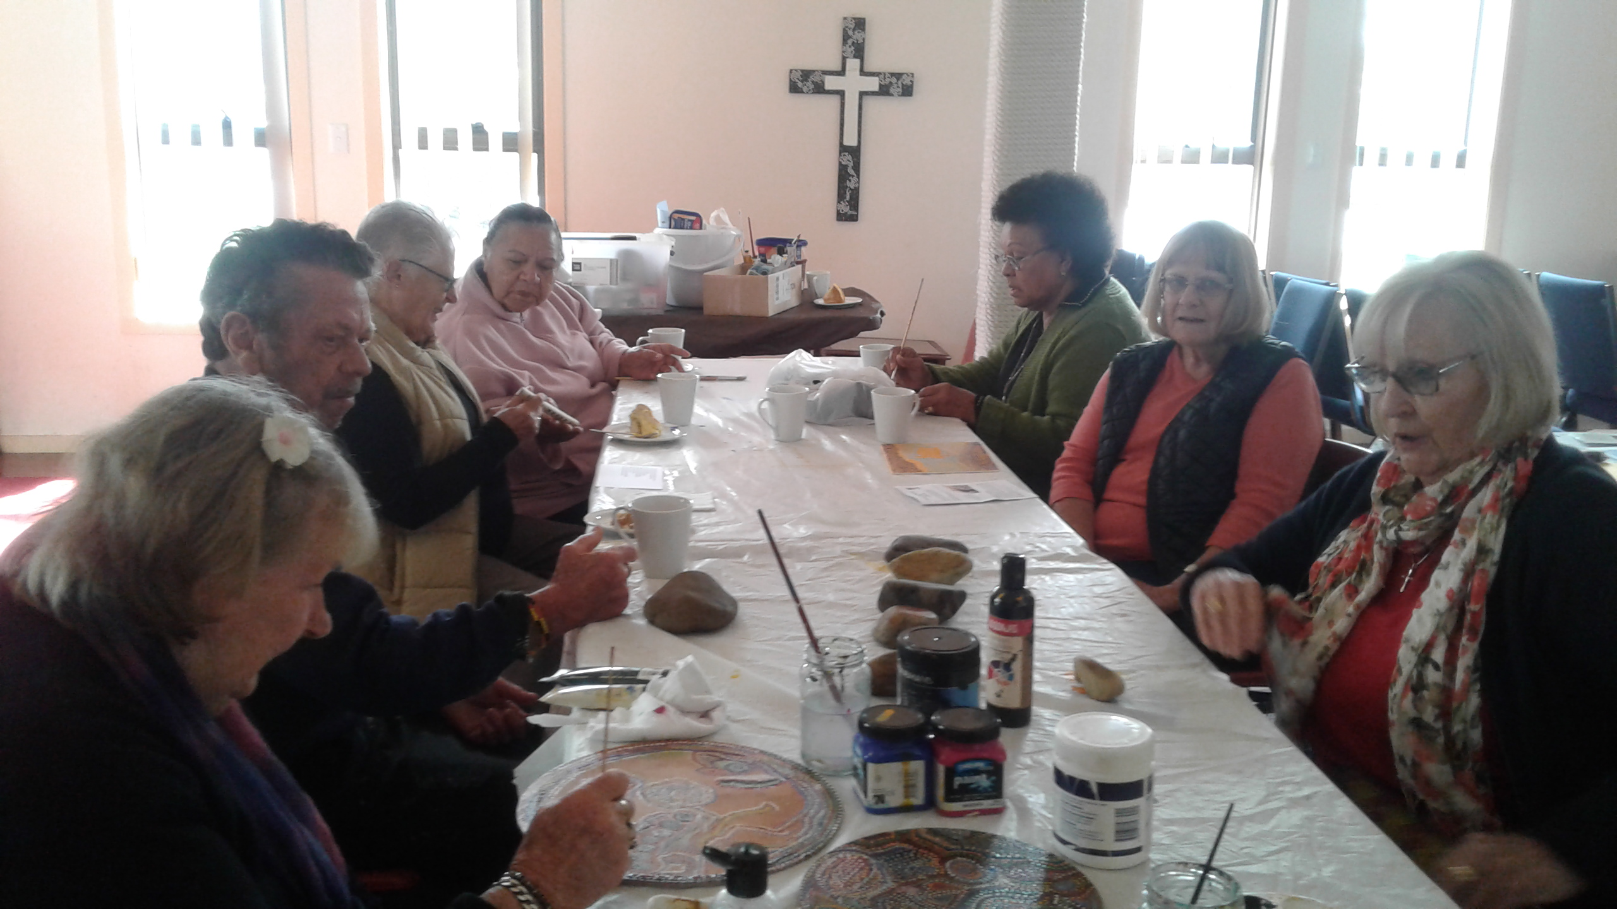

CULTURE AND CHRIST – a very productive group enjoying their craft – held every Monday 9.30am till 11.30am. Contact Rev Helen Quinn for more info.

CONTACT DETAILS
Senior Minister/Rector: Rev’d Mark Harris 0425 265 547
revmarkharris@icloud.com
Priest in Local Mission: Rev Helen Quinn 0427 592 723
Parish Office: St. Alban’s Anglican Church: 5543 7683
info@forsteranglican.com
Parish Secretary: Judy Hall 0400 890 728
Op Shop: Head St Car park 6555 4267
Book Shop: bookshop@forsteranglican.com 5543 7683
Parish Website: www.forsteranglican.com
Fb: Anglican Parish of Forster-Tuncurry.
Items for Parish News: Phone Lyn Davies 0491 136 455 or text, email clivelyn46@gmail.com, or Parish Office 5543 7683 by noon Wed, thanks.
Our bank details: BSB 705077 Account 000400710
Account name: Anglican Parish of Forster/Tuncurry

