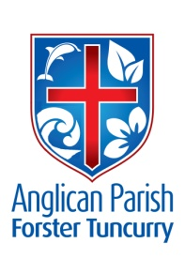
ADVENT 2 – PREPARING THE WAY 1
9th DECEMBER, 2018.

By the tender mercy of our God, the dawn from on high will break upon us, to give light to those who sit in darkness and in the shadow of death, to guide our feet into the way of peace. Luke 1.⁷⁸⁻⁷⁹

OUR PARISH VISION:
We will connect meaningfully with our community in order to inspire hope and transformed lives through faith in Jesus.

OUR MISSION FOCUS FOR DECEMBER IS THE CHRISTMAS BOWL.

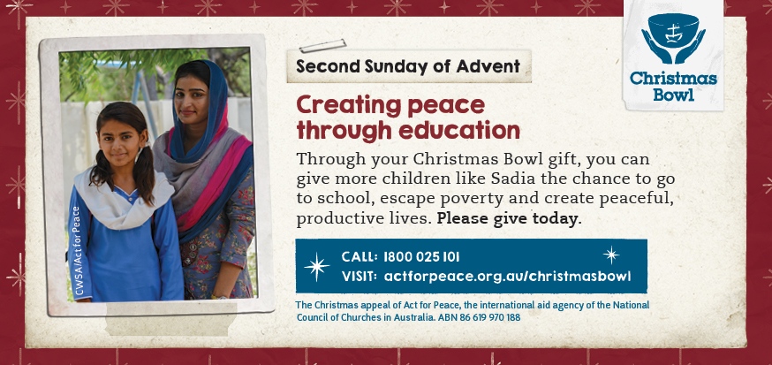

Jesus tells us that to live our faith; we must actively work to spread peace across the Earth. In war-torn Pakistan, building a just, peaceful society starts with breaking down the barriers to education. Through your Christmas Bowl gifts, you can give children like Sadia the chance to go to school, escape poverty and create peaceful, productive lives.

NEXT SUNDAY, 16th DECEMBER, BISHOP PETER WILL BE VISITING THE PARISH. THERE WILL BE ONLY ONE COMBINED SERVICE HELD AT ST. ALBAN’S FORSTER AT 9.30 am
5th SUNDAY IN DECEMBER
Sunday, 30th December, there will be only one combined parish service at St. Nicholas’, Tuncurry, 9.30am.

ADVENT IN AUSTRALIA (An Advent Reflection) Anglican Overseas Aid.
Pray: Ask God to lift our vision of Christmas above the tree and the tinsel
- Would you be able to see the star today? Does the ‘noise’ surrounding our urban lives compete with God’s message for us?
- Do you consider that love is the ultimate driving force of the universe?
- Can you see the love of Jesus in your local neighbourhood? How and where?

MEMBERS OF OUR CHURCH COMMUNITY AND FRIENDS WITH ONGOING NEEDS
Ella Engel, Jenny Lawson, Maureen Armstrong, George Hodgson, Louise, Keith Roach, Michelle, Max Kennedy, Beryl Allen, Nadia Maybury, Sue Hollis, Lyn Thompson, Marion & Peter Roberts, Allan Peel.
We commend to God’s keeping those who have recently died, Lesley Peel, and we pray for those who mourn her passing.
We remember with thanks those whom we have loved whose anniversary occurs at this time, Harry Underwood, Colin Ellison, Trevor Humphries.

DECEMBER MINI LUNCH
This Wednesday, 12th December is our Christmas Mini Lunch, 11.30am for 12 noon, $8.00 each for a delicious two course meal, plus tea or coffee. The Trading Table will be offering all types of yummies, plus – hmm – maybe when you come along to the luncheon you will see for yourself!! Need more info? Wilma 6554 8163, Helen B. 0419 996 594.

RUG RATS
The Craft Group will be in recess till early February, 2019.

SERVICE TIMES FOR 2019
As of the first Sunday in 2019 (6th January) service times will change. They will be as follows:
- St. Alban’s 8.30am, 10am and 5.30pm
- St. Paul’s & St. John’s 10am

OUR SPECIAL PRAYER FOR A FAMILIES MINISTER
Loving and Generous God:
We bring before you all who minister in your name in this parish and we pray for the need for a Families’ Minister. Please give wisdom and guidance on the raising of finance to support this outreach. May we approach this with the generosity of Spirit you show us. Give to those who will be tasked with this selection, courage, guidance, sensitivity and discernment in the implementation of this ministry initiative. We ask these things through your Son our Saviour, Jesus Christ our Lord. Amen.

A THOUGHT
What is the BEST thing that can happen if I DO this?
What is the WORST thing that can happen if I DO this?
What is the BEST thing that can happen if I DON’T do it?
What is the WORST thing that can happen if I DON’T do it?

CHRISTMAS CAROL SERVICES
Monday, December 24th 5.30pm BBQ, followed by 6pm All Age Carol Service. 11pm Traditional Communion Service, St. Alban’s.
7pm Traditional Carol Service, St. Paul’s, Nabiac.
Tuesday, December 25th 9am All Age Communion Service, St. Alban’s.
9.30am Traditional Communion Service, St. Nicholas.

KULAROO BAPTIST CARE
This Tuesday, 11th December, 7pm, Carols by Candlelight. The Salvation Army Band will be playing and there’s a Sausage Sizzle, sweet treats, etc. You are asked to bring a chair.
Wednesday, 19th, our Chapel Service will be held at 11am.
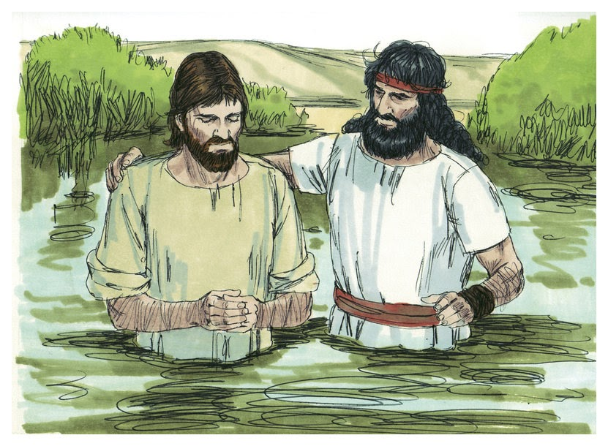

SAMARITANS DONATIONS
Thoughts for December – holiday food – popcorn, chips, biscuits, jelly, topping, tins of fruit, long life custard, or what is YOUR favourite holiday food? Once again, our collection has been graciously picked up to be made ready for distribution for those in need in our area. The group is always so thankful for our ongoing support.

THE ENCOUNTER, DECEMBER/JANUARY
A “New Look” Encounter Magazine is to be published quarterly from 2019, focusing on the key seasons of the Anglican Diocese of Newcastle. December/January issue now available in all churches.

Senior Minister/Rector: Rev’d Mark Harris 0425 265 547
revmarkharris@icloud.com
Priest in Local Mission: Rev Helen Quinn 0427 592 723
Parish Office: St. Alban’s Anglican Church: 5543 7683
info@forsteranglican.com
Parish Secretary: Judy Hall 0400 890 728
Op Shop: Head St Car park 6555 4267
Book Shop: bookshop@forsteranglican.com 5543 7683
Parish Website: www.forsteranglican.com
Fb: Anglican Parish of Forster-Tuncurry.
Items for Parish News: Lyn Davies 0491 136 455. Parish Office 5543 7683 by noon Wed, Thanks.
Our bank details: BSB 705077 Account 000400710
Account name: Anglican Parish of Forster/Tuncurry

