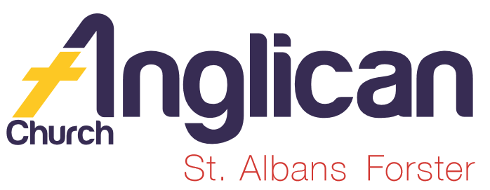
PARISH NEWSHEET

FORSTER & NABIAC 10th November, 2019

PENTECOST 22 – WHAT TO PRAY FOR

“Finally, brothers and sisters, pray for us,so that the word of the Lord may spread rapidly and be glorified everywhere, just as it is among you.” 2 Thess. 3:1a

SAMARITANS DONATIONS FOR NOVEMBER
We’ll continue with donations of Christmas food. Gifts for the family, especially the children, would be much appreciated. The gifts are to be left unwrapped, this assists the Samaritans with their distribution – of course you could always supply Christmas paper, etc.

OUR BOOKSHOP
As mentioned last week, we have an amazing selection of Christmas cards – BUT – thinking of donations to the Samaritans – CD’s, pens, bookmarks, journals, shopping bags, coffee mugs and an impressive selection of books for children at very reasonable prices – worth checking…
BUNNINGS BBQ FOR TODDLERTIME
Saturday, 7th December, there’s a worksheet in the parish hall. Always keen to have new parishioners help out! If you’re unsure of just what’s involved ask one of the regulars – Clive, Dawn, Heather D. & Heather M, Paul, Rosa, Coralie, Kathleen and no doubt others that I can’t think of at the moment. Just 2 hour shifts, not too challenging.

OUR LEADERSHIP TEAM
Senior Minister: Rev. Mark Harris 0425 265 547
Families Minister: Rev. James Brooks 0411 335 087
Priest in Local Mission:Rev.Helen Quinn 0427 592 723

CONNECT WITH US
FACEBOOK ………………… Forster Anglican Church Community
PARISH WEBSITE………… www.forsteranglican.com
CHURCH OFFICE ………… info@forsteranglican.com 5543 7683

PRAYERS FOR THE SICK AND RECOVERING
Ella E, Jenny L, Keith R, Lyn T,Marion & Peter R, Michelle, Rachael,Max S.

PRAYERS FOR THE ARNETT FAMILY
Peter passed away peacefully, Tuesday 6th, in Forster Private Hospital. The funeral was last Friday. Peter will be sadly missed by his fellow parishioners.

ANNIVERSARIES OF LOVED ONES FOR NOVEMBER
Bill Coleman, Campbell Belton, Kenneth McGovern, William Newman.

Items for the Parish News till the end of 2019 to Lyn Davies via phone
0491 136 455, text or call. Email: clivelyn46@gmail.com by 12noon Wednesday, thanks.
DIRECT DEBIT GIVING the account name is: Anglican Parish of Forster/Tuncurry, BSB:705077, Account:000400710.
“for God loves a cheerful giver.” 2 Cor. 9:7b.

PRAYER No. 434 Connects with “BLESSED BE YOUR NAME”
(M. Redman)

In the best of times and in the worst of times,
Lord, we still make that choice to bless your name,
to worship you,
Because, whatever is going on in our lives, you are still
worthy of our worship.
We will praise you when things go well,
We will remember your goodness to us.
Then, when suffering comes, we will not forget who you are.
Even when it hurts to say anything at all,
In our darkest hour, we will still find strength to say:
“My Saviour lives.”

TODDLER TIME
Last Monday, 4th, yet another birthday for one of our toddlers and there were 34 toddlers!! A wonderful connection, fabulous noise and the little people have so much energy – give me some!

SALVATION ARMY : MY CALLING DAY
Last Tuesday, 5th, three parishioners went along and joined in worship and met the new Officer, Paula Glover, delightful spirit filled, she spoke from her heart. An uplifting morning.
Paula chose as her theme for the morning -
“Taste and see that the Lord is good…” Psalm 34:8.
PARISH LUNCH
A great occasion – thanks to Suellen’s hard work beforehand, and entertainment on the day. Always love the “flee” “flea”!!
Great chatter, catching up with friends we don’t see so often. We were encouraged to talk about what has happened in our parish over the past twelve months and to give thanks to our Leadership Team for their joint efforts.
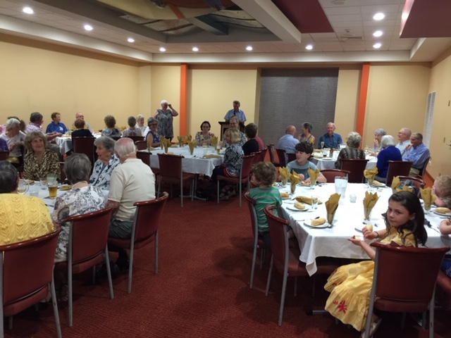

DYERS CROSSING CHURCH
The church is being auctioned, on site, next Saturday, 16th November @ 10am.

OUR PARISH VISION
Connecting Meaningfully. Inspiring Hope. Transforming
Lives. Through faith in JESUS.

