LENT 1 – JESUS TEMPTED
10TH MARCH, 2019.

Worship the Lord your God, and serve only him. Luke 4.⁸

ISRAELI LUNCHEON, TODAY
Rev’d Mark and Trisha, Judy Hall, Patricia & Binny Dastidar will be speaking to us about their trip to Israel and we’ll have a chance to view their photos. A typical Israeli luncheon will be served $15.00 each.

COMBINED PARISH SERVICE 9.30am FORSTER – next Sunday 17th
As we gather to-gether as a parish family let us give thanks to God for prayers answered as we continue to have faith in Jesus and connect meaningfully to inspire hope and transformed lives.
ANNUAL GENERAL MEETING will follow morning tea.

SUNDAY, 31ST MARCH
This Sunday will be normal times and places as we are holding our combined parish worship on the 17th March.

SEDER MEAL
Thursday 18th April, a Passover Meal on the eve of Good Friday, mark the date, details soonish.

MEMBERS OF OUR CHURCH COMMUNITY AND FRIENDS WITH ONGOING NEEDS
Ella Engel, Jenny Lawson, George Hodgson, Keith Roach, Michelle, Nadia Maybury, Lyn Thompson, Marion & Peter Roberts, Isabel McBride, Margaret Burrows.
We commend to God’s keeping those who have recently died, and we pray for those who mourn their passing.
We remember with thanks those whom we have loved whose anniversary occurs at this time Nellie Avery, Gwenda Kidd.
OUR MISSION FOCUS FOR MARCH IS BCA

Bush Church Aid
Bush Church Aid has a heart for people living in remote and regional Australia. Pray for our Field Staff as they serve their communities and reach Australia for Christ.

During the month of March Suellen counts the monies that you have collected in your BCA boxes, so bring them in this month and keep Suellen busy. Mission box always available for extra monies.

Monday 11th – Katherine, Kristan & Kathryn Slack & family
Tuesday 12th – Kangaroo Island, Brad & Joh Henley & family
Wednesday 13th – Roxby Downs, Glen & Beth McDonald & family
Thursday 14th – Sunraysia South, Dale & Rachel Barclay & family
Friday 15th – Strathfieldsay, Steve & Vanessa Weickhardt
Saturday 16th – King Island, Chris & Wendy Thiele

OP SHOP – WE NEED LOTS MORE GEAR
All manner of things, clothing, kitchenware, towels, sheets, books, craft gear, puzzles, games to mention just a few. Thanks for the gear so far received, please keep it coming in.

SAMARITANS DONATIONS
For the month of March we are suggesting TOILETRIES all sorts of gear that you use in the bathroom – for the whole family – from babies to adults. It’s been great to see donations coming in that have absolutely nothing to do with the suggested items – that’s the idea – just whatever you think or know would be helpful for those in need. Well done!

BUNNINGS BBQ
Saturday, 30th March, mark the date, lists in a couple of weeks. Dates for the following two bbqs Saturday, 25th May and Saturday 13th July.

REV’D JAMES BROOKS
Will be visiting St. Paul’s, Nabiac for the 10am service on Sunday, 24th March.

SOMETHING SPECIAL CHRISTIAN BOOKSHOP
Take a look at all the stock for this season of Lent. Then easter cards are in stock and interesting and challenging works on the Easter story. Also children’s books to delight the youngsters and massive display of second hand gear at very low prices.

PRAYER FOR THE END OF THE DAY
Lord God,
Thank you for seeing me through this day.
Thank you for the chance to rest now –
Body and soul.
You have been with me, alongside me, even working through me;
You have guided and watched over me,
Forgivie me for when my faith has been weak today.
Forgive me for the things I have done wrong today.
And give me the strength to forgive those who have wronged me
Now Lord, I pray you would give me deep and restful sleep,
And protect me and all those who I love
May I rise again tomorrow to serve you once more,
But until then, I will end this day by saying:
God – your holy name be praised.

Based on a prayer by Dietrich Bonhoeffer (1906-45)
Prayer No. 115 – “500 Prayers for Young People” by Martin Saunders.

1 PETER 1^{3,4}
Praise be to the God and Father of our Lord Jesus Christ! In his great mercy he has given us new birth into a living hope through the resurrection of Jesus Christ from the dead, and into an inheritance that can never perish, spoil or fade – kept in heaven for you,
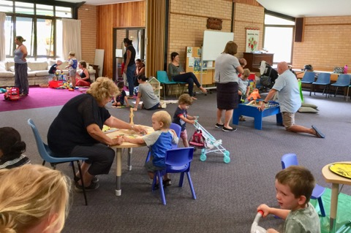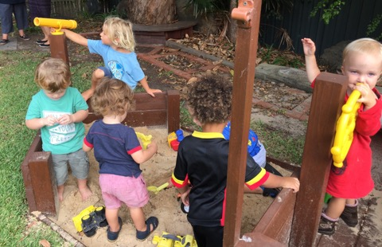

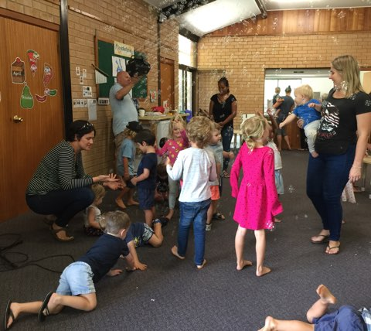
TODDLER TIME -
The toddlers have a fabulous time each Monday for two hours, 9.30-11.30am,
So much energy and enthusiasm and they enjoy their craft and delight in taking it home.
Fabulous outdoor equipment.

Senior Minister/Rector: Rev’d Mark Harris 0425 265 547
revmarkharris@icloud.com
Family’s Minister: Rev’d James Brooks 0411 335 087
jamesknac@gmail.com
Priest in Local Mission: Rev Helen Quinn 0427 592 723
rqu783662@bigpond.com
Parish Office: St. Alban’s Anglican Church: 5543 7683
info@forsteranglican.com
Parish Secretary: Judy Hall 0400 890 728
Op Shop: Head St Car park 6555 4267
Book Shop: bookshop@forsteranglican.com 5543 7683
Parish Website: www.forsteranglican.com
Fb: Anglican Parish of Forster-Tuncurry.
Items for Parish News: Lyn Davies 0491 136 455 or Parish Office 5543 7683 by noon Wed, Thanks.

Opportunity To Give
For direct credit offertories:
BSB: 705077 Account: 000400710
Account name: Anglican Parish of Forster/Tuncurry

