PENTECOST 25 – DO NOT WORRY
11th NOVEMBER, 2018.

Give and it will be given to you. A good measure, pressed down, shaken together, running over, will be put into your lap; for the measure you give will be the measure you get back. Luke 6.38

OUR PARISH VISION:
“We will connect meaningfully with our community in order to inspire hope and transformed lives through faith in Jesus.”

OUR MISSION FOCUS FOR NOVEMBER is ABM – Anglican Board of Mission, working for Love, Hope & Justice.
BCA box opening in September. On behalf of the Bush Church Aid Society “THANK YOU” an amount of $906.80 will be forwarded to the society. Suellen

A PRAYER FOR REMEMBERANCE DAY
Eternal God, the only source of peace, we pray for all who serve in the Defence and Police Forces in this land. Give them courage and comfort in danger, patience in waiting, and discipline in the just use of force. Help us to seek for all people the freedom to serve you and each other in compassion and peace. We ask this through Jesus Christ our Lord. Amen.

CHRISTMAS DINNER
The Combined Churches of Forster Tuncurry invite you to their Annual Christmas Dinner, 6pm Friday, 7th December at the Forster Bowling Club. Tickets: Adults $20, Kids $10. (Drinks not included). The evening will include an opportunity to give towards SIFT (scripture in our high schools). Colourful posters in all churches with extra information. Tickets available in our Book Shop.
MEMBERS OF OUR CHURCH COMMUNITY WITH ONGOING NEEDS
Ella Engel, Jenny Lawson, Maureen Armstrong, George Hodgson, Louise, Keith Roach, Michelle, Max Kennedy and Beryl Allen.

If you would like to add someone to the Parish Prayer list, be sure to obtain permission from the person concerned and then contact the Parish Office.

We commend to God’s keeping those who have recently died and we pray for those who mourn their passing.
We remember with thanks those whom we have loved whose anniversary occurs at this time, Kenneth McGovern.

BUNNINGS BBQ for TODDLERTIME
Saturday, 17th November is the date, a sign on sheet is at St. Alban’s BUT please phone the office if you are able to help. It would be great to have different helpers for this community event. Thanks for the quick response, we are still in need of two more helpers, cashier & drinks for the 8.30am-11am and 1pm-finish.

THOUGHTS ON SAMARITAN DONATIONS FOR OCTOBER AND NOVEMBER
During the next two months we are asking for CHRISTMAS FARE, from food to gifts for the whole family. The gifts do not require wrapping as the Samaritans find it more helpful to actually see the items before distribution.

Day to day items are always appreciated from tea, coffee, milk, sugar, toothpaste, soap the list is endless. Check out the half price specials!
Wonderful donations coming in, all manner of thoughtful things, well done!

EVENING BYO PICNIC IN THE PARK
Tuesday, 20th November, 5.30pm, John Wright Park, Tuncurry. The idea is to bring your own picnic or buy Sausage Sangers from the Salvation Army Food Waggon. There will be games for kids and Live Music from 6.30pm “The Southern Cross Vocal Band”. Posters in all churches.
SING THE JOY OF CHRISTMAS
Manning Valley Choral Society is presenting a Choral Prelude to Christmas. 7.00pm Saturday, 1st December at St. Alban’s Church, Forster. Tickets $20.00 and are available at the door and Dan’s Ladies Wear, Taree.

WHAT’S HAPPENING AT RUG RATS?
The group’s new project is a knitting project to support Australia’s Biggest White Ribbon for Victims of Domestic and Family Violence. This particular initiative has been launched by the Manning Great Lakes Police District. Like more info – speak to Coralie, or google.

Tuesday morning is an inspiring morning at St. Alban’s, knitting and crocheting group – the Bookshop is open, the Gardeners are there, counters are counting money, morning tea is available if you’d like to just sit with a friend and relax for a while, or speak to God, through Jesus.

A NOTE FROM THE OP SHOP
There will be a meeting for all Op Shop helpers this Wednesday, 14th November, 4.00pm at St. Alban’s. Please come along have a cup of tea and bring all your comments and concerns. Thanks, Janet.

HAPPENINGS
Wednesday, 14th – Mini Lunch, St. Alban’s, 11.30am for 12 noon.
Saturday, 17th – Bunnings BBQ for Toddler Time

Senior Minister/Rector: Rev’d Mark Harris annual leave
revmarkharris@icloud.com
Priest in Local Mission: Rev Helen Quinn 0427 592 723
Parish Office: St. Alban’s Anglican Church: 5543 7683
info@forsteranglican.com
Parish Secretary: Judy Hall 0400 890 728
Op Shop: Head St Car park 6555 4267
Book Shop: bookshop@forsteranglican.com 5543 7683
Parish Website: www.forsteranglican.com
Fb: Anglican Parish of Forster-Tuncurry.
Items for Parish News: Lyn Davies 0491 136 455. Parish Office 5543 7683 by noon Wed.
Our bank details: BSB 705077 Account 000400710
Account name: Anglican Parish of Forster/Tuncurry
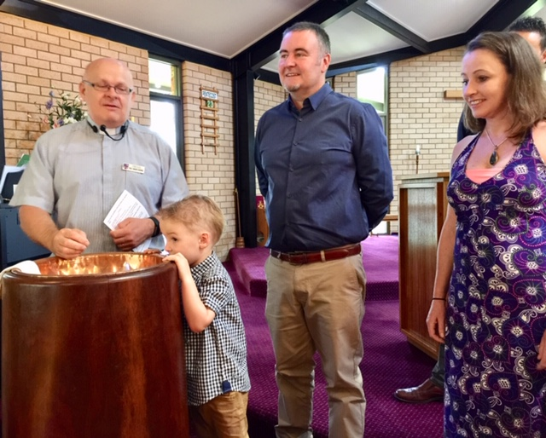

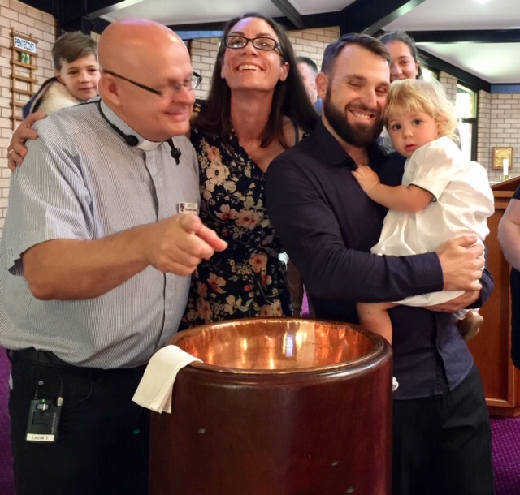

Beautiful family photos of William and Neive at their baptisms.

