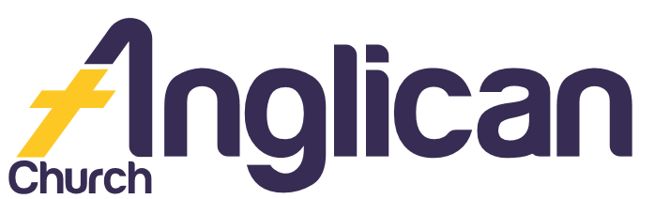
12th May 2019

PARISH NEWS
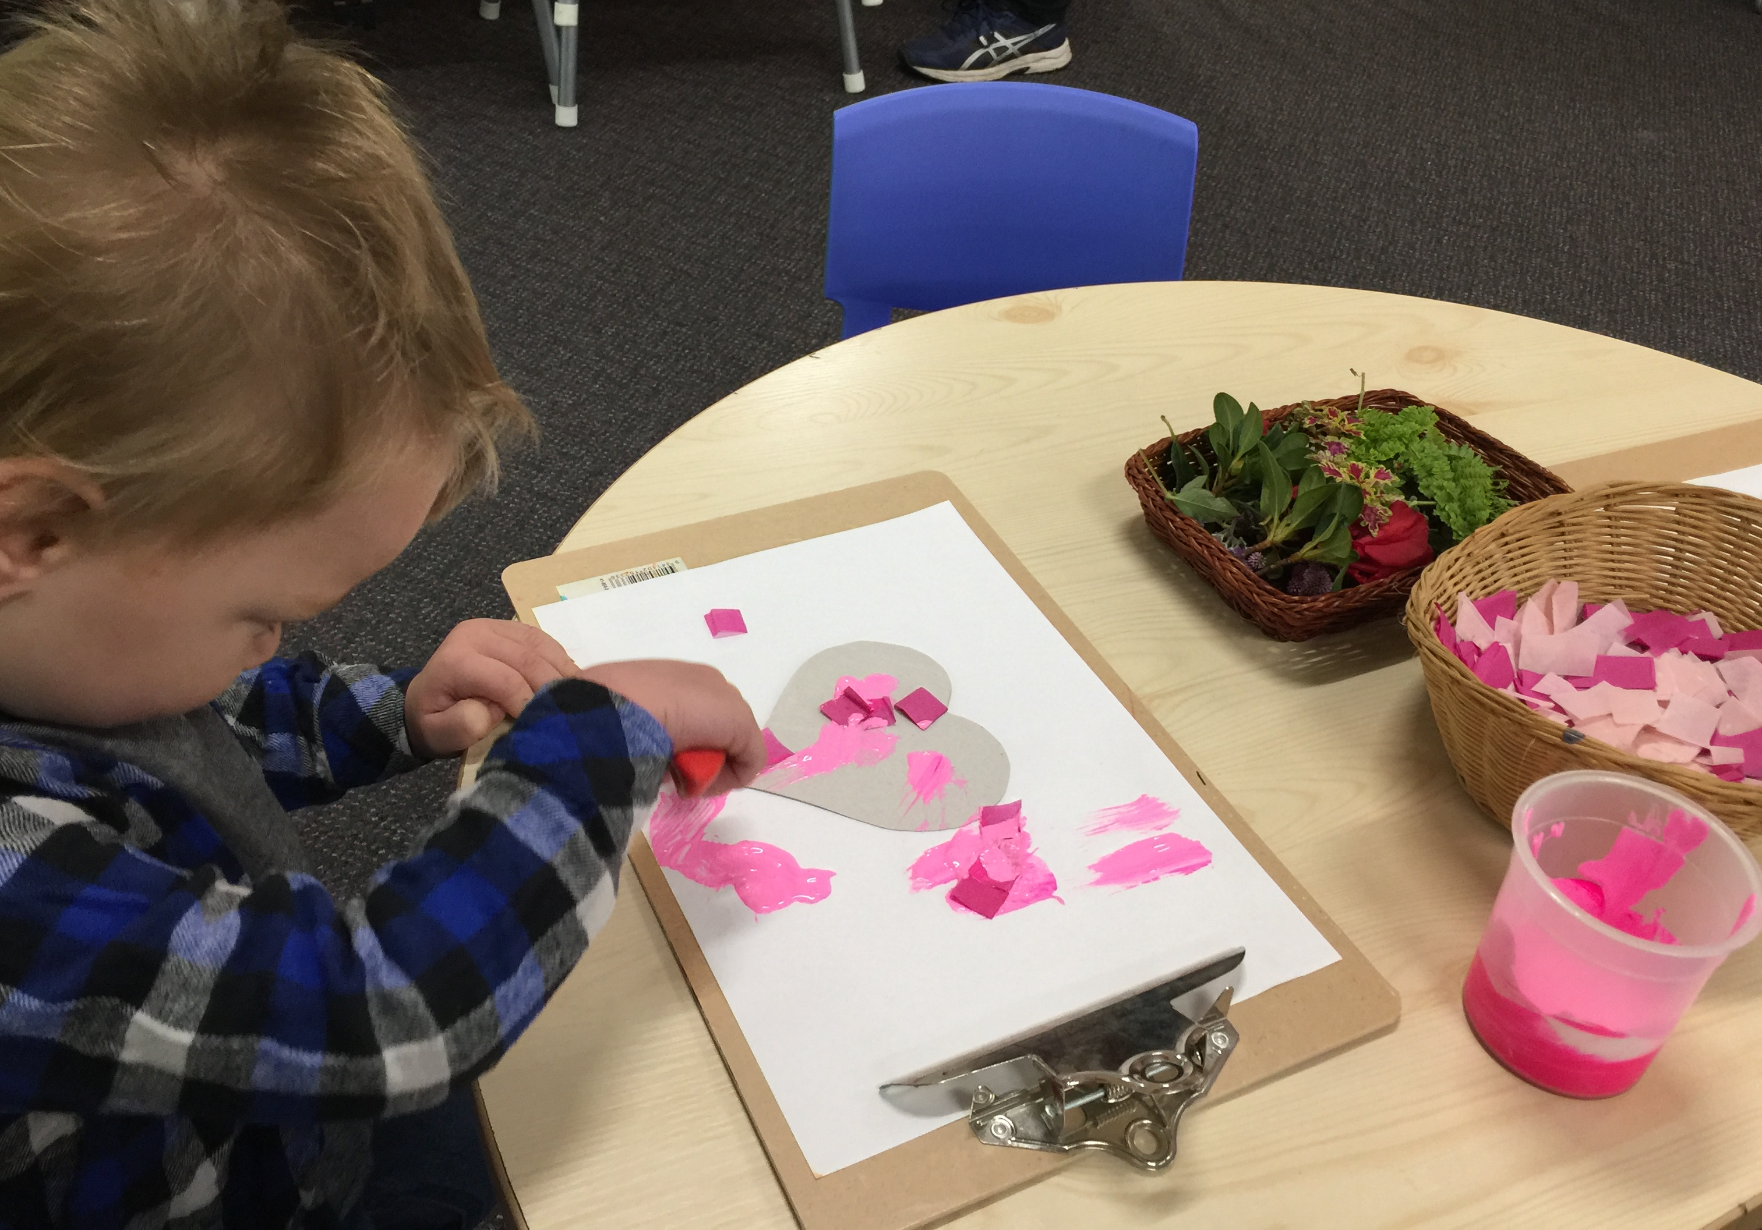
Happy Mothers Day 2019!

“I give them eternal life, and they will never perish.
No one will snatch them out of my hand”
John 10:28

Happy Mothers Day!
Happy Mothers Day to all our amazing Mummies, Mothers, Nans,

Grandmas, Nonnas, and Omas! We thank God for you and we love you!

Men’s Dinner Event
Join us on Tuesday 4 June for our next Men’s Dinner! Only $15 for a delicious meal! Come and hear Rev James share his life and faith journey. RSVP to Clive on 0412 653 061.

Seniors Events
Join us on Wednesday 5 June at 10am for a Cuppa and Chat in the Church Hall!
Come along on Wednesday 12 June at 11.30 for Light Lunch! Only $8.00!

BY HELEN B

Biggest Morning Tea!
We raised $1277.75 for cancer research! Our Friendship Group thanks you all for your generous support!

BY HELEN B

GLECCA
Join us on Saturday 18 May at 3pm at Forster Baptist Church for an afternoon of sacred music with the Sydney Male Voice Choir. All proceeds to support GLECCA!

Pray at all times
for: Ella E, Jenny L, George H, Keith R, Michelle, Nadia M, Lyn T, Marion & Peter R, Isabel M, Margaret B, and Laurie M.
Growth Groups
Come into our Great Lakes Christian Bookshop and get your “Full of Promise” Bible Guide today! Only $5.00!
Make a Difference
Donate to Samaritans now! Your shopping list for those doing it tough –
Wheat/rice crackers; Tinned soup; spaghetti; baked beans; pasta; juice, and Vegemite. Thank you!

New Books
Come into our Christian Bookshop today! Browse our inspirational new books and giftware!

Fundraiser
Join us on Saturday 25 May 8:30am - 4pm for our Bunnings BBQ fundraiser! All proceeds to ToddlerTime!

Shine Your Light
Join us in supporting the Church Missionary Society as they share God’s love globally. Your care, through prayer and/or financial support, is greatly appreciated!

BY SUELLEN B

Country Church
Join us at Dyers Crossing Church for worship services until the amazing renovation is completed at St Paul’s Nabiac!
BY KIT C

Volunteer Today

Op Shop………………….Heather D ……………………6555 4267

Book Shop……………….Phillip or Deb ………………..5543 7683
bookshop@forsteranglican.com

Items for Parish News……………trishaharris10@gmail.com
or Parish Office 5543 7683 by noon Wednesday
For Direct Debit Giving

Account name: Anglican Parish of Forster/Tuncurry
BSB: 705077 Account: 000400710

Thank You For Your Generous Hearts!

Connect With Us

Senior Minister……….. Rev Mark Harris …………0425 265 547
revmarkharris@icloud.com

Family Minister………. Rev James Brooks ………0411 335 087
jamesftac@gmail.com

Church Office………….Clive Davies ………….………5543 7683
info@forsteranglican.com

………………….Forster Anglican Church Community

Parish Website…………………….www.forsteranglican.com

