PARISH NEWS
PENTECOST 12- IMITATING GOD
12th AUGUST, 2018.

Be imitators of God, as beloved children, and live in love, as Christ loved us and gave himself up for us. Ephesians 5.¹⁻²

OUR PARISH VISION –
“We will connect meaningfully with our community in order to inspire hope and transformed lives through faith in Jesus.”

INFO FOR PARISH NEWS –
Please contact Janet Lawrence- 6554 5981, 0448 502 684 – email jan2max@bigpond.net.au for articles of “news” to appear in the PN for Sunday 19th and 26th August.

OUR MISSION FOCUS FOR AUGUST –
Anglican Board of Mission (ABM) – working for Love, Hope & Justice – is our central thought for mission this month. Mission boxes in all churches for your donations.

PARISH FETE -
Saturday, 20th October. Our fete meeting was well attended and achieved a good amount of discussion, decision etc. The next meeting will be held two weeks prior to the fete.
Time to start potting, sewing, gathering items for the white elephant stall, crafty items, all manner of interesting things. Check out the list of stall holders and assistants and see if you can help out.
There will be a number of parishioners helping an hour here and there to give relief – maybe you could go on that type of roster. See Trisha.

MEN’S DINNER –
35 men attended the dinner, five men coming for the first time. A night of fellowship, good food and an engaging speaker.

AS WE WORSHIP OUR GOD WE INCLUDE IN OUR PRAYERS THIS WEEK:
Bishop Peter’s Prayer
Prayer for a Families Minister
Bishop Peter & Nicki
Asst. Bishop Charlie Murry & Melissa
Asst. Bishop Sonia Roulston
Rev’d. Mark & Trisha
Rev’d. Helen & Dick
Indigenous sisters and brothers.

MEMBERS OF OUR CHURCH COMMUNITY WITH ONGOING NEEDS –
Hugo Walmsley, Elaine Latta, Alan Winston, Nina Learmond, Rosalyn Ferris, Ella Engel, Jenny Lawson, Maureen Armstrong, George Hodgson, Louise, Dianne Hardin, Wayne Thompson, Keith Roach, Helen Cole, Paul McIntosh, Michelle, Max Kennedy.
If you would like to add someone to the Parish Prayer list, be sure to obtain permission from the person concerned and then contact the Parish Office.

8am WELCOME ROSTER FOR ST. ALBAN’S –
Patricia Dastidar 0400 655 880 has asked if someone from the 8am traditional service at St. Alban’s would coordinate the roster.

DATES FOR YOUR DIARY –
17th August – SIFT- Trivia Night.
1st September – Safe Ministry Training – Les Forester – St. Alban’s.
28th September – Fashion Parade, Dyer’s Crossing,
30th September – Parish Luncheon.
20th October – Parish Fete, St. Alban’s.

FRIENDSHIP GROUP –
At our last meeting the group decided to send their morning tea coins to the Hay-Run – Kempsey Appeal. The first delivery of hay went to Attunga. We added personal donations and the sales of cooking, to friends.
If anyone is interested, perhaps we can do it all again. Everyone will be most welcome to our next morning tea and chatter on Wednesday, 5th September in St. Nicholas’ Church, Tuncurry, 9.30 for 10 .00am. Helen Barber.

SAMARITANS DONATIONS OF FOOD FOR AUGUST –
Cans fish – tuna, salmon, sardines – plus packets and bottles to make a complete meal with the tinned fish – protein rich. If the “fishy” idea isn’t your genre then check out the ½ price specials – any ideas that you have and know they will be helpful to those in need will be greatly appreciated.

SIFT TRIVIA NIGHT –
Friday, 17th August – tables of eight - $10.00pp – tickets available at our bookshop – BYO nibbles and drinks and gold coins for games and raffles. Auction of original artwork from locals. Marg Aldous is the contact 0447 670411. Monies raised to Scripture In Forster/Tuncurry.

ST. JOHN’S, DYER’S CROSSING –
This year the fashions will be from Margo’s, Centrepoint, Taree. Friday, 28th September is the date. Always a great day – details to come.

ENCOUNTER –
August/September issue out now – be sure to collect your copy. “The Voice of our youth” – articles include Hearing our Youth, Seasons of Change, Space for Children.
From Bishop Peter: “We have done important work but in the coming season of our Diocesan Life we need to build our capacity to hear and speak in our multiple voices.”

AGED CARE SERVICES –
A beautiful morning at Estia, Forster – first Wednesday of the month, 10.30am – we engaged eighteen participants in the service – they absolutely love the Lord and sing mightily and enjoy the visit.
Kularoo Gardens – Baptist Care – this Wednesday, 15th August, 11am. There is a need here for parishioners to come along and bring clients from their rooms to the service. Speak to Mark or Helen Q. if you feel called.

1 CORINTHIANS 13:4-8 –
“Love is patient; love is kind; love is not envious or boastful or arrogant or rude. It does not insist on its own way; it is not irritable or resentful; it does not rejoice in wrongdoing, but rejoices in the truth. It bears all things, believes all things, hopes all things, endures all things. Love never ends.

ST. ALBAN’S NEW KITCHEN –
Installation completed and all working well. It has been used successfully for Combined Morning Tea for the Parish, a Men’s Dinner and a Mini Lunch. Our thanks and appreciation must go to all who donated, installed, took time to explain points of interest and persevered – it has been well worth it.

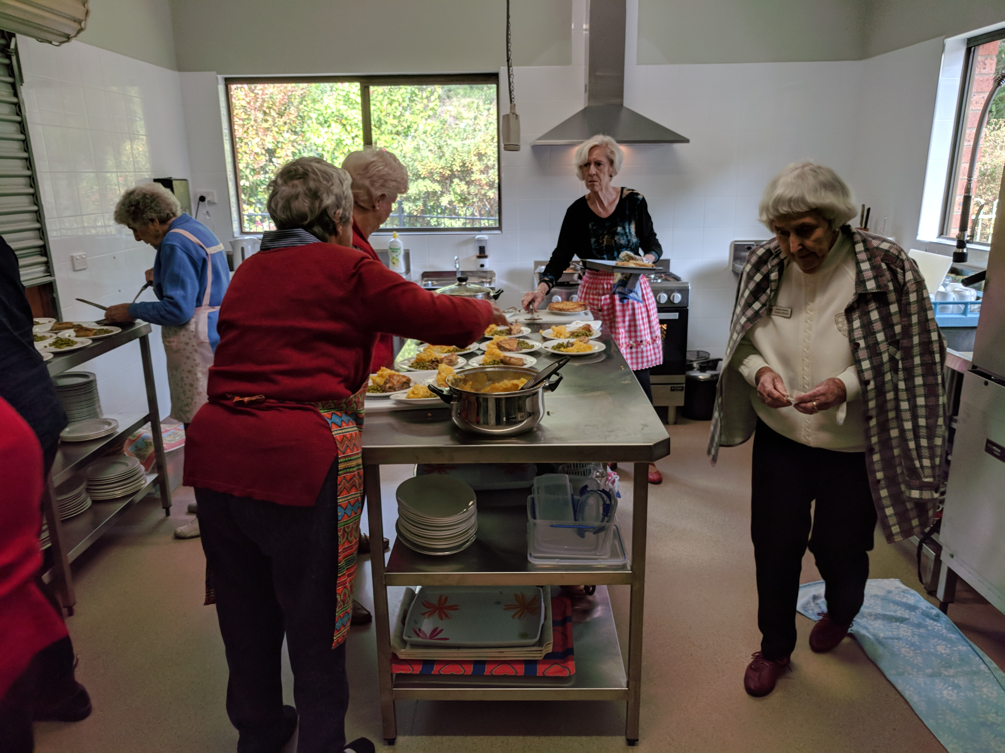
Mini lunch catering, Wednesday, 8th August.

CONTACT DETAILS
Senior Minister/Rector: Rev’d Mark Harris 0425 265 547
revmarkharris@icloud.com
Priest in Local Mission: Rev Helen Quinn 0427 592 723
Parish Office: St. Alban’s Anglican Church: 5543 7683
info@forsteranglican.com
Parish Secretary: Judy Hall 0400 890 728
Op Shop: Head St Car park 6555 4267
Book Shop: bookshop@forsteranglican.com 5543 7683
Parish Website: www.forsteranglican.com
Items for Parish News: Phone Janet Lawrence 0448 502684-phone or text. Email jan2max@bigpond.net.au. or Parish Office 5543 7683 by noon Wed, thanks.
Our bank details: BSB 705077 Account 000400710
Account name: Anglican Parish of Forster/Tuncurry

