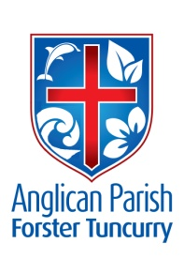
PARISH NEWS
EIGHTEENTH SUNDAY AFTER PENTECOST

13th October 2019

What shall I return to the Lord for all his bounty to me? I will lift up the cup of salvation and call on the name of the Lord, I will pay my vows to the Lord in the presence of all his people.
Psalm 116.12–14

MUSIC TO UPLIFT THE SPIRIT
The Silver Tones Singers (Manning Valley U3A) will present a charity concert of “Music to Uplift the Spirit”. All proceeds will go to local welfare programs delivered by Manning Uniting Church.
Venue: St Alban’s Church, Forster
Date: Sunday, 20th October
Time: 2.00pm
Cost: Adults $10, children $5. Tickets at door.

OUR NEW GROWTH GROUP
A new Growth Group has commenced on Monday evenings in the Parish Hall, 7.30pm. The group is off to a great start – if you’d like to join, make contact with Rev’d Mark. This group will continue through the school holidays.

SAMARITANS DONATIONS
Christmas is the theme for October – hams, puddings, jelly, custard, fruit salad, any types of Christmas goodies you can think of. We’ve also been asked for bathroom gear for the whole family. Lots of scope there!

PARISH LUNCH – Bookings close Sunday, 27th October. For details see inside.

MEMBERS OF OUR CHURCH COMMUNITY AND FRIENDS WITH ONGOING NEEDS
Ella E, Jenny L, Keith R, Lyn, Marion & Peter R, Michelle, Rachael, Peter A.
We remember particularly those whom we have loved whose anniversary occurs at this time: Will Buddery, Ray Handley, and Elsie Medway Dowes.

CMS – OUR MISSION FOR OCTOBER
The Church Missionary Society was founded in 1799 in England by a small group of Anglican evangelicals with a passion for worldwide gospel outreach. They included John Newton, who wrote Amazing Grace, and William Wilberforce, who was a leader in abolishing the slave trade in England.

MESSAGE FROM CORALIE
We have a surplus of champagne glasses, beer glasses, tea cups and white dinner plates. Samples of the above can be seen in the church hall. If you would like some, a small donation to the fete would be appreciated.
Thank you. Coralie.

PARISH LUNCH
Bookings are now being taken for the Parish Lunch on Sunday, 3rd November. At Forster, contact Suellen and at Nabiac the Warden or sidespersons.

VENUE: Club Forster

TIME: 12 for 12.30

COST: $26 Adult - $12 Child

Bookings will close on Sunday, 27th October.

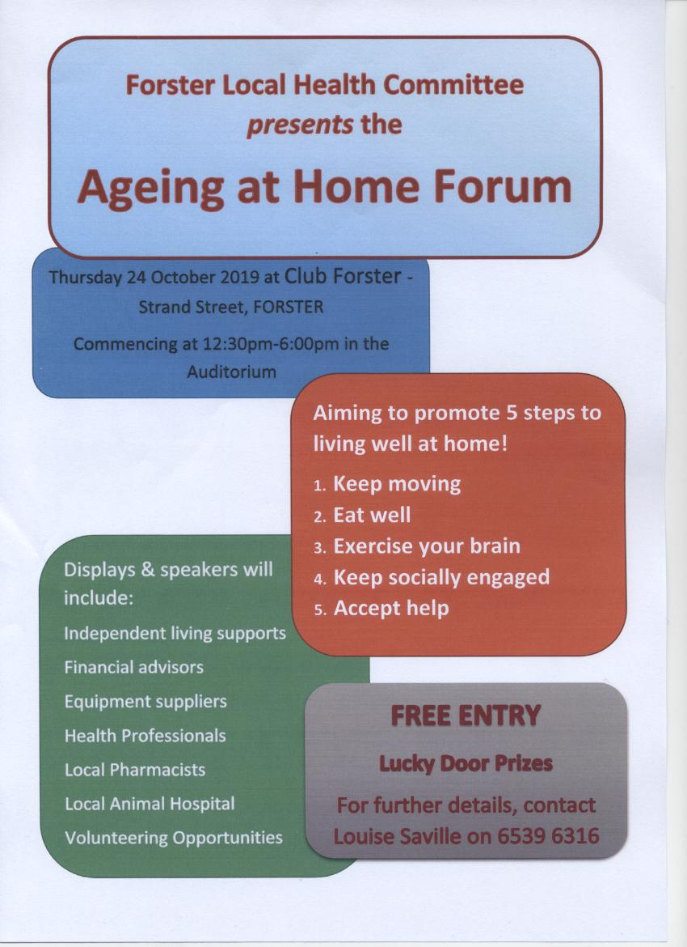
CONNECT WITH US:
FACEBOOK ………………… Forster Anglican Church Community
PARISH WEBSITE………… www.forsteranglican.com
CHURCH OFFICE ………… info@forsteranglican.com 5543 7683

Senior Minister/Rector: Rev’d Mark Harris 0425 265 547
revmarkharris@icloud.com
Families Minister: Rev’d James Brooks 0411 335 087
jamesftac@gmail.com
Priest in Local Mission: Rev’d Helen Quinn 0427 592 723
rqu783662@bigpond.com
Parish Office: St. Alban’s Anglican Church: 5543 7683
info@forsteranglican.com
Parish Secretary: Judy Hall 0400 890 728
Op Shop: Head St car park 6555 4267
Book Shop: St Alban’s Hall 5543 7683
bookshop@forsteranglican.com
Parish Website: www.forsteranglican.com
Items Parish News: Janet Lawrence, email: jan2max@bigpond.net.au, 6554-5981 or
0448-502-684 or Parish Office 5543-7683 by noon Wednesday.

Opportunity To Give
For direct credit offertories:
BSB: 705077 Account: 000400710
Account name: Anglican Parish of Forster/Tuncurry

