PARISH NEWS
SIXTH SUNDAY IN LENT
PALM SUNDAY

14th April 2019

At the name of Jesus, every knee shall bend, in heaven and on earth and under the earth, and every tongue confess that Jesus Christ is Lord, to the glory of God the Father. Philippians 2.10–11

SEDER MEAL – LAST CHANCE!
The Seder (Passover) meal will be held on Maundy Thursday, 18th April, at St Alban’s Hall. The evening will b a reflection on the Last Supper and will commence at 5.00pm for 5.30. The cost is $15 per person (children under 12 free). Attendance list will be at the back of the church.
If you are able to help in some way, please contact Deborah Laurie (0402-359-780). Maybe you could help set up, or serve the meal, or help clean up afterwards. Also we need a few people to cook roast lamb and roast vegetables.

ATTENTION COFFEE DRINKERS
The caffeine addicts have recently raised $211.80 for the admirable purpose of financing a High School chaplain. A mug of “real” coffee is available for $3 a mug – a bargain price! Thank you, coffee drinkers, and also many thanks to Keith and Rosa who manipulate the coffee machine.

LAY TRAINING DAY - SATURDAY 25th MAY
For Lay Leaders, Lay Liturgical Assistants, Lay Readers and All Who are Interested.

All are welcome to attend this special day hosted by the Diocese at Bishop Tyrrell Anglican College. Please note there is no cost to attend this day and Refreshments and Lunch are provided. People may like to bring along their own notebook and pen.
RSVP - By Wednesday 15 May 2019
Via Email to: events@newcastleanglican.org.au
Please provide your name, parish/organisation/entity name and email, along with any special dietary requirements. Or phone 4926-3733.

MEMBERS OF OUR CHURCH COMMUNITY AND FRIENDS WITH ONGOING NEEDS
Ella Engels, Jenny Lawson, George Hodgson, Keith Roach, Michelle, Nadia Maybury, Lyn Thompson, Marion & Peter Roberts, Isabel McBride, Margaret Burrows, Carolyn Lane and Laurie Medcalf.
We remember with thanks those whom we have loved whose anniversary occurs at this time: Joan Hill and Robert Learmond.

Our Aboriginal Art Project with Estia Tuncurry
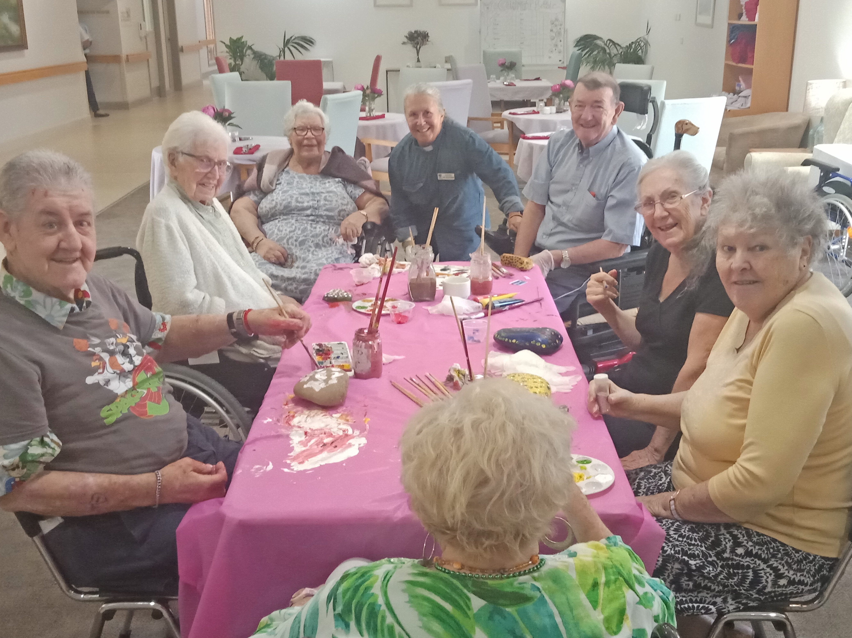

PRAYER GRID
The grid consists of a group of approximately 20 dedicated church members whoi accept prayer requests for thos in need. Doug Dowling is the contact person, you can talk to him at the 8.30am service or phone 0400-172-502. As always, approval from recipient is required.

SAMARITANS DONATIONS
For the month of April – Anything at all you feel might be useful and suitable!

PARISH NEWS
Janet wil continue to produce the Parish News for the time being. Items of interest always welcome. Phone 6554 5981 or
0448-502-684, email jan2max@bigpond.net.au

Quote for the week:
You don't choose your family. They are God's gift to you, as you are to them. Desmond Tutu

Senior Minister/Rector: Rev’d Mark Harris 0425 265 547
revmarkharris@icloud.com
Family’s Minister: Rev’d James Brooks 0411 335 087
jamesknac@gmail.com
Priest in Local Mission: Rev Helen Quinn 0427 592 723
rqu783662@bigpond.com
Parish Office: St. Alban’s Anglican Church: 5543 7683
info@forsteranglican.com
Parish Secretary: Judy Hall 0400 890 728
Op Shop: Head St Car park 6555 4267
Book Shop: bookshop@forsteranglican.com 5543 7683
Parish Website: www.forsteranglican.com
Fb: Anglican Parish of Forster-Tuncurry.
Items for Parish News: Janet Lawrence 6554 5981, 0448 502 684, jan2max@bigpond.net.au or Parish Office 5543 7683 by noon Wed, Thanks.

Opportunity To Give
For direct credit offertories:
BSB: 705077 Account: 000400710
Account name: Anglican Parish of Forster/Tuncurry

