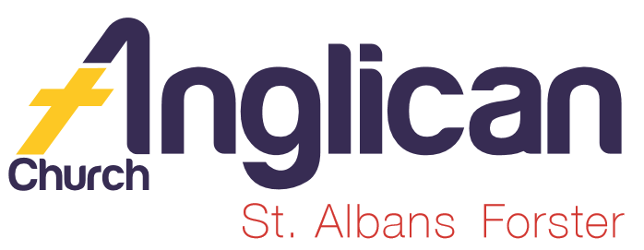
PARISH NEWS

FORSTER-TUNCURRY & NABIAC 15th MARCH, 2020

COMBINED PARISH WORSHIP – TODAY!!

As we gather together as a parish family, let us give thanks to our gracious God for prayers answered. As we continue to have faith in Jesus and connect meaningfully with our community to inspire hope and transformed lives.
At an appropriate time, take a look around, and if you see someone you don’t know or wonder where they attend services, go along and introduce yourself!
As we get together after our service let’s enjoy each other’s company over morning tea, and discuss just where we are in our walk of faith.
Following morning tea, we will meet together for our -

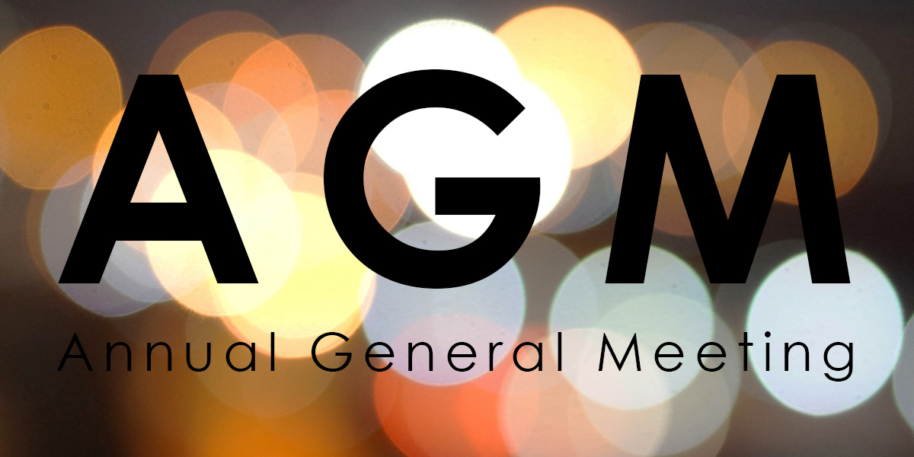

AN IMPORTANT MESSAGE FROM BISHOP PETER – CHANGED GUIDANCE ON CHURCH PRACTICES – CORONAVIRUS
(COVID-19)
This message is printed out on a separate page for your convenience.

CONNECT WITH US
FACEBOOK ………………… Forster Anglican Church Community
PARISH WEBSITE………… www.forsteranglican.com
CHURCH OFFICE ………… info@forsteranglican.com 5543 7683

PRAYERS FOR THE SICK AND RECOVERING
Ella E, Keith R, Lyn T,Marion & Peter R, Michelle, Rachael, Margaret B,
Zac L, Aileen G, Vicki L, Charlotte T, Peter B.

BCA-BUSH CHURCH AID IS OUR MISSION FOCUS FOR MARCH.
This week we especially pray for Jacob & Sarah Kelly. Jacob is the student minister at Christchurch Echuca and Sarah is a teacher at a local Christian school. They ask for prayer for the upcoming Diocese of Bendigo Youth Camp that more youth will be able to attend and that all will be spiritually nourished.
March is the month we bring our BCA boxes in for Suellen to open and count all the monies we have been putting aside. Monies will be sent to BCA for their ongoing work in the Australian bush. Don’t have a BCA box? Speak to Suellen, she will be delighted that you intend joining in this missionary work.

AN AFTERNOON AT THE MOVIES- GLECCA- “I STILL BELIEVE”
Mark the date – next Sunday, 22nd March, 2pm at the Great Lakes Theatre, Tuncurry. Tickets are available at our bookshop, also available today from Heather Webster, $20.each. Supper and a chat will be provided after the movie to give time to mingle with other Christians in the area.

DATE FOR THE NEXT MEN’S DINNER
Tuesday, 7th April, at St. Alban’s Forster – 6pm for 6.30pm. The speaker on this occasion is Bill France a retired BCA missionary from North Western Australia. $15.00ph. lists at both churches or phone Clive 0412 653 061.

OUR LEADERSHIP TEAM:
Senior Minister: Rev. Mark Harris 0425 265 547
Families Minister: Rev. James Brooks 0411 335 087
Priest in Local Mission:Rev.Helen Quinn 0427 592 723

WORLD DAY OF PRAYER 2020.
Last Friday, six parishoners attended this insightful day at the Baptist Church. Next year, 2021, is OUR YEAR! The country is Vanuatu and the theme is: BUILD ON A STRONG FOUNDATION.

THE PRAYER MEETING: the best night of the week!
Praying together is a serious mark of belonging. It is good to pray on our own: it is also good, and very natural, and potentially powerful, to pray with our brothrs and sistes in Christ.
Our pastors are as deeply encouraged by an eager and active participation in our prayer meetings as they are by our being present on Sundays. Make these a priority, and we will put a spring in the step of our pastors. (The Book your Pastor wishes you would Read…$10 from ourn Bookshop)

Our weekly Prayer Meeting is Wednesday morning at 9am.
OUR MONTHLY PRAYER MEETING IS THIS WEDNESDAY, 18TH MARCH, at St. Alban’s, commencing at 5pm. If you have 30 minutes to spare, Mark, James & Helen will be encouraged, maybe make it one of your prayer points.

Items for the Parish News for March to Lyn Davies via phone 0491 136 455, text or call. Email: clivelyn46@gmail.com by noon Wednesday, thanks.

DIRECT DEBIT GIVING –
ANGLICAN PARISH OF FORSTER/TUNCURRY.
BSB: 705077
ACCOUNT: 000400710

REDEFINING BOUNDARIES- John 4:5-42
This passage poses many questions for us today. Does the Living Water still taste as sweet and liberating for us? Why/Why not? Do you think we sometimes find ourselves confined by invisible social boundaries? How do Jesus’ disciples react to his example? The Living Water of inclusion and truth has a wonderful name: JESUS. Draw deeply from his well! (Learning for Life- A Lenten Reflection)

ANGLICAN WOMEN AUTUMN GATHERING 2020
Anglican women from our region will gather in Gloucester at St Paul’s on Monday May 18.
The gathering will begin at 10 for a 10:30 Eucharist followed by a guest speaker. Lunch is a ‘bring and share ‘and will be followed by a talk by Barnados' 2019 Mother of the Year Noelene Lever and Rev. Helen Quinn on their work with the Aboriginal community in the Forster Tuncurry area. The meeting will close around 2pm.I do encourage the women of our Parish to attend this gathering to show support for our Christian faith in this region.
I will provide a list in our churches where names can be added. There is funding available to us for the hiring of a bus.
Enquiries to Rev. Helen or Heather Webster.

EDUCATION ON WASTE MANAGEMENT
Save the date for education on waste management. What goes in what bins and what can be recycled? An imminent presenter from Midcoast Council will inform us on Thursday 2nd April 2020 at 11.30am at St Albans Hall. More details to come. Heather Webster – Safety Delegate.

