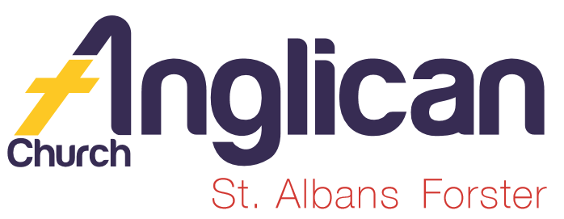
PARISH NEWSHEET

FORSTER & NABIAC 15th September, 2019
PENTECOST 14 – GETTING READY FOR THE LAST DAY

SIFT (SCRIPTURE IN FORSTER TUNCURRY)
“OVERCOMER” – movie posters in both churches. An easy way to raise monies for SIFT. This afternoon @ 2pm at Great Lakes Cinemas, Tuncurry.

ST. PAUL’S ANGLICAN CHURCH, NABIAC
“Church Warming No.1”
On Sunday morning, 8th September, the congregation, which included members of the Uniting Church, Nabiac, enjoyed a Church Warming service which was a mix of traditional and contemporary forms of worship.
A light lunch and lively fellowship followed; a very happy occasion. It was also an opportunity for us to celebrate with Pat Goldsmith on her 90th birthday. From Geraldine Carson.

OUR PARISH VISION.

Connecting Meaningfully.
Inspiring Hope.
Transforming Lives. Through faith in Jesus

DIRECT DEBIT GIVING the account name is: Anglican Parish of Forster/Tuncurry, BSB:705077, Account:000400710, “for God loves a cheerful giver.” 2 Cor. 9:7b.

OUR MISSION FOCUS FOR THE MONTH OF SEPTEMBER is BUSH CHURCH AID. September is the month that we bring in or send in our BCA boxes. If you would like more info or a BCA box please see Suellen.
To-day, 15th we pray for Jacob & Sarah Kelly, BCA Youth worker, Echuca, Vic.

SAMARITANS DONATIONS For September we’re thinking of tins of salad vegetables, ingredients to to make an easy meal. A wonderfully generous amount of goodies coming in – well done.

PARISH LUNCH – SAVE THE DATE – well, I wonder how many parishioners tried to save the date? Would have been difficult as it was the wrong day and date!!! So the day and date is
SUNDAY, 3rd NOVEMBER,
the parish will meet at Club Forster. $26pp. More details later on. Suellen.

OUR PRAYERS FOR THE SICK AND RECOVERING
Ella E, Jenny L, Keith R, Lyn T, Marion & Peter R, Margaret B, Michelle,
Rachael H.

BOOK REVIEW by one of our Bookshop Volunteers
BARBOURS ENCYCLOPEDIA OF GREAT CHRISTIAN QUOTES.
A great quotation can provoke thought, brighten a day, even change a life. This handy reference features the words of the early church fathers through the twenty-first cnetury’s best writers, and is categorized into nearly 500 topics both biblicial and contemporary. $9.99

OUR OP SHOP Spring has sprung!! Oops, well off and on!! As you go through your collection of spring and summer clothes remember our Op Shop and your opportunity to help others.
CMS COASTAL MISSION DAY 2019- THE MISSION OF PRAYER This year, Stephen Shead, Senior Minister at St. Barnabas, Fairfield with Bossley Park Anglican Church, will be speaking on the topic “The Mission of Prayer.” Leaflets available in both churches.
Saturday, 19th October, 9.30am-3pm, EV Church, 331 Terrigal Drive, Erina. Register online $10. cms.org.au/cmd

JOIN US FOR PRAYER
Weekly, each Wednesday morning at St. Alban’s, 9am-9.30am.

LIFE AFTER DEATH – PRAYER NO. 399. FIVE HUNDRED PRAYERS
Thank you, God, for letting us in on the end of the story;
For giving us a vision of the way things will be,
God, we cannot begin to thank you for the chance to live eternally;
Our heads cannot comprehend the idea that we will not die.
Yet that is what you offer:
Through your resurrected Son you offer us life that does not end;
Eternity in your presence.
We worship you because you are victorious over evil, and even over death.
We praise you because you are God eternal, our King.

LIFE IS A JUNGLE
It was great to meet Jose’ Vergara at St. Alban’s last Sunday as he told us of his role in bringing God’s word to the youth in our high schools. Rev. James interviewed Jose’ and the congregation were asked to continue praying for the work being carried out in our high schools.
To keep scripture in our high schools there is a financial need. One of the ways to do this is to pick up the “SURGE 100x20 “ leaflet and support SIFT.

LIDS FOR KIDS Penny is delighted with the accumulation of lids that appear each week.

TODDLER TIME so many gorgeous little people, they don’t stay still long enough to count !! about 22-25 last Monday plus babies!! A great joy to watch them practicing for our fete.

CONNECT WITH US
FACEBOOK ………………… Forster Anglican Church Community
PARISH WEBSITE………… www.forsteranglican.com
CHURCH OFFICE ………… info@forsteranglican.com 5543 7683

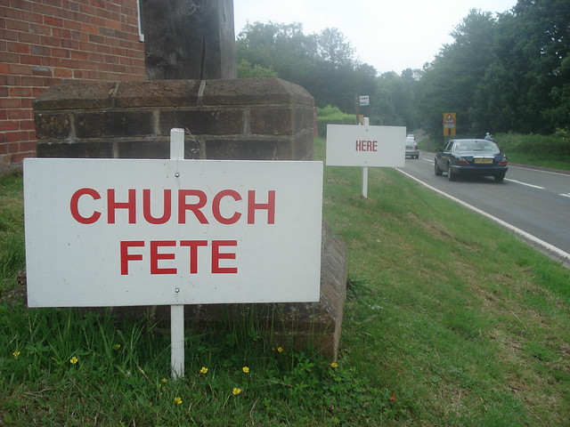

SATURDAY, 12TH OCTOBER, 8am – 1pm.

OUR LEADERSHIP TEAM:
Senior Minister: Rev. Mark Harris 0425 265 547
Families Minister: Rev. James Brooks 0411 335 087
Priest in Local Mission: Rev. Helen Quinn 0427 592 723

Items for the Parish News for September to Lyn Davies via phone
0491 136 455, text or call. Email: clivelyn46@gmail.com by 12noon Wednesday, thanks.

