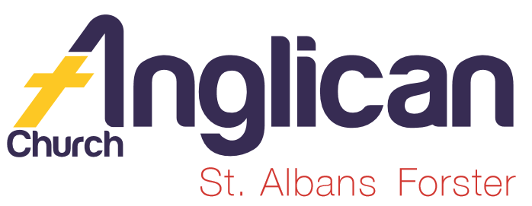
PARISH NEWS

FORSTER & NABIAC 15th December, 2019.

ADVENT 3 – THE GLORY OF THE COMING ONE
LET US LIGHT THE CANDLE OF JOY

Strenthen the weak hands, and make firm the feeble knees. Say to those who are of a fearful heart, “Be strong, do not fear! Here is your God” Isaiah 35.³⁻⁴
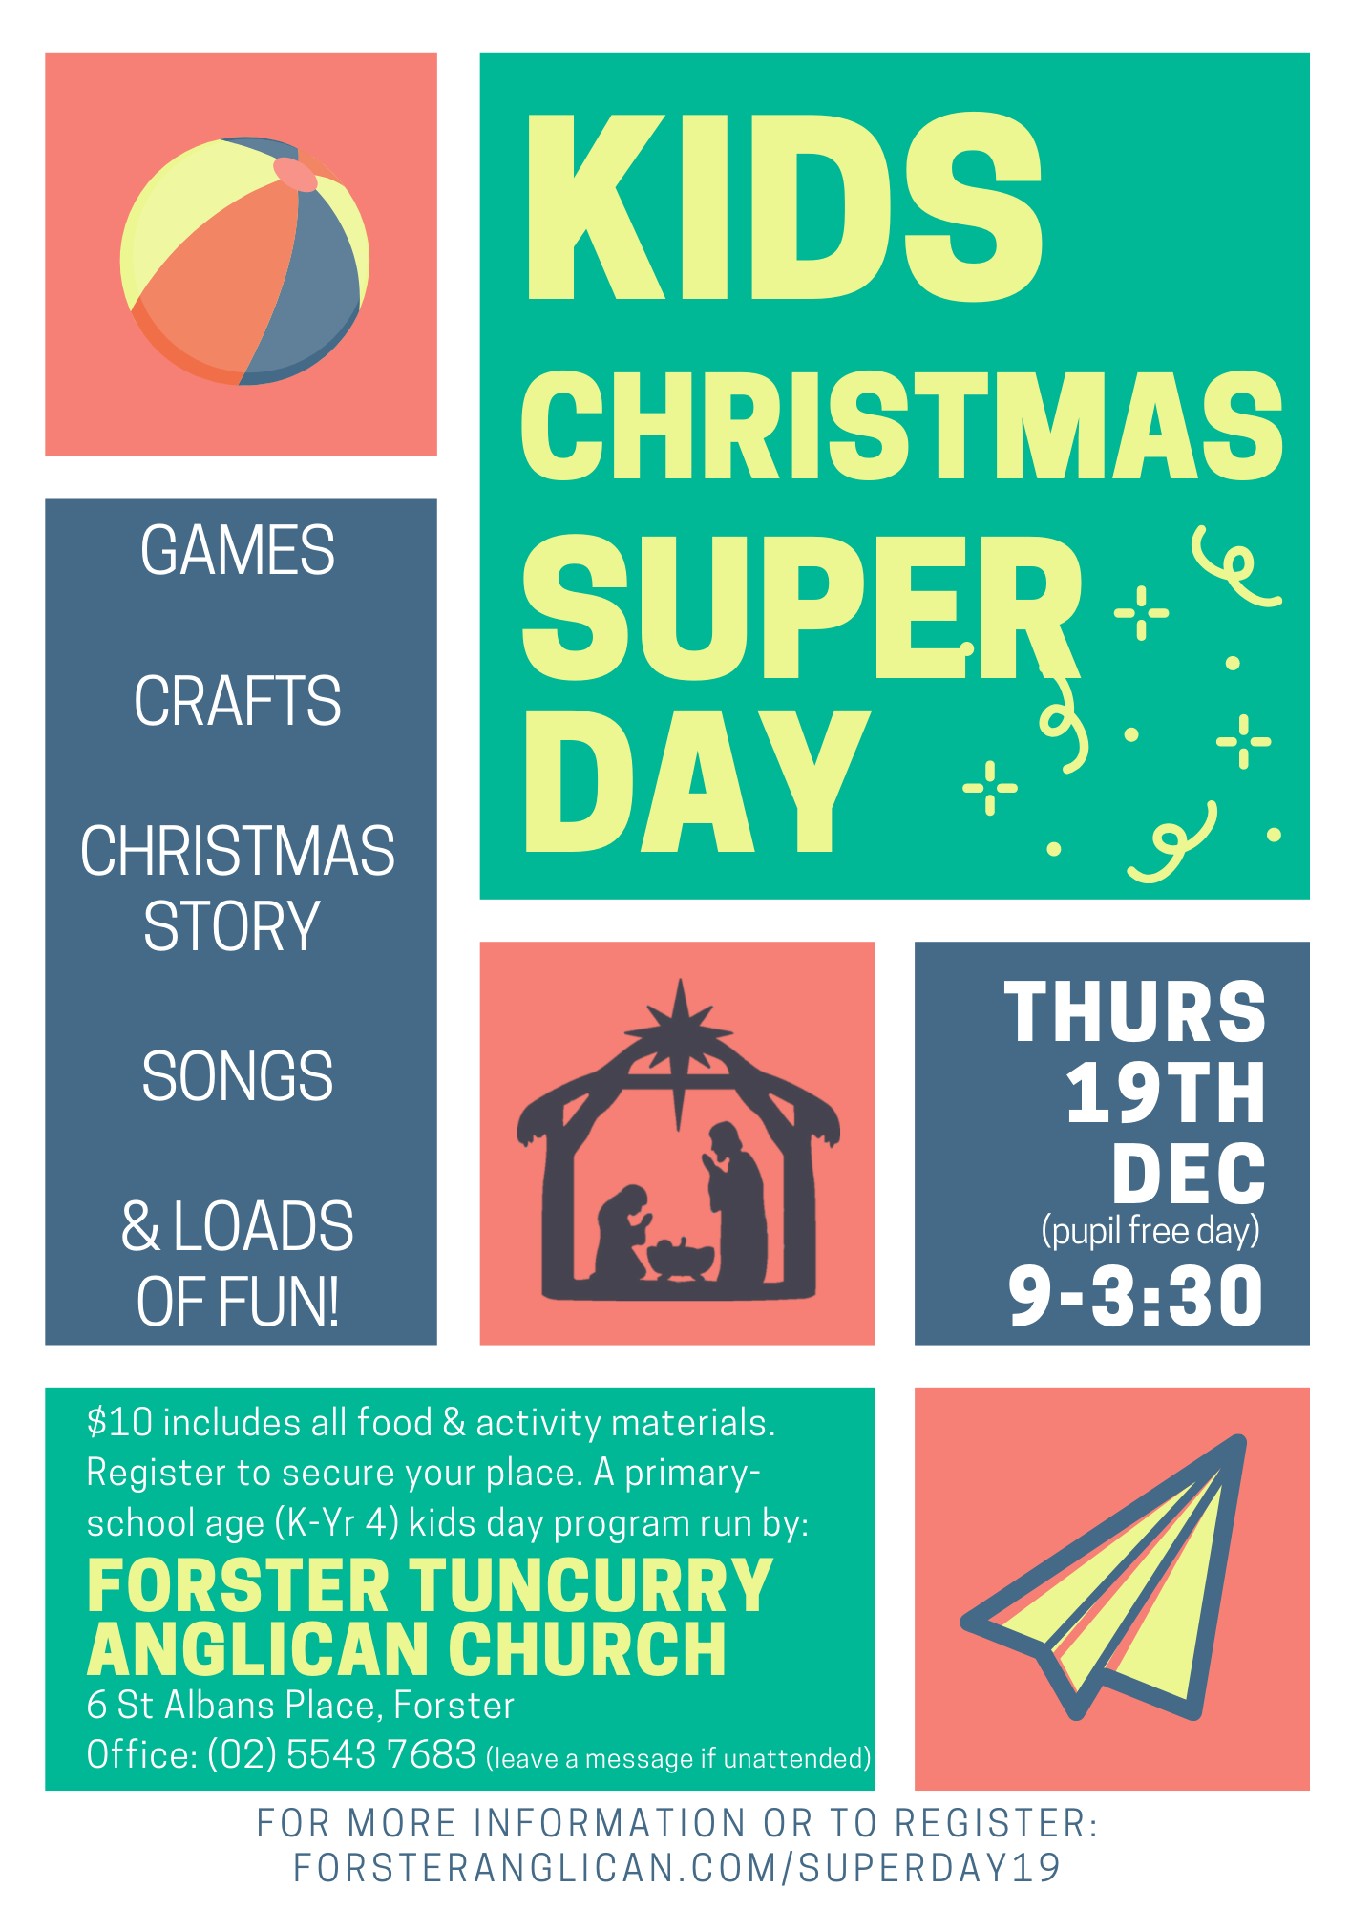

OUR LEADERSHIP TEAM
Senior Minister: Rev. Mark Harris 0425 265 547
Families Minister: Rev. James Brooks 0411 335 087
Priest in Local Mission:Rev.Helen Quinn 0427 592 723

CHRISTMAS SERVICES
Christmas Eve - Forster 11pm. Nabiac 7pm.
Christmas Day - Forster, 9.00am. Nabiac 10.00am.

PLUS – CHRISTMAS EVE
5pm FREE!!!! SAUSAGE SIZZLE, 6pm ALL AGE CAROL SERVICE
An excellent opportunity to enhance our Parish Vision by Connecting Meaningfully, Inspiring Hope, Transforming Lives, Through faith in JESUS
Many parishioners will be needed to make this occasion an eventful one, there will be jobs for people of all skills and abilities. Contact the office 5543 7683, or speak to one of the wardens. Let’s make it a great night!

PRAYERS FOR THE SICK AND RECOVERING
Ella E, Keith R, Lyn T, Marion & Peter R, Michelle, Rachael, Margaret B,
Zac L.

DYER’S CROSSING CHURCH
Great news, SOLD for $199,000, and exchanged.

ADVENT STUDY SERIES DECEMBER 2019
The glory of the coming one study 4 covers this week’s readings. If you haven’t a copy of the study, then please collect one to-day. The studies are for personal or growth groups, and cover old and new testament readings. Study 5 (last study) next week The sign of the Lord: a virgin with child, Immanuel.

BUNNINGS BBQ
We have been offered Saturday, 25th January for the next BBQ. Nett profit from Saturday, 7th $580. List in the new year BUT please mark the date, thanks.
NEWS FROM NABIAC
An exciting week out here!
Firstly, the renovation of St. Pauls should be finished as this goes to press with the carpenters at work very early Monday morning to replace the folding doors with more modern and attractive ones as well as completing updates to the porch. But the best news is that the stained glass windows from St. Johns Dyers Crossing are installed with lighting behind them! Absolutely beautiful and wonderful to share with those who came to worship with us last Sunday!
Watch for pictures next week. Many thanks to all involved and special thanks to Kit and Geraldine Carson for their hard work and dedication to our church and to those from Dyers Crossing who have become even dearer friends since the closing of their cherished church.
Secondly, our Culture Group travelled out to Rev. Helen's for a Christmas luncheon on Monday. A very happy occasion with lively conversation, singing and far too much eating. Next Monday the group will gather at The Bull Ring for the final session of 2019. A new art work is in progress and it's hoped it will be completed early in the New Year.
Blessings to all from St. Paul's Nabiac. (Email from Rev. Helen Quinn)

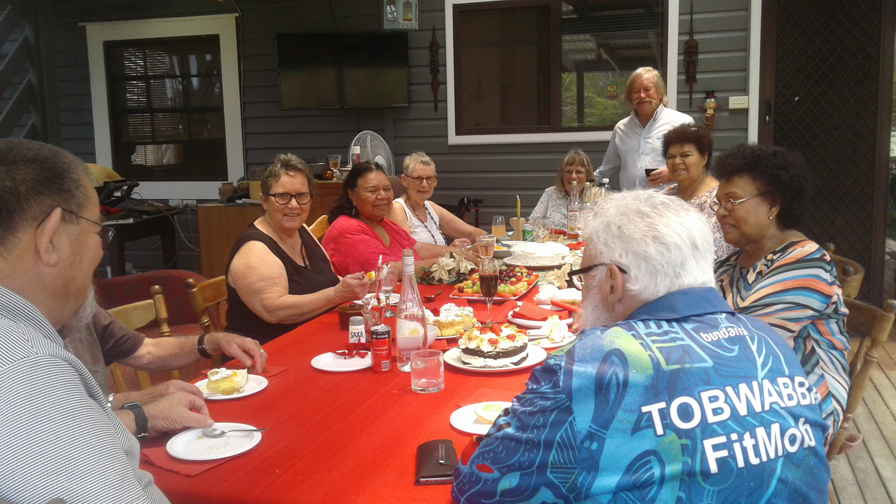

ROTARY CAROLS BY CANDLELIGHT
Monday, 16th December, 6.30pm, John Wright Park, Tuncurry. The Children’s Talk is being given by Rev. James Brooks, once again a great community connection, come along, pray for those attending, that their lives will be transformed, through faith in Jesus.

RUGRATS
Our Craft Group have finished for this year and resume on 4th February. Many groups have a break over Christmas/New Year, BUT important to keep in touch with one another.
The mums were given a small gift at the last Toddler Time for the year, which included a Christmas tree decoration made by the Rugrats. A million little people – I know – I counted them! Lyn

DECEMBER MISSION FOCUS –THE CHRISTMAS BOWL
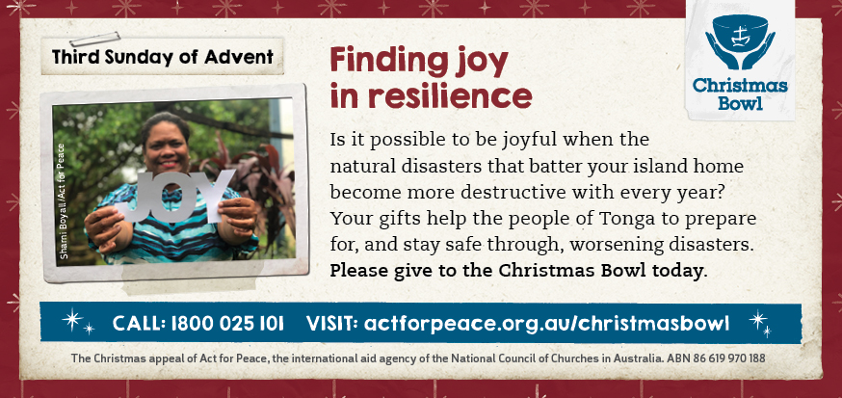

CONNECT WITH US
FACEBOOK……………………Forster Anglican Church Community
PARISH WEBSITE…………..www.forsteranglican.com
CHURCH OFFICE…………….info@forsteranglican.com 5543 7683

Items for the Parish News till the end of 2019 to Lyn Davies by 12 noon Wednesday, thanks. Phone 0491 136 455 text or call or email
clivelyn46@gmail.com

