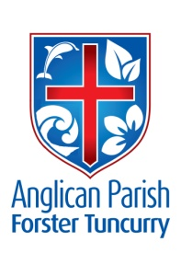
TRINITY SUNDAY – THE KINGDOM COMES
16TH JUNE, 2019.

Does not wisdom call, and does not understanding raise her voice? ‘The Lord created me at the beginning of his work, the first of his acts of long ago.’ Proverbs 8.^{1,22}

Our Parish Vision:
CONNECTING MEANINGFULLY.
INSPIRING HOPE.
TRANSFORMING LIVES.
THROUGH FAITH IN JESUS.

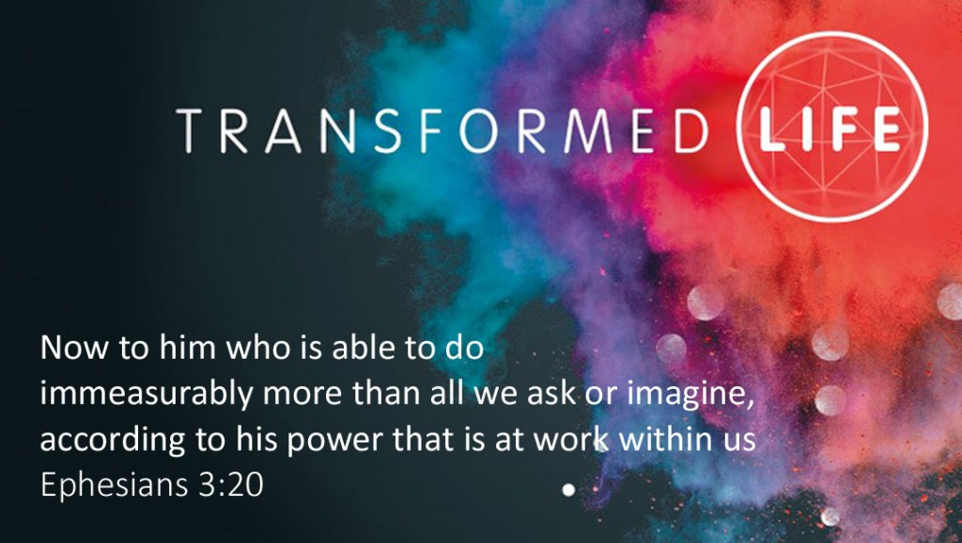

THE DECONSECRATION OF ST. JOHN’S, DYERS CROSSING.
Bishop Charlie Murry will be at this Service of Thanksgiving on Sunday, 30th June at 10.am. Please note corrected time.

PRAYER

SICK AND RECOVERING
Ella Engel, Jenny Lawson, Keith Roach, Nadia Maybury, Lyn Thompson, Marion & Peter Roberts, Margaret Burrows, Laurie Medcalf, the Pearson family, Peg Sawyer.

OUR MISSION FOCUS FOR JUNE IS THE SAMARITAN FOUNDATION.

MEN’S BREAKFAST AT ST. ALBAN’S
Come along and have breakfast with NICK PREO next Saturday morning, 22nd June, 7.30am, at St. Alban’s. $10 each. Combined Churches Men’s Fellowship. See promotion poster for details. Helpers needed for kitchen duties. Talk to Phillip Castle.

GLECCA FILM PREMIERE
“The Least of These” Sunday, 30th June at 2.00pm. Tuncurry.
Tickets from Heather Webster and the Bookshop $20.00 each including afternoon tea after the movie. See promotion poster for details.

HUNTER CHRISTIAN SRE

BASIC SRE Training
For current & prospective SRE (Scripture) Teachers & Helpers
Module 7: DUTY OF CARE IN SRE. Thursday, 27th June, 2019.
Time: 10am – 12.30pm. At St. Alban’s Anglican Church.

Cost: Donation for Morning Tea.
RSVP by next Friday 21 Jun 2019 to Jose Vergara on
0431 434 553 or jose.vergara@generate.org.au

SAMARITANS DONATIONS
During June we’re concentrating on MEALS in a tin or a packet.

Sermon Notes: The Kingdom Comes
2 Samuel 7:1-7; 1 Kings 4:20-21
Psalm 2 Romans 5:1-5 Matthew 1:1-17
Forster:
James Brooks Mark Harris
8.30am, 10am, 5.30pm 10am

Dyers Crossing:
Helen Quinn
10am

Senior Minister: Mark Harris
T: 0425 265 547. Parish Email:info@forsteranglican.com.
Fb:Forster Anglican Church Community

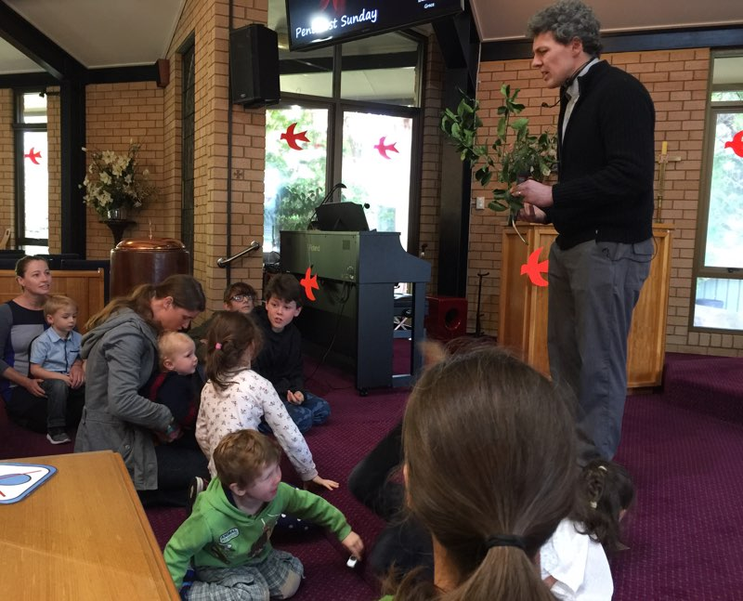
Last Sunday (Pentecost) the children were sitting at the front of St. Alban’s listening to James telling them a story about the fruit of the Spirit. What a beautiful sight!!

Mark’s prayer at the end of last week’s message
My prayer for us all is:
That we would choose to deeply and authentically love Jesus.
That we’d listen to the Holy Spirit as he brings scripture to our minds.
That we’d let God teach us, spend more time with God in prayer, spend more time studying His word.
And that we’d be strengthened to love each other deeply.

