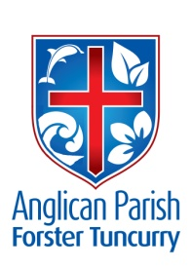
ADVENT 3 – PREPARING THE WAY
16th DECEMBER, 2018.

Do not fear. The Lord, your God, is in your midst, a warrior who gives victory; he will rejoice over you with gladness, he will renew you in his love. Zephaniah 3 ¹⁶⁻¹⁷

WE WELCOME THE RIGHT REVEREND
DR. PETER STUART, BISHOP OF NEWCASTLE
TO OUR PARISH THIS MORNING.

OUR MISSION FOCUS FOR DECEMBER IS THE CHRISTMAS BOWL.

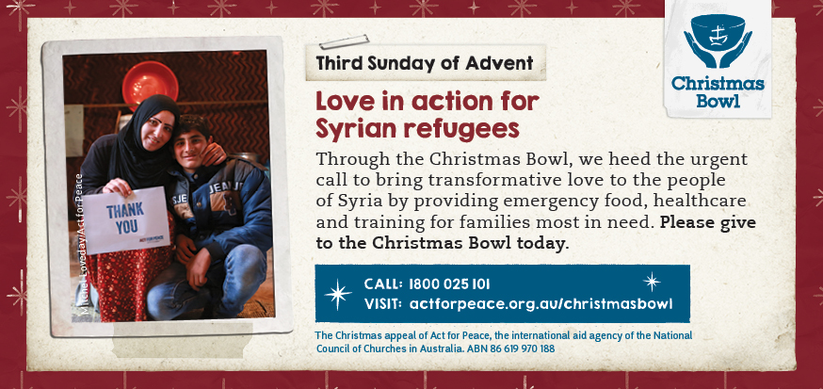

As Christians, it’s our duty to share God’s love to bring healing and wholeness to those who are suffering. Through the Christmas Bowl, we heed the urgent call to bring this transformative love to the people of Syria. More than five million people have fled the devastating Syrian war and are now living as refugees, facing challenges every day.

5th SUNDAY IN DECEMBER
Sunday, 30th December, there will be one Combined Parish service at
St. Nicholas’, Tuncurry, 9.30am, our final Tuncurry service for worship at St. Nicholas’ Church.

SUNDAY EVENING SERVICES
There is to be a break from these services till Sunday. 6th January, 2019.

SERVICE TIMES FOR 2019
As of the first Sunday in 2019 (6th January) service times will change. They will be as follows:
- St. Alban’s 8.30am, 10am and 5.30pm
- St. Paul’s & St. John’s 10am

ADVENT IN AUSTRALIA (An Advent Reflection) Anglican Overseas Aid.
Pray: Consider whether there are specific obligations that come with living in a country like Australia, and pray how you might fulfil them.
Reflect:
- The birth of children brings extraordinary joy. What is the same/different about the birth of Christ?
- What do you find the most joyous part of Christmas?
- How does joy differ from happiness or pleasure? In your experience, do Christians express the joy of their faith? Why/Why not?

MEMBERS OF OUR CHURCH COMMUNITY AND FRIENDS WITH ONGOING NEEDS
Ella Engel, Jenny Lawson, Maureen Armstrong, George Hodgson, Louise, Keith Roach, Michelle, Max Kennedy, Beryl Allen, Nadia Maybury, Sue Hollis, Lyn Thompson, Marion & Peter Roberts, Allan Peel, Renae and family.
We commend to God’s keeping those who have recently died, John Alfred Hubbard and McKenzie Dee Kerrison and we pray for those who mourn their passing.
We remember with thanks those whom we have loved whose anniversary occurs at this time.
BOOKSHOP NEWS from Phillip Castle
Check out the Christmas cards and gifts in our bookshop.
There are some VERY CHEAP Study Bibles on sale. NIV Study Bible $7;
CSB Study Bible only $15. Read the Bible in a year $10 NLT.
Also, we have music CD’s by the City of Light band from St Paul’s Castle Hill – which we often sing from in the Contemporary Services. (A member of the band attended our 5.30pm service two weeks ago).
Bookshop closed Monday 24th December, reopen Monday 7th January.
Thankyou for your custom this year.

CHRISTMAS SERVICES
Monday, December 24th 5.30pm Sausage Sizzle, followed at 6pm - All Age Carol Service. 11pm Traditional Communion Service, St. Alban’s.
7pm Traditional Carol Service, St. Paul’s, Nabiac.
Tuesday, December 25th 9am All Age Communion Service, St. Alban’s.
9.30am Traditional Communion Service, St. Nicholas.

SAMARITANS DONATIONS
Thoughts for December – holiday food – popcorn, chips, biscuits, jelly, topping, tins of fruit, long life custard, or what is YOUR favourite holiday food?
WOW! An amazing collection of donations was picked up last Wednesday! Thanks once again from the Samaritans for your ongoing support.

50 YEAR ORDINATION ANNIVERSARY FOR REV’D. STUART BENSON
From Leonie - Stuart was ordained to the priesthood at Christ Church Cathedral, Newcastle on St. Thomas’ Day, 21st December, 1968. There will be a special celebration on Sunday, 23rd December at St. Paul’s, Gloucester. Sadly, Stuart is too unwell to robe and take part in the service, but we are hoping that it will be a special time for him anyway. Please pray for Stuart at this special time.
Stuart was the Rector of this parish when St. Alban’s was built and lived in Clergy house, Tuncurry, with his wife, Leonie and children, Sarah, Nicholas and Pip.
ST. ALBAN’S THURSDAY BIBLE STUDY GROUP
The group is now in recess, as are many other groups, till February, 2019. This group has been doing an old testament study on the book of Nehemiah and have found it so interesting and now feel they really know the man himself.

OUR PARISH VISION:
We will connect meaningfully with our community in order to inspire hope and transformed lives through faith in Jesus.

TODDLERTIME
Last Monday, 10th, was the last day in 2018 for this group. An amazing group, such a noisy riotous morning, just fabulous to see approximately 33 children (ever tried to count toddlers!) and 25 adults.
They are a very caring and thoughtful group always helping each other.

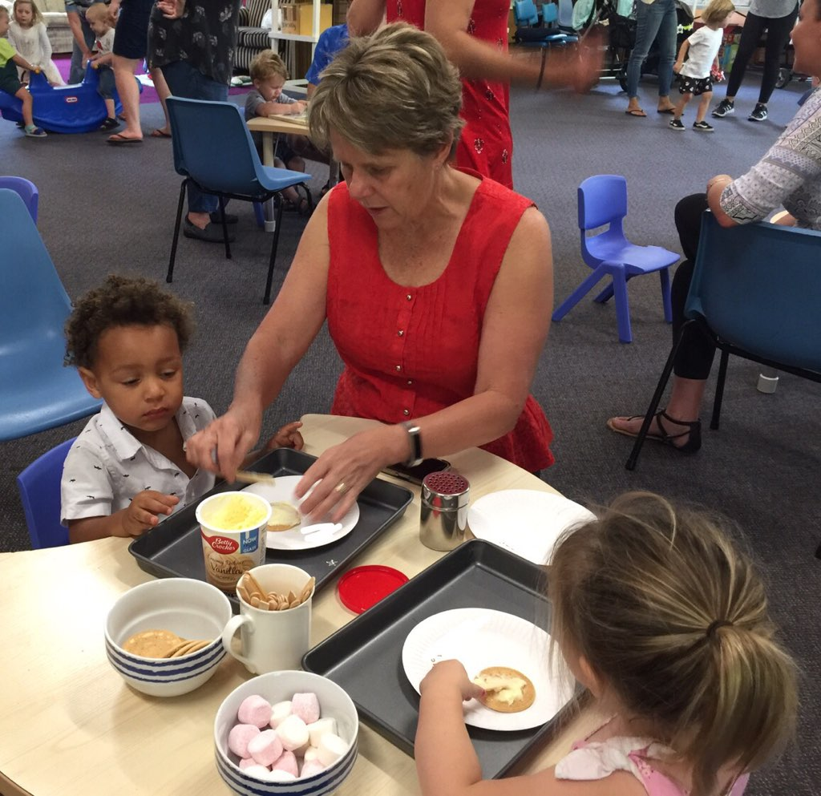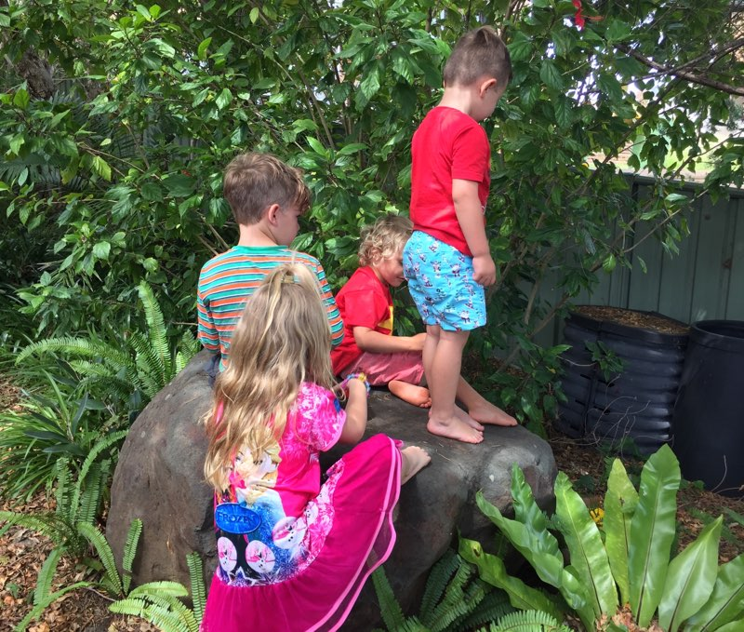

Senior Minister/Rector: Rev’d Mark Harris 0425 265 547
revmarkharris@icloud.com
Priest in Local Mission: Rev Helen Quinn 0427 592 723
Parish Office: St. Alban’s Anglican Church: 5543 7683
info@forsteranglican.com
Parish Secretary: Judy Hall 0400 890 728
Op Shop: Head St Car park 6555 4267
Book Shop: bookshop@forsteranglican.com 5543 7683
Parish Website: www.forsteranglican.com
Fb: Anglican Parish of Forster-Tuncurry.
Items for Parish News: Lyn Davies 0491 136 455. Parish Office 5543 7683 by noon Wed, Thanks.
Our bank details: BSB 705077 Account 000400710
Account name: Anglican Parish of Forster/Tuncurry

