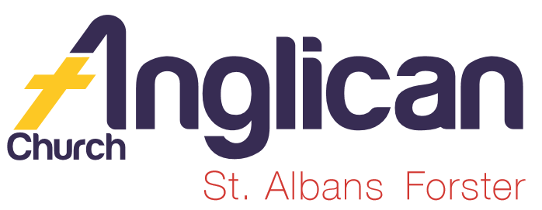
PARISH NEWSHEET

FORSTER & NABIAC 17th November, 2019

PENTECOST 23 – NEVER TIRE OF DOING WHAT IS GOOD

Same-sex attraction and the Church – Notes from Rev James.
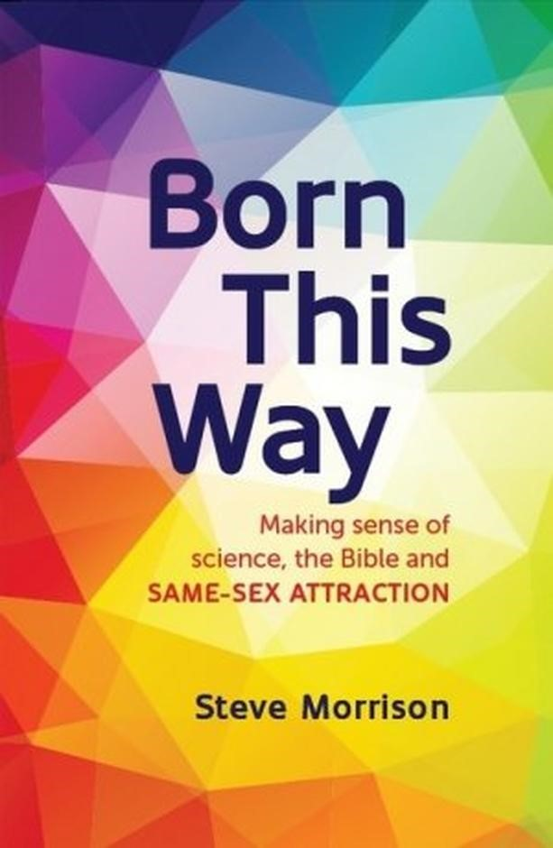
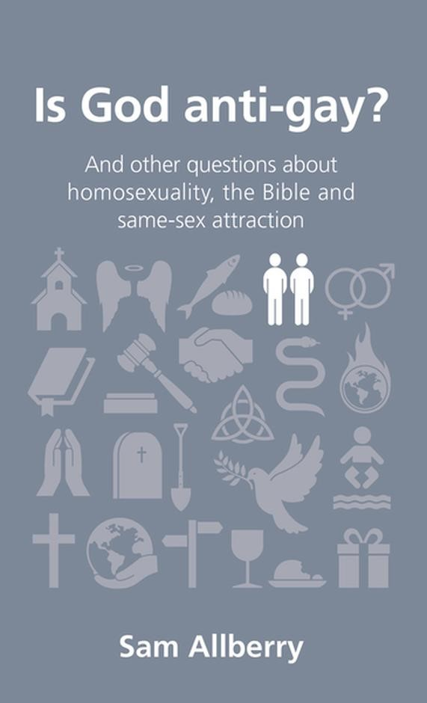
There have been many questions brought up recently about God, same-sex attraction, and how we in the church should think and love people in this situation. What does God think about it all? Is God really ‘anti-gay’ as some put it? How can we oppose people who are ‘in love’ or who may describe themselves as being ‘born this way’? These are significant and important questions that we must not ignore, nor must we simply go along with what society says around us. It’s important that we deeply consider God’s word to us on the subject in the Bible. To that end, can I commend to you the books we have available in our bookstore on the subject. As a first step you might read ‘Is God anti-gay?’ by Sam Alberry - an Anglican minister from the UK who has personally experienced same-sex attraction. Secondly, consider reading ‘Born this way’ by Steve Morrison as it explores the particular questions around what science and genes say about homosexuality. Thirdly, ’The plausibility problem’ by Ed Shaw explores in a deeper way what the Bible really says about human sexuality in this area and whether what Jesus says is actually good news, or just a ‘bad deal’. Ed Shaw also personally experiences same sex attraction and yet is committed to what God says in the scriptures. He contributes to the online resource www.livingout.org in support of those experiencing same-sex attraction. Let’s encourage one another in truth and love in this area - why not read one of these books with some others at the same time and discuss together?
SAMARITANS DONATIONS FOR NOVEMBER
We’ll continue with donations of Christmas food. Gifts for the family, especially the children, would be much appreciated.

VOLUNTEERS NEEDED
The Samaritans have asked our parish to assist in any emergency relief centre that might be set up in Forster/Tuncurry in response to any future disaster or emergency situation. If you would like to help, please contact Deborah Laurie 0402 359 780, to discuss what might be involved. You will need a current Working With Children Check to be involved.

OUR LEADERSHIP TEAM
Senior Minister: Rev. Mark Harris 0425 265 547
Families Minister: Rev. James Brooks 0411 335 087
Priest in Local Mission:Rev.Helen Quinn 0427 592 723

REV’D MARK & TRISHA
Yes, they did get away! Off to New Zealand for a well deserved break. They haven’t travelled to NZ before, so they are in for a treat.

OUR BOOKSHOP
As mentioned , we have an amazing selection of Christmas cards. Also, quite a few books on PRAYER. As Rev’d Mark said in his message last Sunday “Our God loves us to talk to him! That’s amazing isn’t it”

BUNNINGS BBQ FOR TODDLERTIME
Saturday, 7th December, there’s a worksheet in the parish hall. Always keen to have new parishioners help out!

CONNECT WITH US
FACEBOOK ………………… Forster Anglican Church Community
PARISH WEBSITE………… www.forsteranglican.com
CHURCH OFFICE ………… info@forsteranglican.com 5543 7683

PRAYERS FOR THE SICK AND RECOVERING
Ella E, Jenny L, Keith R, Lyn T,Marion & Peter R, Michelle, Rachael,Max S, Margaret B.

DIRECT DEBIT GIVING the account name is:
Anglican Parish of Forster/Tuncurry, BSB:705077, Account:000400710.
“for God loves a cheerful giver.” 2 Cor. 9:7b.

OUR PARISH VISION
Connecting Meaningfully. Inspiring Hope. Transforming
Lives. Through faith in JESUS.

500 PRAYERS by Martin Saunders
PRAYER No 234. QUESTIONING SEXUALITY
This prayer is designed for someone who is struggling with or questioning their sexuality. It seeks to make no judgment – only to draw us closer to the God who loves us, whoever we are.
God of love, you know my struggle.
You know I have questions, that I feel different;
Help me to understand what it all means – help me to truly know myself better;
Speak to me about who I am, and who you want me to become.
Above all, Lord, I know that you love me completely, without condition;
Your love for me is wider and higher and fuller than I could possibly imagine.
As I think and pray and live through these questions,
Never allow me to forget the truth or the power of you love for me.

A THANK YOU CARD FOR RUGRATS FROM GLAICA
Theresa, Lifestyle Teamleader at GLAICA HOUSE says, “Thank you for your beautiful blankets they bring so much comfort & warmth to our residents here at Glaica”.

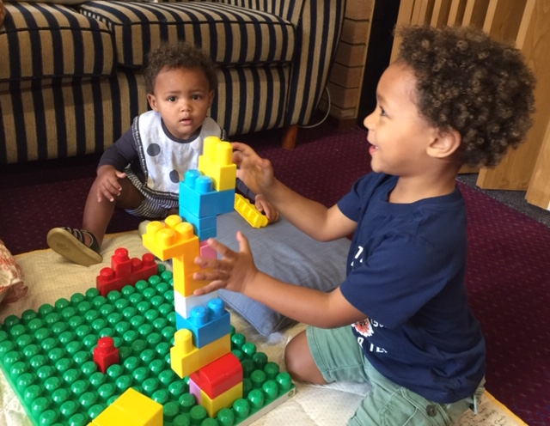

TODDLER TIME
Last Monday, 11th, yet another birthday for one of our toddlers and there were approximately 32 toddlers!! A wonderful connection, and they spent their craft time making “manger scenes” aka “gingerbread houses”.
The photo here is from a few weeks back, brothers Zamari and Isaiah, enjoying building with duplo.

MEN’S DINNER
The next Men’s Dinner is on Tuesday, 3rd December, at St. Alban’s. The speaker is Captain Paula Glover, newly arrived Salvation Army Officer, and her topic is “My Life and Calling”. 6pm for 6.30pm $15 each. List in both churches or call Clive 0412 653 061.

Items for the Parish News till the end of 2019 to Lyn Davies via phone
0491 136 455, text or call. Email: clivelyn46@gmail.com by 12noon Wednesday, thanks.

