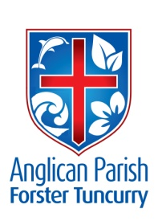
PARISH NEWS
NINETEENTH SUNDAY AFTER PENTECOST

20th October 2019

Will not God grant justice to those who cry to him day and night? Will he delay long in helping them? Luke 18.7–8

AFTER THE FETE
In spite of the wet weather, our Parish Fete was extremely successful, making a profit of over $4000. Many thanks to all those who contributed time and effort, and also financially, to the Fete’s success. There was a real community feeling in the air, with the coffee for chaplaincy in schools stall and the sausage sizzle stall run to raise funds for the Women’s Refuge. The performing toddlers were a delight and the new Indigenous singing group is a great initiative. Congratulations to one and all, particularly the stall holders who worked so hard!

REMINDERS
Parish Lunch – 3rd November. Bookings close next Sunday, 27th October. See Suellen at Forster or wardens at Nabiac.
Ageing at Home Forum – Club Forster, Thursday, 24th October, 12.30 – 6.00pm Free entry.
Charity concert – This afternoon, Sunday, 20th October. 2.00pm at St Alban’s, $10 pay at door.
Samaritans – Christmas goodies and/or bathroom gear.
CMS – Our mission for October

RHEMA 106.5 FM - Changing Lives For Good
An opportunity of hear some Christian music! Elle Limebear, live in Concert. Tuesday, 29th October, 7.00pm at Taree Baptist Centre. Admission - FREE.

MEMBERS OF OUR CHURCH COMMUNITY AND FRIENDS WITH ONGOING NEEDS
Ella E, Jenny L, Keith R, Lyn, Marion & Peter R, Michelle, Rachael, Peter A.
We remember particularly those whom we have loved whose anniversary occurs at this time: Gwen Martin and Stanley Ravell.

PRAYERS FOR STUDENTS
Many of us have grandchildren who will be sitting for their HSC in the next few weeks. This is a very stressful time for the students and their families so you might like to include them in your prayers. We send them all our very best wishes!

MANNING VALLEY NEIGHBOURHOOD SERVICES
As part of the Migrant Settlement Service, MVNS provides free programs to newly arrived migrants to help them improve their English and social confidence and to develop a sense of belonging in the community. Two of the services are the Language Café and the Multicultural Women’s group. Both groups are open to migrants from either Taree or Forster. For details see notice board in hall.

OUR PARISH PRAYER
Gracious God,
We give you thanks and praise for our parish.
May we always delight in and care for our beautiful wildlife, flora waterways, land and sky.
Bless us as we minister to our communities in the power of your Spirit.
Unite us in faith and bind us together in love, that we may proclaim your gospel with courage and enthusiasm, build your Church, and bring you glory in all we do.
This we ask through Jesus Christ our Lord.
Amen.

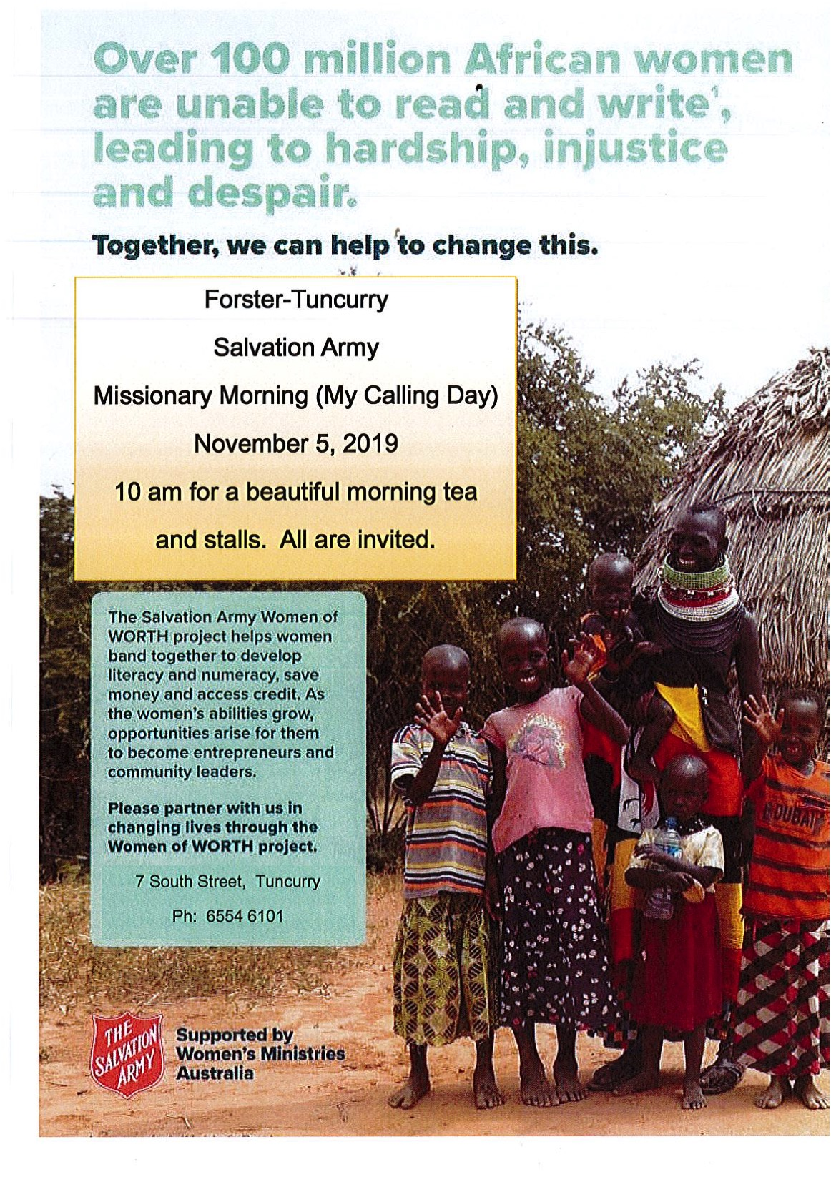
CONNECT WITH US:
FACEBOOK ………………… Forster Anglican Church Community
PARISH WEBSITE………… www.forsteranglican.com
CHURCH OFFICE ………… info@forsteranglican.com 5543 7683

Senior Minister/Rector: Rev’d Mark Harris 0425 265 547
revmarkharris@icloud.com
Families Minister: Rev’d James Brooks 0411 335 087
jamesftac@gmail.com
Priest in Local Mission: Rev’d Helen Quinn 0427 592 723
rqu783662@bigpond.com
Parish Office: St. Alban’s Anglican Church: 5543 7683
info@forsteranglican.com
Parish Secretary: Judy Hall 0400 890 728
Op Shop: Head St car park 6555 4267
Book Shop: St Alban’s Hall 5543 7683
bookshop@forsteranglican.com
Parish Website: www.forsteranglican.com
Items Parish News: Janet Lawrence, email: jan2max@bigpond.net.au, 6554-5981 or
0448-502-684 or Parish Office 5543-7683 by noon Wednesday.

Opportunity To Give
For direct credit offertories:
BSB: 705077 Account: 000400710
Account name: Anglican Parish of Forster/Tuncurry

