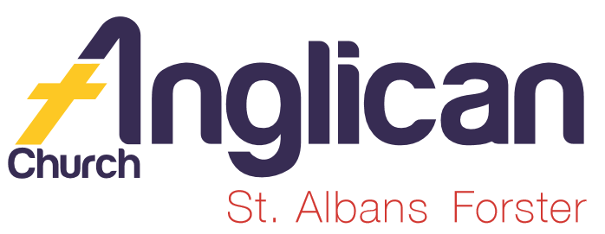
PARISH NEWSHEET
FORSTER & NABIAC 22ndSeptember
PENTECOST 15 – HOW TO DO ‘CHURCH’ IN THE LAST DAYS

Connecting Meaningfully.
Inspiring Hope.
Transforming Lives. Through faith in Jesus

OUR PARISH VISION
Connecting …………
INSPIRING ….
………..lives.
Through ….. in …..
A NEW GROWTH GROUP!
Starting this Monday night, 23rd September, 7.30pm in the Parish Hall, with Rev’d. Mark. Need more info – speak to Mark.

MEN’S DINNER
Tuesday, 1st October , 6pm for 6.30pm, $15 each for a two course meal. The speaker is Mr. John Coster “Retirement”. Sign-on lists in both churches. Phone Clive 0412 653 061 if you’d like details.
MY COMMUNITY PROJECT
The parish’s submission for funding was not successful. Two schools and amenities at a public swimming pool were the three successful applicants in Myall Electorate. Thanks so much to all who voted for our project.
The parish is now in the process of applying for another grant.

OUR MISSION FOCUS FOR THE MONTH OF SEPTEMBER is BUSH CHURCH AID. September is the month that we bring in or send in our BCA boxes. If you would like more info or a BCA box please see Suellen.
The Bible Society’s Spring edition of ‘SOWER’ is available for taking home and reading of some of God’s amazing plans as lives are changed and saved through God’s word - in African jails and Top End in Oz.

OUR PRAYERS FOR THE SICK AND RECOVERING
Ella E, Jenny L, Keith R, Lyn T, Marion & Peter R, Margaret B, Michelle,
Rachael H.

BOOK REVIEW by one of our Bookshop Volunteers
BIOGRAPHY – THE SEASON OF SINGING HAS COME. Shaadia Firoz.
Russsian born Shaddia grew up in a Moslem family, in the fearful shadow of her drunken and abusive father. Despite searching for a close relationship with Allah she could not find the peace she so longed for.
Everything changed when she encountered Jesus and finally found unconditional love.
Challenging, honest and raw – this is the inspiring true story of a real ‘disciple’ who lives all out for Jesus – no matter what the cost. $16.99

JOIN US FOR PRAYER –
Ever wondered who the “US” is? Come along and find out!!
Weekly, each Wednesday morning at St. Alban’s, 9am-9.30am.

GOLDEN PONDS MONTHLY CHURCH SERVICE
This Wednesday, 25th September, commencing at 10am with morning tea, followed by the service at 10.30am. This month Rev’d. Mark will be our service leader. Come along and join us – bring a friend or two.
THE LATEST NEWS ON GIVING- from Phillip Castle

The level of weekly giving is quite erratic, as can be seen from the graph, but I am pleased to say there has been a growing trend over the past six months. The graph below shows total giving, both what is collected during services as well as electronic funds transfer (EFT). Almost 30% of giving is through EFT. The preferred option of giving is by EFT as this provides regularity.
For the last three weeks offertories have reached budget. Thanks to everyone who has increased their giving.
For those who use the weekly envelopes for regular giving, the new sets are now available. This is an appropriate time to reconsider your weekly offering, for those who haven’t done so recently. It would be helpful if we could catch up on some of the period when we didn’t meet budget. About $20,000 still needs to be found.
At present, offertories are used for the cost of employing of our pastors Rev Mark and Rev James as well as the Parish’s ongoing running costs. The cost of the physical improvements made on our buildings at Nabiac and Forster are currently being funded from a trust fund administered by the Diocese from the sale of the Bungwahl property.

CONNECT WITH US
FACEBOOK ………………… Forster Anglican Church Community
PARISH WEBSITE………… www.forsteranglican.com
CHURCH OFFICE ………… info@forsteranglican.com 5543 7683

“OVERCOMER” this inspirational movie raised $1,500.00 for SIFT last Sunday.

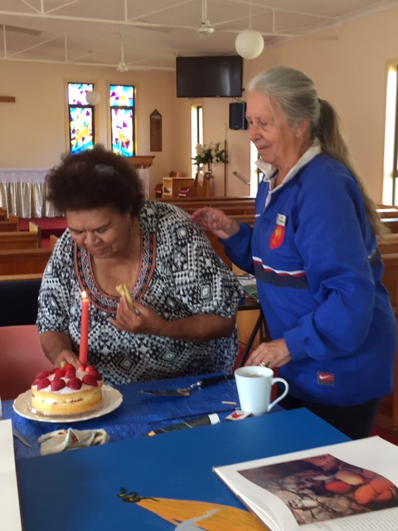
Worimi Elder, Janice Paulson, celebrating her birthday with Rev. Helen at the Culture and Christ Group. Mon. 9.30-11.30am. Tuncurry.
Anglican Women. Thank you boxes are now ready for collection. Hunter Medical Research Institute is the target for this year. Begin your “thank you” project by placing an offering in the box each time you give thanks to God for your blessings. Rev. Helen

I WILL CHASE AFTER YOU- a prayer based on Psalm 63.
There really is a God – and I will chase after you.
Deep within me there is a longing,
A need to be close to you.
As long as I live, I will keep walking towards you,
Praising you, worshipping you;
Day and night I will think of you,
Each step I take will be in your direction.

OUR LEADERSHIP TEAM:
Senior Minister: Rev. Mark Harris 0425 265 547
Families Minister: Rev. James Brooks 0411 335 087
Priest in Local Mission: Rev. Helen Quinn 0427 592 723

Items for the Parish News for September to Lyn Davies via phone
0491 136 455, text or call. Email: clivelyn46@gmail.com by 12noon Wednesday, thanks.

