PARISH NEWS

FORSTER & NABIAC 22nd December, 2019.

ADVENT 4 – THE SIGN OF THE LORD:
A VIRGIN WITH CHILD, IMMANUEL
LET US LIGHT THE CANDLE OF LOVE
“A virgin shall conceive and bear a son, and his name shall be called Emmanuel: God with us”. Matthew 1:²³

CHRISTMAS SERVICES
Christmas Eve - Forster 11pm. Nabiac 7pm.
Christmas Day - Forster, 9.00am.
APOLOGIES FOR LAST WEEK’S ERROR RE NABIAC.

PLUS – CHRISTMAS EVE
5pm FREE!!!! SAUSAGE SIZZLE, 6pm ALL AGE CAROL SERVICE
An excellent opportunity to enhance our Parish Vision by Connecting Meaningfully, Inspiring Hope, Transforming Lives, Through faith in JESUS
Many parishioners will be needed to make this occasion an eventful one, there will be jobs for people of all skills and abilities. Contact the office 5543 7683, or speak to one of the wardens. Let’s make it a great night!

CHRISTMAS LUNCH
For those who would like some company this Christmas Day, we will be providing Christmas lunch in the Parish Hall from 12 noon till 2pm. Please RSVP by noon Monday, 23rd, as numbers are essential for catering purposes. Mark 0425 265 547 & Trish 0433 952 360.

CONNECT WITH US
FACEBOOK……………………Forster Anglican Church Community
PARISH WEBSITE…………..www.forsteranglican.com
CHURCH OFFICE…………….info@forsteranglican.com 5543 7683
“ADORE” (Chris Tomlin) CD Christmas Songs of Worship
He shall reign forevermore – a few words worth sharing –“ Here within the manger lies the One who made the starry skies, this baby born for sacrifice – Christ the Messiah, into our hopes into our fears, the Saviour of the world appears, the promise of eternal years.”
Available in our Bookshop, plus many, many others meaningful items.

FROM THE PARISH FRIENDSHIP GROUP (via Helen Barber)
A big thank-you to those who helped and/or attended the December “Light Lunch”. We feel the “Sing as One” Choir certainly made the day memorable.
We now invite you to our monthly lunch on Wednesday, January, 8th – as usual, $8.00. Please come, and bring a friend (or relation) or 2.

DECEMBER MISSION FOCUS –THE CHRISTMAS BOWL

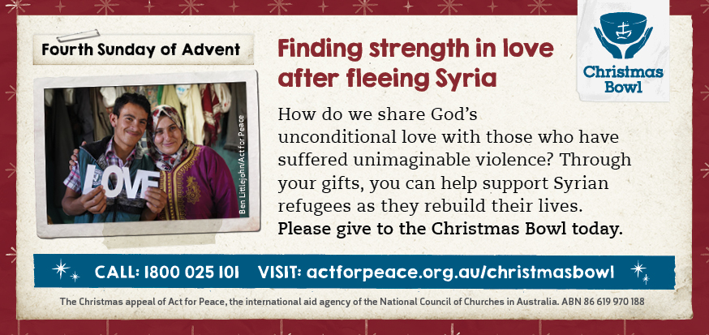

OUR LEADERSHIP TEAM
Senior Minister: Rev. Mark Harris 0425 265 547
Families Minister: Rev. James Brooks 0411 335 087
Priest in Local Mission:Rev.Helen Quinn 0427 592 723

PRAYERS FOR THE SICK AND RECOVERING
Ella E, Keith R, Lyn T, Marion & Peter R, Michelle, Rachael, Margaret B,
Zac L, Aileen G.

ADVENT STUDY SERIES DECEMBER 2019
Study 5 (last study) this week The sign of the Lord: a virgin with child, Immanuel.
“For everything that was written in the past was written to teach us, so that through endurance and the encouragement of the scriptures we might have hope.” Romans 15:4

FROM PARISH COUNCIL
Communion Rails
Now that Communion is being served on the first step in front of the altar at St Albans, Parish Council voted for work to be undertaken to remove the Communion rails. Quotes have been received, and a suitable one selected to patch the carpet with offcuts from the existing carpet to make the area presentable. The carpet that has been water damaged near the left-hand side rear door will be removed and replaced by tiles. This work will be carried out in the near future.

Pews versus Chairs
Demands on the use of St Alban’s Hall are increasing and there is a need for more flexible space in St Alban’s church itself. Parish Council are currently investigating options for replacing some or all of the pews with chairs – similar to those at St Paul’s, Nabiac. Parish Council are interested in hearing your views on this matter. Please let any of the members know your feelings/thoughts.
Judy Hall

SAMARITANS
Remember to buy something extra as you shop – always appreciated.

Items for the Parish News till the end of 2019 to Lyn Davies by 12 noon Wednesday, thanks. Phone 0491 136 455 text or call or email
clivelyn46@gmail.com
HOPE – this Christmas message appeared in The Advocate,
11th December, 2019.

It’s because of what happened that first Christmas that we can have a hope filled life!

I think all of us hope for something, sometimes many things. It might be a great life full of fun times, or a special loving relationship, or a great win at the lottery, or a fantastic new home or car. It might be all of these things and more.

But as we get older many of us don’t always get the things we hope for do we? Our hope is little more than a wish.

What Jesus did for us that first Christmas gives everyone who will put their trust in him something far greater than a wish for something good. Jesus gives us the hope of God being ‘with us’ and God being ‘for us’. And this hope isn’t a wish. Hope placed in Jesus is a ‘sure thing’ because it’s based on what God promises to do for us, and not in our ability.

By following Jesus in faith, we have the assurance that he lives with us in the person of his Spirit. Even in the tough times Jesus is there to help. He is also there when things are great! But Jesus is also ‘for us’, the word of God who created everything became that human baby Jesus to save people for eternal life! “For God did not send his Son into the world to condemn the world, but to save the world through him”. (John 3:17)

May you and your loved ones have a truly blessed Christmas. Please think about the hope that Jesus offers and may you re-connect with your local Church community in the year ahead, for the support and encouragement we all need!

From all of us in the Anglican Parish of Forster-Tuncurry,
we wish you all a hope filled Christmas.

Rev.Mark Harris, Senior Minister,
Anglican Parish of Forster-Tuncurry.

