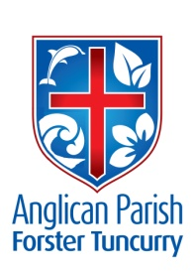
PENTECOST 2 - THE KINGDOM GOES
23RD JUNE, 2019.

God anointed Jesus of Nazareth with the Holy Spirit and with power; and he went about doing good and healing all who were oppressed by the devil, for God was with him. Acts 10.³⁸

Our Parish Vision:
CONNECTING MEANINGFULLY.
INSPIRING HOPE.
TRANSFORMING LIVES.
THROUGH FAITH IN JESUS.

THE DECONSECRATION OF ST. JOHN’S, DYERS CROSSING.
Bishop Charlie Murry will be at this Service of Thanksgiving next Sunday, 30th June at 10.am. Please note corrected time.

ST. ALBAN’S, FORSTER
Next Sunday, 30th June, both the Traditional Service 8.30am and the All-Age service at 10am will be held and also the 5.30pm at night.
Every Thursday, 9.30am Holy Communion.

PRAYER
SICK AND RECOVERING
Ella Engel, Jenny Lawson, Keith Roach, Nadia Maybury, Lyn Thompson, Marion & Peter Roberts, Margaret Burrows, Laurie Medcalf, the Pearson family, Peg Sawyer.

OUR MISSION FOCUS FOR JUNE IS THE SAMARITAN FOUNDATION.

GLECCA FILM PREMIERE
“The Least of These” NEXT SUNDAY , 30th June at 2.00pm. Tuncurry.
Tickets from Heather Webster and the Bookshop $20.00 each including afternoon tea after the movie. See promotion poster for details.

SAMARITANS DONATIONS
During June we’re concentrating on MEALS in a tin or a packet.

NOTES FROM PARISH SECRETARY, JUDY HALL -
PIANOS FOR SALE
The parish has two pianos to sell. These are: the one in St Alban’s Hall and the one from Nabiac. Please make an offer to one of the wardens should you wish to purchase/have one – otherwise they will be sold in the community. Both pianos will need tuning. According to ‘those in the know’ the one at Nabiac is of better quality than the one at St Alban’s.
(The piano located at St Nicholas’ will be brought over for use in St Alban’s Hall)
SRE
Rev James is currently looking for one or two parishioners to help out with Scripture at Forster Public each Friday morning – after lunch. He needs someone to help him in the classroom and possibly with his lunchtime group.
Interested? Talk to Reverend James.
Also, please keep this request/matter in your prayers.
SIFT
The local SIFT Committee is looking for someone to take on the role of being the SIFT champion in our parish. Interested? See Reverend James
FETE
The date for the Parish Fete has been set down for September 21st. Please begin to consider how you can assist in making this occasion a success – both financially and socially. Thanks, Judy

ACRONYMS
Do we all know the meanings behind GLECCA, SIFT, SRE?

BUNNINGS BBQ FOR TODDLER TIME
Saturday, 13th July – calling for volunteers to assist for two hour shifts. Check out the notice board and see where you can help out. New volunteers encouraged to join in this community event.
We have also received further dates for this year – Saturday, 17th August and Saturday 7th December. A good idea to mark the dates on your calendar now, thanks.

QUARTERLY CLEANING OF ST. ALBAN’S
Set down for NEXT SATURDAY 29th June – yet another list on the notice board. Starting time 8.00am thru to 11.30am, BUT, come along whenever you can. Be sure to mark which particular work you intend doing when you arrive. Thanks.
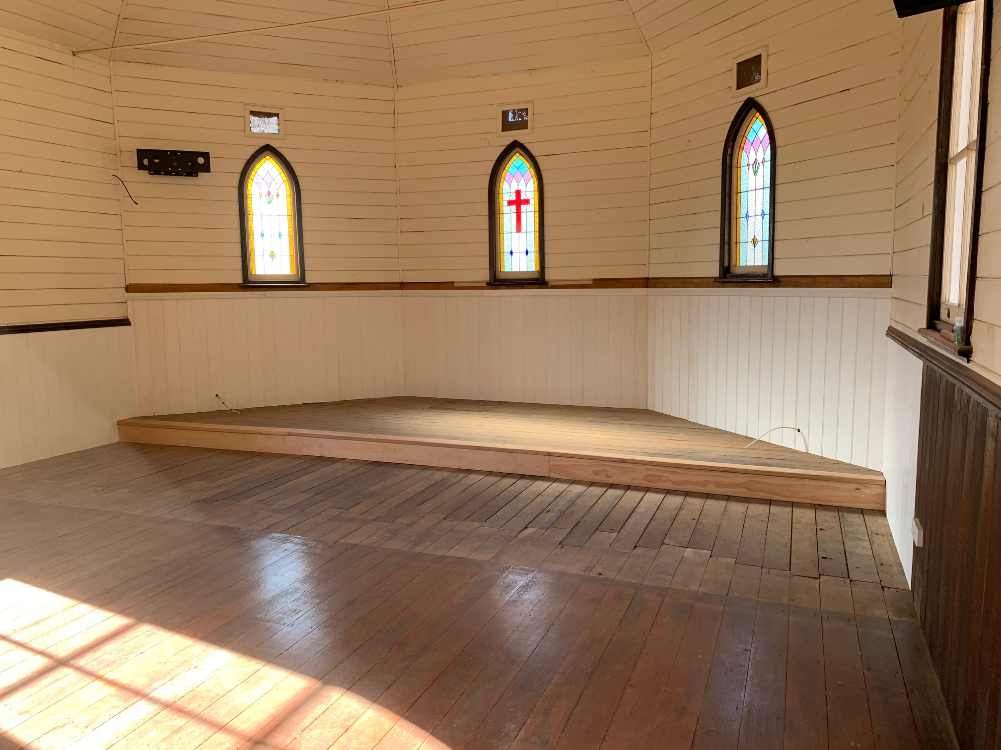

ST. PAUL’S, NABIAC
The upgrade of our country church at Nabiac is well under way. Many staff and parishioners have been involved in this manual task. The painting commenced last Monday, lights were installed on Wednesday.
What a fabulous job is being done with Kit and Mark at the helm.

RUGRATS
Come along and join this busy, crafty group. Friendship, fun & food!:

ROMANS 8:38,39
For I (Paul) am convinced that neither death nor life, neither angels nor demons, neither the present or the future , nor any powers, neither height nor depth, nor anything else in all creation, will be able to separate us from the love of God that is in Christ Jesus our Lord.

Senior Minister: Mark Harris
T: 0425 265 547. Parish Email:info@forsteranglican.com.
Fb:Forster Anglican Church Community.

