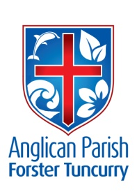
PENTECOST 18 – WHO WANTS TO BE GREATEST?
23rd SEPTEMBER, 2018.

Whoever wants to be first must be last of all and
servant of all. Mark 9.³⁵

OUR PARISH VISION:
“We will connect meaningfully with our community in order to inspire hope
and transformed lives through faith in Jesus.”

NEXT SUNDAY, 30th SEPTEMBER – 5TH SUNDAY IN THE MONTH – WE WILL CELEBRATE WITH ONE PARISH SERVICE AT ST. ALBAN’S AT 9.30AM.

OUR PARISH LUNCHEON – SUNDAY, 30th SEPTEMBER, 2018 – NEXT SUNDAY!
From Suellen – Our Parish Luncheon is being held at Club Forster next Sunday, 30th September.
The cost is $26.00 and Suellen is taking names and cash at Forster, Pat Sanderson is the one to talk to at Tuncurry and Helen Martin will be looking after Nabiac and Dyer’s Crossing.

THE CULTURE AND CHRIST GROUP speak to Rev. Helen Quinn for info.
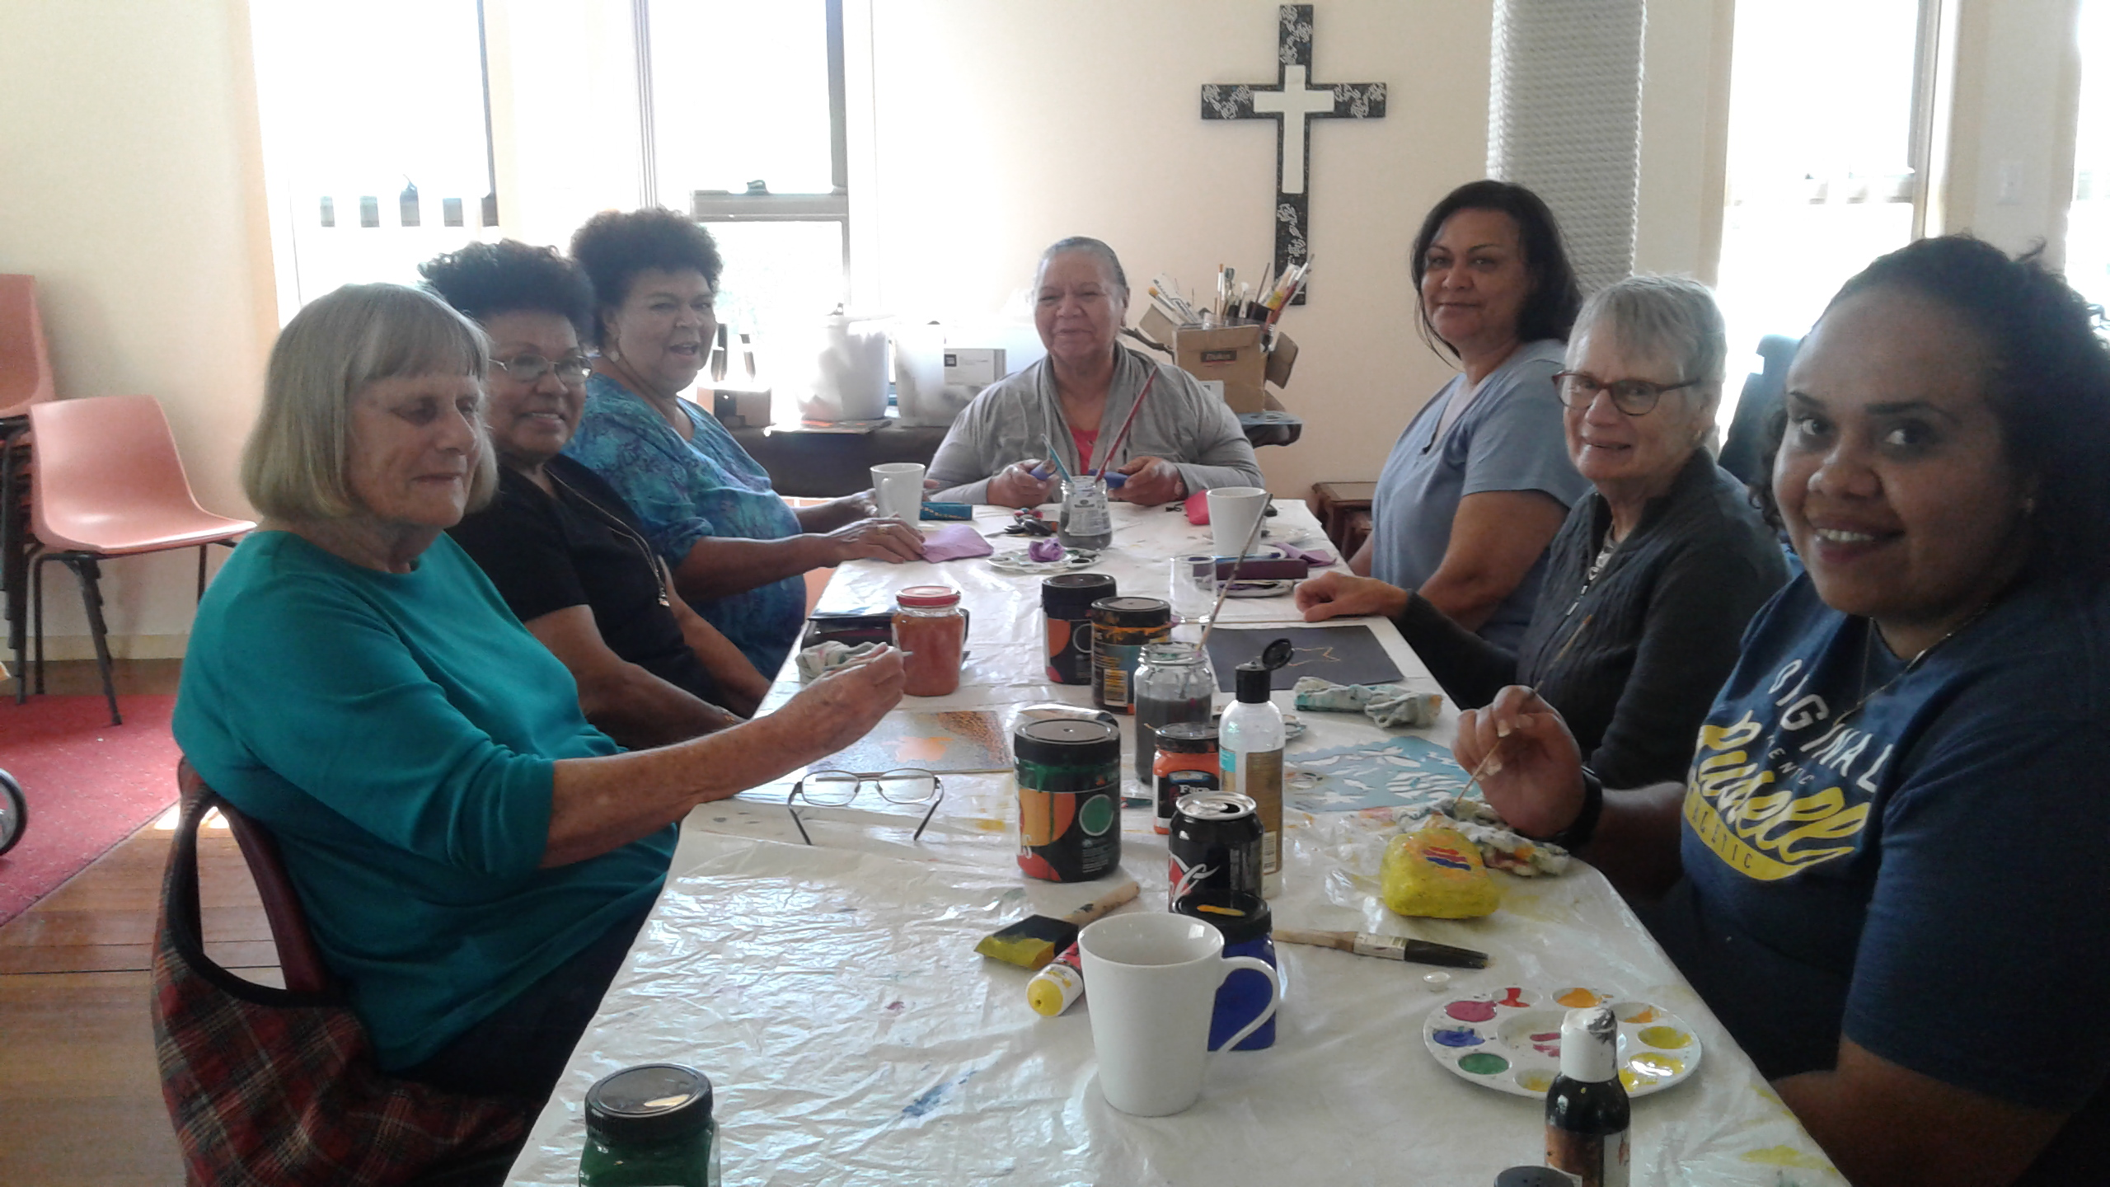

AS WE WORSHIP OUR GOD WE INCLUDE IN OUR PRAYERS THIS WEEK:
Bishop Peter’s prayer.
Our prayer for a Families Minister.
Bishop Peter & Nicki
Asst. Bishop Charlie Murry & Melissa
Asst. Bishop Sonia Roulston
Rev. Mark Harris & Trish

MEMBERS OF OUR CHURCH COMMUNITY WITH ONGOING NEEDS –
Hugo Walmsley, Alan Winston, Ella Engel, Jenny Lawson, Maureen Armstrong, George Hodgson, Louise, Keith Roach, Paul McIntosh, Michelle, Max Kennedy, Enid Ellison
If you would like to add someone to the Parish Prayer list, be sure to obtain permission from the person concerned and then contact the Parish Office.

OUR MISSION FOCUS FOR SEPTEMBER, BUSH CHURCH AID
September is “BCA Box opening month” please send your boxes to Suellen Belton via your church “boxes”.

DYERS CROSSING ANNUAL SPRING LUNCHEON & FASHION PARADE:

Let’s celebrate with
ST. JOHN’S LADIES GUILD, DYERS CROSSING
In the Nabiac Agricultural Hall, NABIAC
Friday, 28th September, 2018 – 11.15am
for their
ANNUAL SPRING LUNCHEON & FASHION PARADE
from Margo’s Boutique, Taree.
Delicious lunch, tea & coffee. Trading table.
$20.00 per person
RSVP before 24th Sept. Helen 6550 2383, Moya 6559 1265,
Aileen 6559 1541

PARISH FETE - WHITE ELEPHANTS well, I guess we probably all have the odd white elephant living with us. From Monday, 8th October you will be able to find a new home for the elephants. Always a great diversity of bric-a-brac, we especially encourage you to bring along SMALLISH items of a quality that you would purchase yourself.
UPCOMING EVENTS:
Wednesday, 26th September – Service at Golden Ponds, 10am
Friday, 28th September – Annual Fashion Parade, Dyer’s Crossing.
Two weeks school holidays NSW
Sunday, 30th September – 5th Sunday, Parish Service 9.30am St. Alban’s,
Followed by our Parish Luncheon at Club Forster.
Tuesday, 2nd October – Men’s Dinner, St. Alban’s.
Wednesday, 3rd October – Service at Estia, Forster, 10.30am
Friendship Group, St. Nicholas, 10am.
Saturday, 6th October – Bunnings BBQ
Sunday, 7th October – Daylight Saving starts
Saturday, 13th October – 8am-11.30am Working Bee at St. Alban’s.
Saturday, 20th October – Parish Fete at St. Alban’s.

PEWS AND SCONCES. There are two pews left for sale @ $200.00each and six sconces @ $100.00each and two sconces @ $150.00each. These items can be viewed at St. Alban’s. Speak to Kit or Clive.

BUNNINGS BBQ SATURDAY, 6th OCTOBER proceeds to Toddler Time. The next BBQ date that we have been offered is Saturday, 6th October. List for volunteers is on the board at St. Alban’s or phone Clive 0412 653 061.
Bunnings have advised us of two further BBQ dates for Toddler Time, the dates are Saturday, 17th November and Saturday, 19th January.

SIX STEPS TO LOVING YOUR CHURCH. From the Ministry of the Few to the Ministry of the Pew. The presenter, Tony Payne is the Publishing Director at Matthias Media, is married to Alison, and has five children – Gemma, Chloe, Miriam, Luke and Nicholas.
The assignment for LAST Sunday: don’t sit in your ‘normal’ seat (if you have one). Pray about where to sit, and sit next to someone different.
The assignment for TO-DAY: Choose at least one new thing you could do during church to encourage and help others, and put it into practice.

MEN’S DINNER. TUESDAY, 2nd October, 6pm for 6.30pm. Cost $15.00 each plus drinks. Our guest speaker will be Rev’d. Les Forester, speaking about his trip to Israel with accompanying overheads. Lists at all churches or phone the parish office.

PARISH BOOKSHOP
Phillip Castle has let me know that the Bookshop will be closed on Thursday 27th and Friday 28th September. Also there will be a week’s sale of 10% off all stock commencing on the day of the Parish Fete, Saturday, 20th October thru to Friday 26th October.

RUGRATS CRAFT GROUP, ST. ALBAN’S, TUESDAY MORNINGS speak to Coralie for info

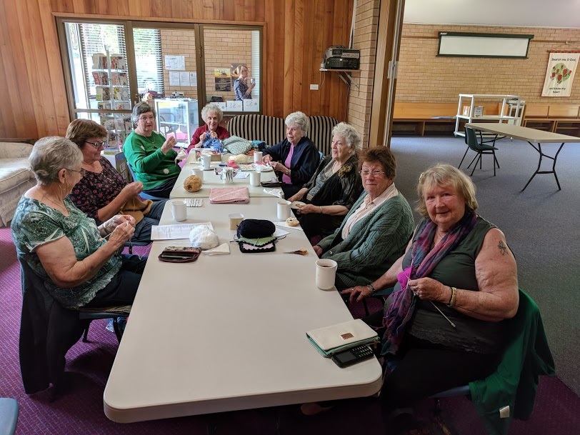

Senior Minister/Rector: Rev’d Mark Harris 0425 265 547
revmarkharris@icloud.com
Priest in Local Mission: Rev Helen Quinn 0427 592 723
Parish Office: St. Alban’s Anglican Church: 5543 7683
info@forsteranglican.com
Parish Secretary: Judy Hall 0400 890 728
Op Shop: Head St Car park 6555 4267
Book Shop: bookshop@forsteranglican.com 5543 7683
Parish Website: www.forsteranglican.com
Fb: Anglican Parish of Forster-Tuncurry.
Items for Parish News: Phone Lyn Davies 0491 136 455 or text, email clivelyn46@gmail.com, or Parish Office 5543 7683 by noon Wed, thanks.
Our bank details: BSB 705077 Account 000400710
Account name: Anglican Parish of Forster/Tuncurry

