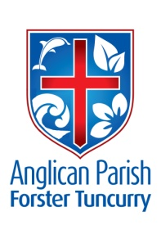
ADVENT 4 – MY SOUL MAGNIFIES THE LORD
23rd DECEMBER, 2018.
Blessed is she who believed that there would be a fulfilment of what was spoken to her by the Lord.
Luke 1.⁴⁵

OUR PARISH VISION:
We will connect meaningfully with our community in order to inspire hope and transformed lives through faith in Jesus.

OUR MISSION FOCUS FOR DECEMBER IS THE CHRISTMAS BOWL.

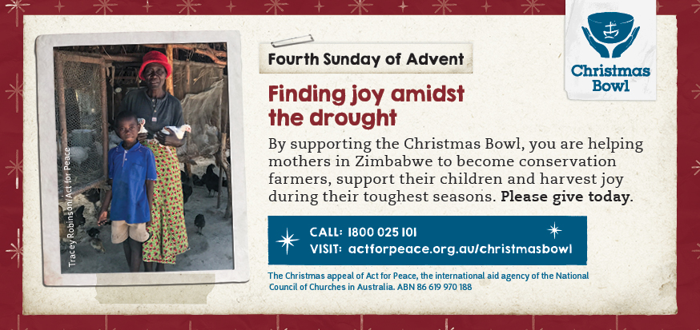

How can a family embrace joy when extreme drought has wiped out their crops and left them struggling to eat? By supporting the Christmas Bowl, we can help mothers in Zimbabwe to become conservation farmers, support their children and harvest joy during their toughest seasons.

SERVICE TIMES FOR 2019
As of the first Sunday in 2019 (6th January) service times will change. They will be as follows:
- St. Alban’s 8.30am, 10am and 5.30pm
- St. Paul’s & St. John’s 10am
CHRISTMAS SERVICE TIMES
CHRISTMAS EVE, Monday, December 24th 5.30pm Sausage Sizzle, followed at 6pm - All Age Carol Service. 11pm Traditional Communion Service, St. Alban’s.
7pm Traditional Carol Service, St. Paul’s, Nabiac.

CHRISTMAS DAY, Tuesday, December 25th 9am All Age Communion Service, St. Alban’s.
9.30am Traditional Communion Service, St. Nicholas.

NEXT SUNDAY - 5th SUNDAY IN DECEMBER
Sunday, 30th December, there will be one Combined Parish service at
St. Nicholas’, Tuncurry, 9.30am, our final Tuncurry service for worship at St. Nicholas’ Church. Bishop Sonia Roulston will be with us on the day.

SUNDAY EVENING SERVICES
There is to be a break from these services till Sunday. 6th January, 2019.

ADVENT IN AUSTRALIA (An Advent Reflection) Anglican Overseas Aid.
Pray: Pray for those in other places for whom celebration of Christmas is a risky business.
Reflect:
- What are the greatest challenges of living out our Christian faith in Australia?
- Getting to know our neighbours is a great way to build friendship and trust. Is there room for someone else around your table this Christmas?
- How can Christmas be made a more peaceful time for you and your family?

ISAIAH 9:6
For a child has been born for us, a son given to us; authority rests upon his shoulders; and he is named Wonderful Counsellor, Mighty God, Everlasting Father, Prince of Peace.

REV MARK’S CHRISTMAS MESSAGE – WHY CHRISTMAS?
(This message appeared in the Advocate, Wednesday, 19th)
What a wonderful time of year Christmas is! For those of us who are older, it brings back memories of our own childhood, our families, and what Christmas was like for us. For those who are younger, there’s the excitement of presents, as well as the family get together, and usually a delicious Christmas dinner! For Christians, Christmas is all of those things, and more. And the ‘more’ is the most significant part.

Significant evidence that Jesus is who He claimed to be [the eternal Son of God] is found in prophecy. There are literally hundred of prophecies written about the Messiah who was to come that were all fulfilled in the one person – Jesus Christ. The probability of this happening by chance is nearly ‘zero’, suggesting we need to consider carefully who Jesus is. Both prophecy and Jesus Himself, tell us that Jesus came for us. God wants to reconnect with us, so that we can live with Him forever! God entered into His own creation and became a human. Jesus is God in human form! He died on a cross and then rose from the dead, so that everyone who believes in him and follows him can live forever when this life is over.

What a wonderful offer! Eternal life is up for grabs! All we need to do is believe and follow Him.

May you and your loved ones have a truly blessed Christmas, as you think about how Jesus IS the reason for the season, and may you re-connect with your local Church community in the year ahead, for the support and encouragement we all need!

From all of us in the Forster-Tuncurry Anglican Church community, we wish you all a holy and peaceful Christmas!

BUNNINGS BBQ
Saturday, 19th January is the date set down for the next BBQ. Monies raised are used for the extension of Toddlertime. People are always delighted to read that the BBQ involves toddler activities and it’s a great outreach to customers who come along with “little people”.
MEMBERS OF OUR CHURCH COMMUNITY AND FRIENDS WITH ONGOING NEEDS
Ella Engel, Jenny Lawson, Maureen Armstrong, George Hodgson, Louise, Keith Roach, Michelle, Max Kennedy, Beryl Allen, Nadia Maybury, Sue Hollis, Lyn Thompson, Marion & Peter Roberts, Allan Peel, Renae and family.
We remember with thanks those whom we have loved whose anniversary occurs at this time, Simon Allon and Doris Humphries.

BOOKSHOP NEWS from Phillip Castle
There are some VERY INEXPENSIVE Study Bibles on sale. NIV Study Bible $7; CSB Study Bible only $15. Read the Bible in a year $10 NLT
Also, we have music CD’s by the City of Light band from St Paul’s Castle Hill – which we often sing from in the Contemporary Services.
Bookshop closed Monday 24th December, reopen Monday 7th January.
Thankyou for your custom this year.

SAMARITANS DONATIONS
Thoughts for December – holiday food – popcorn, chips, biscuits, jelly, topping, tins of fruit, long life custard, kid’s drinks or what is YOUR favourite holiday food?

THANKYOU FROM ISABEL McBRIDE
Isabel has greatly valued the visits, cards, flowers and especially the prayers whilst she spends time in Forster Private Hospital. Isabel has now moved into rehab.

Senior Minister/Rector: Rev’d Mark Harris 0425 265 547
revmarkharris@icloud.com
Priest in Local Mission: Rev Helen Quinn 0427 592 723
Parish Office: St. Alban’s Anglican Church: 5543 7683
info@forsteranglican.com
Parish Secretary: Judy Hall 0400 890 728
Op Shop: Head St Car park 6555 4267
Book Shop: bookshop@forsteranglican.com 5543 7683
Parish Website: www.forsteranglican.com
Fb: Anglican Parish of Forster-Tuncurry.
Items for Parish News: Lyn Davies 0491 136 455. Parish Office 5543 7683 by 3pm Wed, Thanks.
Our bank details: BSB 705077 Account 000400710
Account name: Anglican Parish of Forster/Tuncurry

