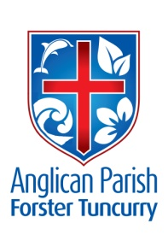
EPIPHANY 7 – SPIRITUAL BODIES?
24TH FEBRUARY, 2019.

Love your enemies, do good, and lend, expecting nothing in return. You will be children of the Most High; for he is kind to the ungrateful and the wicked. Luke 6.³⁵

OUR PARISH VISION:
Connecting meaningfully. Inspiring hope and transformed lives. Through faith in Jesus

DYERS CROSSING HARVEST FESTIVAL
This morning, 24th February at 10.00am there will be a Harvest Festival Thanksgiving Service at St. John’s Church, Dyers Crossing.

ELECTORAL ROLL
To-day is the day that all parishioners need to check the information recorded, this is required to be “in order”at least two weeks before the AGM. If you don’t appear on the roll please sign an “electoral roll” form TODAY. Speak to Clive, Barry or Kit if you need more info.

PARISH ANNUAL GENERAL MEETING – ONE SERVICE 9.30am FORSTER
Date is set down for Sunday, 17th March. Parish Secretary, Judy Hall, asks that all reports be sent to her via email Judy72hall@bigpond.com or hard copy to the office by to-day.

WORKING BEE AT ST. ALBAN’S
Next Saturday, 2nd March, 8am till 11.30am, a cuppa and a bite to eat all thru the morning. List on the notice board. ONLY TWO OFFERS OF HELP SO FAR!! We really need more helpers, so talk to Clive if you need more info. If Saturday is your “sleep in” morning you can always come later – a few already start about 10ish.

MEMBERS OF OUR CHURCH COMMUNITY AND FRIENDS WITH ONGOING NEEDS
Ella Engel, Jenny Lawson, George Hodgson, Keith Roach, Michelle, Nadia Maybury, Lyn Thompson, Marion & Peter Roberts, Isabel McBride, Margaret Burrows.
We commend to God’s keeping those who have recently died, and we pray for those who mourn their passing.
We remember with thanks those whom we have loved whose anniversary occurs at this time Jim Harris, John Griffis.

OUR MISSION FOCUS FOR FEBRUARY IS ABM
ABM – Anglican Board of Mission – Australia. Working for Love, Hope & Justice.
Pew reflections written by Rev Will Johnston, ABM 2019.
The Seventh Sunday after the Epiphany
– Sunday 24 February 2019
- Genesis45.3-11,15;Psalm37.1-11,40-41;
1 Corinthians 15.35-58; Luke 6.27-38
Jesus says to us today: If you love those who love you, what credit is that to you? For even sinners love those who love them. As Christians we are called by Jesus to show God’s love to others. But how? Jesus tells us: Love your enemies. Do good. Lend, expecting nothing in return. Be merciful, just as your Father is merciful. Do not judge. Do not condemn, Forgive. Give. Today is a good day to make a start.
- Pray that each of us today might pick one of Jesus’ commands and begin to incorporate it into our lives, allowing God to shine through us to others.
- Give thanks for Wontulp-Bi-Buya College in Cairns, giving thanks for the educational programs provided to Aboriginal and Torres Strait Islander students.

CRAFT GROUP – RUGRATS
The Group are after any spare buttons you have; any size, any colour, they have a crafty plan for all these buttons!! Speak to Coralie.

OP SHOP – WE NEED LOTS MORE GEAR
All manner of things, clothing, kitchenware, towels, sheets, books, craft gear, puzzles, games to mention just a few.

SAMARITANS DONATIONS
TINS, TINS, TINS – fruit, veggies, tins of spread, jars of jam, vegemite, peanut butter whatever is on half price special!! This collection is delivered in our local area to those less fortunate than ourselves.

MORNING TEA 10am at St. Alban’s
There is a need for an extra helper for the first and fourth Sundays. See Lyn Davies if you can help.

NOTES FROM PARISH COUNCIL -

SHROVE TUESDAY, 5TH MARCH
A Pancake Evening will be held at St. Alban’s at 5.30pm. Details to follow.

ASH WEDNESDAY
Service at St. Alban’s, 10.30am.

ISRAELI LUNCHEON, SUNDAY, 10th MARCH
Rev’d Mark and Trisha, Judy Hall, Patricia & Binny Dastidar will be speaking to us about their trip to Israel and we’ll have a chance to view their photos. A typicial Israeli luncheon will be served $15.00 each. Booking list on the notice board in the hall or phone the office.

BOOKSHOP SURPLUS
These monies are to be shared equally between GLECCA and SIFT. If you’re unsure of what these are – speak to Phillip or Deborah.

TODDLER TIME MONDAY 18th FEBRUARY
Thirty toddlers!! An amazing morning, a great start for the year. The photo shows the group enjoying a fruity morning tea .

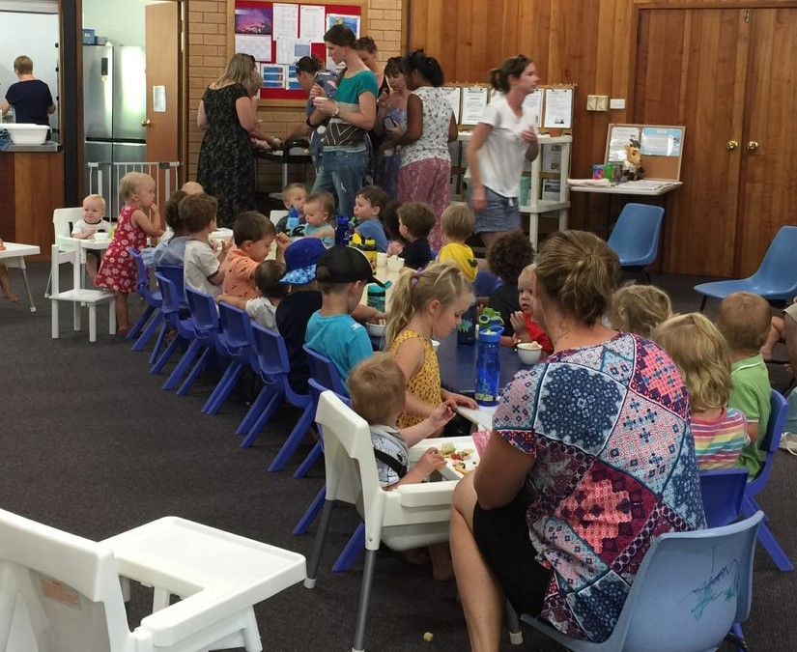

Senior Minister/Rector: Rev’d Mark Harris 0425 265 547
revmarkharris@icloud.com
Families Minister: Rev’d James Brooks 0411 335 087
jamesknac@gmail.com
Priest in Local Mission: Rev Helen Quinn 0427 592 723
rqu783662@bigpond.com
Parish Office: St. Alban’s Anglican Church: 5543 7683
info@forsteranglican.com
Parish Secretary: Judy Hall 0400 890 728
Op Shop: Head St Car park 6555 4267
Book Shop: bookshop@forsteranglican.com 5543 7683
Parish Website: www.forsteranglican.com
Fb: Anglican Parish of Forster-Tuncurry.
Items for Parish News: Lyn Davies 0491 136 455 or Parish Office 5543 7683 by noon Wed, Thanks.
Our bank details: BSB 705077 Account 000400710
Account name: Anglican Parish of Forster/Tuncurry

