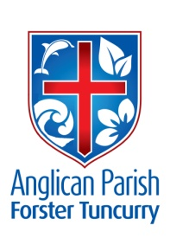
PARISH NEWS
TWENTIETH SUNDAY AFTER PENTECOST

27th October 2019

Truly, I say to you, whoever does not receive the kingdom of God like a child shall not enter it. Luke: 18.17 Sell all that you own, and distribute the money to the poor, and you will have treasure in heaven; then come, follow Jesus. Luke: 18.22

THANK YOU AND A GREAT RESULT!
Thank you to the biscuit makers and waitresses who served afternoon tea last Sunday at the concert. Also thanks to the Silver Tones Singers for selecting St Alban’s as their venue and allowing us to nominate which charity proceeds from afternoon tea should go to. A grant total of $450 was raised in donations for Drought Relief.

BCA BOXES
On behalf of Bush Church Aid, thank you to those boxholders who brought their boxes in for counting in September, especially the people who took new boxes this past year. An amount of $1268.90 has been forwarded to the society.
Suellen – BCA Box Secretary

LIGHT LUNCH
The next Light Lunch will be on Wednesday, 13th November. “Take-aways” available at Midday.

FRIENDSHIP GROUP
Morning tea and a chat, each 1st Wednesday, 10.00am St Alban’s. All welcome.

MEMBERS OF OUR CHURCH COMMUNITY AND FRIENDS WITH ONGOING NEEDS
Ella E, Jenny L, Keith R, Lyn, Marion & Peter R, Michelle, Rachael, Peter A, Max S.
We remember particularly those whom we have loved whose anniversary occurs at this time: Kenneth Claude Conroy.

GAMES AFTERNOONS
“Table Games” afternoons are held on the 2nd Saturday of each month. All ages welcome. 1 – 4pm St Alban’s Hall – with afternoon tea.

OUR NURSING HOME MINISTRY
It would be great if more people could come and share these services with former parishioners and friends. Our regular dates are listed below.
GLAICA TUNCURRY
1st Wednesday, 2.00pm in Chapel. (6th November)
KULAROO BAPTIST CARE
4th Wednesday, 2.00pm in Chapel. (27th November)
ESTIA FORSTER
1st Friday, 10.00am. (1st November)
ESTIA TUNCURRY
10.30am 13th November
GLAICA – Sunday Service 2.00pm, as rostered.

REMINDERS
Parish Lunch – 3rd November. Bookings close today, Sunday, 27th October. See Suellen at Forster or Kit or Geraldine at Nabiac. $26 a head, children $12.
Samaritans – Christmas goodies and/or bathroom gear.
CMS – Our mission for October

PLANTS FOR SALE
We have a variety of cactus plants still for sale.

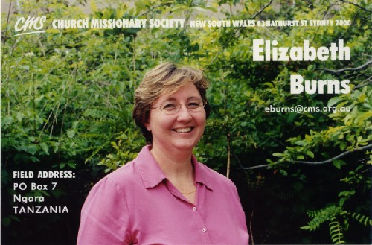
NEWS OF LIZ BURNS
We have received the following from the Rev Garry Dibley, Partnership and Missionary Development Coordinator, CMS NSW & ACT
“Greetings in the name of the Lord Jesus.
As you know, Liz Burns has been back in Australia now for almost 2 years. At the start of 2018, Liz started her deputation but part the way through, it became obvious that burnout had taken a grip and she needed to recover. This burnout was due to several factors which occurred over a period of time on location in Tanzania.
CMS NSW & ACT, in consultation with CMS-A, and with Liz, agreed for her to go on sick leave through the rest of 2018. The plan was for Liz to get better, then return to Tanzania.
When it looked like this process was going to take longer than expected, it was decided to ensure that Liz could recover fully, she would go on 12 months’ unpaid leave. With this time now coming to an end, Liz, in consultation with CMS, has reluctantly, but understandably, decided to resign from CMS. Liz understands that to get back to Tanzania, which still is her prayer, she will need to get well enough to be employed full time, and then to proceed to a ministry role, and then to seek to return to Tanzania.
We thank you for your continued support of Liz over this time. She is happy to come to your church and thank you and your church for this partnership. You are under no obligation to do this. We are currently making a video for Liz to send to all her churches, thanking them, and explaining some of what is in this letter. This may suffice for your church. If you would like Liz to visit your church, you can contact Dan Arthur – darthur@cms.org.au

In Christ,
Rev. Garry Dibley
CONNECT WITH US:
FACEBOOK ………………… Forster Anglican Church Community
PARISH WEBSITE………… www.forsteranglican.com
CHURCH OFFICE ………… info@forsteranglican.com 5543 7683

JOIN US FOR WORSHIP
St Alban’s, Forster: Sundays – 8.30am Holy Communion;
10am All Age + Kids’ Church; 5.30pm All Age + Communion. Thursdays – 9.30am Holy Communion
St Paul’s, Nabiac: 10am All Age Informal 1st & 3rd Sundays
10am Traditional Communion 2nd & 4th Sundays

Senior Minister/Rector: Rev’d Mark Harris 0425 265 547
revmarkharris@icloud.com
Families Minister: Rev’d James Brooks 0411 335 087
jamesftac@gmail.com
Priest in Local Mission: Rev’d Helen Quinn 0427 592 723
rqu783662@bigpond.com
Parish Office: St. Alban’s Anglican Church: 5543 7683
info@forsteranglican.com
Parish Secretary: Judy Hall 0400 890 728
Op Shop: Head St car park 6555 4267
Book Shop: St Alban’s Hall 5543 7683
bookshop@forsteranglican.com
Parish Website: www.forsteranglican.com
Items Parish News: Janet Lawrence, email: jan2max@bigpond.net.au, 6554-5981 or
0448-502-684 or Parish Office 5543-7683 by noon Wednesday.

Opportunity To Give
For direct credit offertories:
BSB: 705077 Account: 000400710
Account name: Anglican Parish of Forster/Tuncurry

