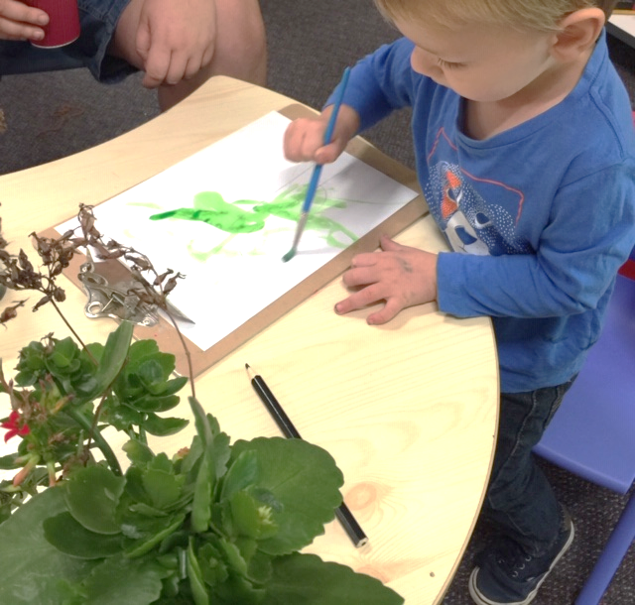
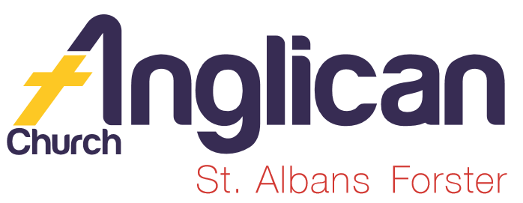
5th May 2019

PARISH NEWS

“In Him was life, and the life was the light of humanity. And the light shines in the darkness,
and the darkness did not overcome it.”
John 1:4-5

ToddlerTime reconnects
We enjoyed a wonderful start to Term 2 with 30 excited toddlers and babies! We painted pictures of gorgeous green plants, and thanked God for our beautiful families!

Inaugural SD Day Event
Siblings of our ToddlerTimers enjoyed our inaugural Staff Development Day Event – with stories, games and paper aeroplanes! We made deeper connections with
our families!

Ministers’ Professional Development
Revs Mark and James enjoyed a challenging and relaxing Clergy Retreat in beautiful Myall Shores National Park. They were encouraged by studying God’s Word in Exodus, as well as through relationship with other clergy!

Biggest Morning Tea!
Thank you so much for your generous support for Cancer research! A huge thank you to Helen B for facilitating!

GLECCA
Join us on Saturday 18 May at 3pm at Forster Baptist Church for an afternoon of sacred music with the Sydney Male Voice Choir. All proceeds to support GLECCA!

Pray…
Prayer is powerful! Please pray for:
Ella E, Jenny L, George H, Keith R, Michelle, Nadia M, Lyn T, Marion & Peter R, Isabel M, Margaret B, Laurie M and Diana C.

Old Testament Overview
Join us as we delve into an overview of the Old Testament! Come into our Great Lakes Christian Bookshop and get your “Full of Promise” Study Booklet today! Only $5.00! All proceeds to GLECCA and SIFT!

Make a Difference

Make a difference in someone’s life! Donate to Samaritans now! Your shopping list for those doing it tough –
Wheat/rice crackers; Tinned soup, spaghetti, baked beans; pasta; juice, and Vegemite. Thank you for your generous hearts!

Connect with our Community
Join us on Saturday 25 May between 8:30am and 4pm for our ToddlerTime Bunnings BBQ fundraiser! Come and buy a sausage sandwich; connect with others; and/or help out on the team!

Shine Your Light

Join us in supporting the Church Missionary Society as they shine their light and share God’s love globally. Your care, through prayer and/or financial support, is greatly appreciated!

BY SUELLEN B.

Connect With Us

Senior Minister…………………….. Rev. Mark Harris ……… 0425 265 547
revmarkharris@icloud.com
Family Minister……………………. Rev. James Brooks ……0411 335 087
jamesknac@gmail.com
Priest in L M………………………… Rev. Helen Quinn ………0427 592 723
rqu783662@bigpond.com

Church Office……………………….Clive ……………………. 5543 7683
info@forsteranglican.com

Parish Secretary……………………Judy Hall………………… 0400 890 728

Op Shop……………………………..Heather D ……………….. 6555 4267

Book Shop…………………………..Phillip or Deb ………….. 5543 7683
bookshop@forsteranglican.com

Parish Website…………………….www.forsteranglican.com

FaceBook…………………………. Forster Anglican Church Community

Items for Parish News……………Email: trishaharris10@gmail.com
or Parish Office 5543 7683 by noon Wednesday.

For Direct Debit Giving –

Account name: Anglican Parish of Forster/Tuncurry
BSB: 705077 Account: 000400710

Thank You For Your Generous Hearts!

