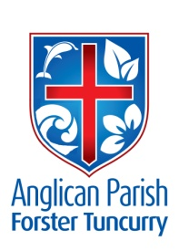**PARISH NEWS**

**SECOND SUNDAY OF EASTER**

**28th April 2019**

*Jesus said to Thomas, ‘Put your finger here and see my hands. Reach out your hand and put it in my side. Do not doubt but believe.’* John 20.27

**BIGGEST MORNING TEA - FOR CANCER**

The Wednesday Friendship Group invites you to:

**The Biggest Morning Tea -** Saturday, 4th May, from 10.00am at St Alban’s Church Hall. Please come and bring a friend or two. All proceeds to Cancer Research. Enquiries - Helen Barber 0419 996 594

**FRIENDSHIP GROUP**

There won’t be Morning Tea for the Friendship Group on Wednesday, 1st May, INSTEAD a Get-Together on Thursday, 2nd May at 2.00pm to prepare for the “Biggest Morning Tea” on Saturday. Everyone invited! (See above.)

**OFFERTORIES 10% BELOW TARGET**

Offertory collections during services for 2019 have totalled $24,860. This is a little more than 10% below the target of $27,700. Electronic giving for this year so far has been $8840 against a target of $11,250, about 20% under.

Many members already give sacrificially, especially some on fixed incomes. However, if everybody could seriously consider whether they could increase their giving by 10%, it would certainly help reaching the target and, more importantly, continue to enable the ministry and witness which we are undertaking to continue.

**MEMBERS OF OUR CHURCH COMMUNITY AND FRIENDS WITH ONGOING NEEDS**

Ella Engels, Jenny Lawson, George Hodgson, Keith Roach, Michelle, Nadia Maybury, Lyn Thompson, Marion & Peter Roberts, Isabel McBride, Margaret Burrows, Carolyn Lane, Laurie Medcalf and Diana Coleman.

We remember with thanks those whom we have loved whose anniversary occurs at this time: **John Noel Ollivier**.

**ABM PEW REFLECTIONS**

The Second Sunday of Easter  
– Sunday 28 April 2016

* Acts 5.27-32; Psalm 118.14-29;  
  Revelation 1.4-8; John 20.19-31

**Love:** Everyone’s different. Thomas was the sort of person that needed proof before he believed anything. He wasn’t going to be a victim of fake news. Today we find Jesus meeting Thomas’ need for proof literally in a visceral way. Though we still give Thomas the epithet, Doubting, because of his fingers going into wounds, we should remember his doubt fast became faith.

* Pray that we might cry, ‘My Lord and my God!’   
  with St Thomas whenever we encounter Jesus Christ our Lord.
* Give thanks for the Church of North India, remembering especially today their ministry in a predominantly non-Christian context.

Text: Robert McLean,  
© Anglican Board of Mission, 2019

**MORE TEA**

The Forster Tuncurry Presbyterian Church, Bruce Street, Forster, invites you to High Tea on Saturday, 4th May, 2.30pm – 4.30pm.

Guest Speaker: Renee Hann. Topic: “A Busy Life – Virtuous or Preoccupied?”

Cost $10. RSVP Lorraine Mills 0499-613-399.

**BUSH CHURCH AID**

Thank you on behalf of Bush Church Aid. The March box opening resulted in $906.19 being forwarded to the Society.

Suellen Belton, Box Secretary

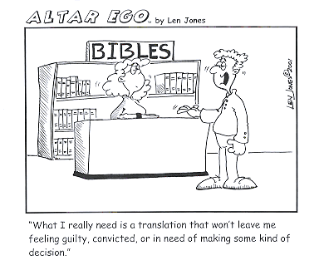

**STUDY BOOKLETS – FULL OF PROMISE**

Next term’s sermon series will be an overview of the Old Testament and a Study Booklet is available for use in home groups or private study. The guide is called “Full of Promise” and will be available for a special price of $5.00, arriving mid-week. Order your copy today!

**SAMARITANS DONATIONS**

For the month of May – Soup (tins or packets) and cracker biscuits. (Or, as usual, anything else you think suitable, e.g. spaghetti, baked beans, cake/bscuit/pancake mixes, juice, jam, sweet biscuits, jars of Chicken Tonight or similar, pasta, etc.)

**PARISH NEWS**

Trisha will be producing the Parish News for the month of May.

Email - [trishaharris10@gmail.com](mailto:trishaharris10@gmail.com), or leave message with Parish Office 5543-7683.

**Senior Minister/Rector**: Rev’d Mark Harris 0425 265 547

[revmarkharris@icloud.com](mailto:revmarkharris@icloud.com)

**Family’s Minister:** Rev’d James Brooks 0411 335 087

[jamesknac@gmail.com](mailto:jamesknac@gmail.com)

**Priest in Local Mission:** Rev Helen Quinn 0427 592 723

[rqu783662@bigpond.com](mailto:rqu783662@bigpond.com)

**Parish Office:** St. Alban’s Anglican Church: 5543 7683

info@forsteranglican.com

**Parish Secretary:** Judy Hall 0400 890 728

**Op Shop:** Head St Car park 6555 4267

**Book Shop:** [bookshop@forsteranglican.com](mailto:bookshop@forsteranglican.com) 5543 7683

**Parish Website:** www.forsteranglican.com

**Fb:** Anglican Parish of Forster-Tuncurry.

**Items for Parish News:** Trisha Harris, email: trishaharris10@gmail.com

or Parish Office 5543-7683 by noon Wednesday.

**Opportunity To Give**

**For direct credit offertories:**

BSB: 705077 Account: 000400710

Account name: Anglican Parish of Forster/Tuncurry