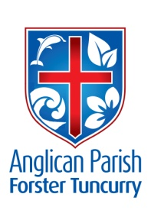
PARISH NEWS
TWENTY-THIRD SUNDAY AFTER PENTECOST
28th OCTOBER 2018

The redeemed of the Lord shall return and come to Zion with singing; and everlasting joy shall be upon their heads. Isaiah 51.11

BAPTISMS
Today, at the 9.30am Family Service, we will celebrate the baptisms of Neive Ridley and William Duffy as we welcome them into our church family. Neive and William have been regular attenders at our Family Service and William is also a Toddler Timer.

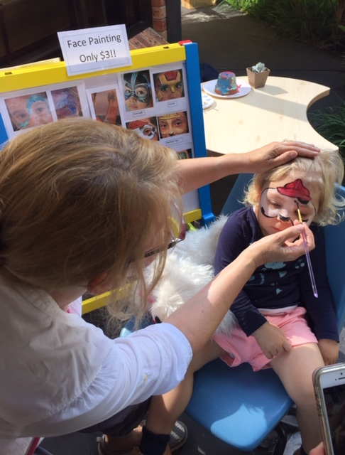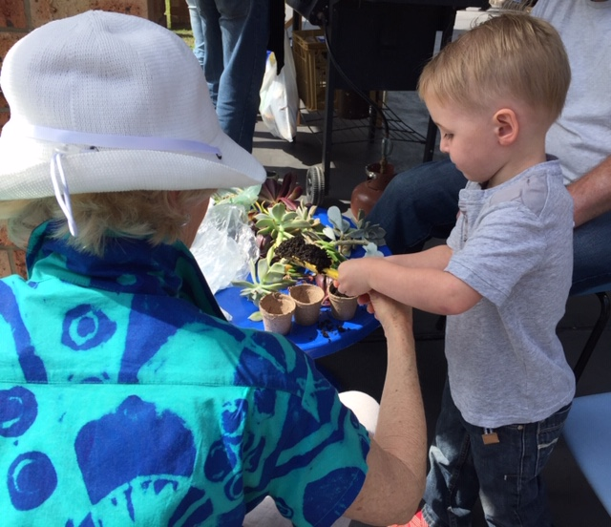
Neive William
OUR FETE
We have no final figure yet but it is estimated that profit from the Fete will be about $4000. Congratulations all round and many thanks to those who contributed in any way to the social and financial success.

AS WE WORSHIP OUR GOD WE INCLUDE IN OUR PRAYERS THIS WEEK:
Bishop Peter’s prayer
Our prayer for a Families Minister
Bishop Peter & Nicki
Asst. Bishop Charlie Murry & Melissa and Asst. Bishop Sonia Roulston
Rev. Mark & Trisha and Rev. Helen & Dick

MEMBERS OF OUR CHURCH COMMUNITY WITH ONGOING NEEDS
Beryl Allen, Ella Engel, Jenny Lawson, Maureen Armstrong, George Hodgson, Louise, Keith Roach, Paul McIntosh, Michelle, Max Kennedy and Judy Hall.

If you would like to add someone to the Parish Prayer list, be sure to obtain permission from the person concerned and then contact the Parish Office.

We commend to God’s keeping those who have recently died and we pray for those who mourn their passing. We remember with thanks those whom we have loved whose anniversary occurs at this time: Kenneth Claude Conroy

POSITION VACANT
From 1 January, 2019 St Alban’s 8:30am Church Service needs a Co-ordinator for its ‘Welcomers’.
If you would like to assist, please contact the Parish Office, 02 5543 7683.

ITEMS FOR THE PARISH NEWS
Lyn will be back doing the Parish News from next week – Sunday 4th November.

PRAISE & PRAYER UPDATE
A Praise & Prayer update from José Vergara is on the notice board in the hall.

VISIT OF FR. ROD BOWER
(Rector of Gosford)
For those who missed his dynamic talk, here are some of the main points he made:
He spoke of a priest in South America, who, when he fed the poor was called a saint, but when he asked “Why are they poor?” was called a communist! He also told of a ‘tweet’ from a refugee in desperation on Manus Island who begged him to get water to them. Sadly he replied “Until 80 million voters support your request, I cannot get you any water." He told of his grief that it was becoming too late to help all the children and young teenagers on Nauru who had lost all hope and become catatonic, just lying with eyes closed, unable to speak or eat and some close to death, and, of others who had attempted suicide, all at colossal expense to the Australian taxpayer. This is in spite of an appeal to the government by 5000 doctors last week. Among other points he told of the great number of kind, generous, good people around, but who may not realise we should also be just; and that all of us, especially the Christian church people, should also be prepared, when aware of unjust situations, to work for justice.

Senior Minister/Rector: Rev’d Mark Harris 0425 265 547
revmarkharris@icloud.com
Priest in Local Mission: Rev Helen Quinn 0427 592 723
Parish Office: St. Alban’s Anglican Church: 5543 7683
info@forsteranglican.com
Parish Secretary: Judy Hall 0400 890 728
Op Shop: Head St Car park 6555 4267
Book Shop: bookshop@forsteranglican.com 5543 7683
Parish Website: www.forsteranglican.com
Fb: Anglican Parish of Forster-Tuncurry.
Items for Parish News: Parish Office 5543 7683 by noon Wed.
Our bank details: BSB 705077 Account 000400710
Account name: Anglican Parish of Forster/Tuncurry

